Day 22

insertAdjacentHTML, insertAdjacentElement and insertAdjacentText:
Method | Adds | Accepts | Used For
insertAdjacentHTML() | HTML code | String | Insert HTML
insertAdjacentElement() | DOM element | Element node | Insert created elements
insertAdjacentText() | Plain text | String | Insert text only

1. insertAdjacentHTML()
Adds HTML code at a specific position relative to an element.
Positions
Position | Meaning
"beforebegin" | Before the element
"afterbegin" | Inside → start
"beforeend" | Inside → end
"afterend" | After the element
Example:
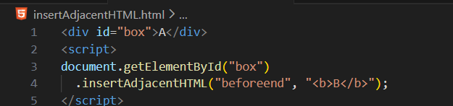

Output:
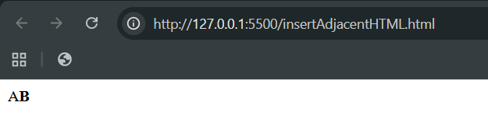
2. insertAdjacentElement()
Adds an actual DOM element (not HTML string) at a specific position.

Example:
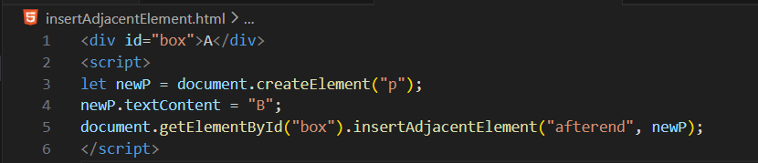
Output:
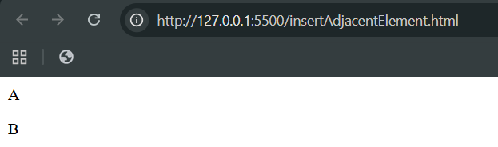
3. insertAdjacentText()
Adds plain text at a specific position (no HTML parsing).
Example:
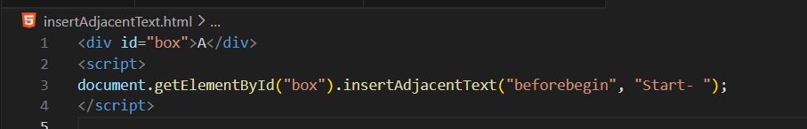

Output:
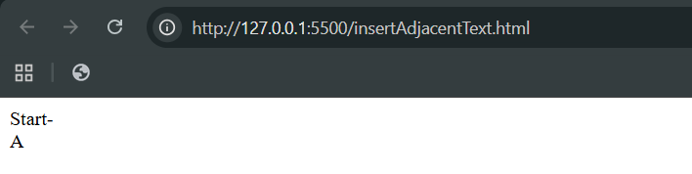
--The End--

