Day 26
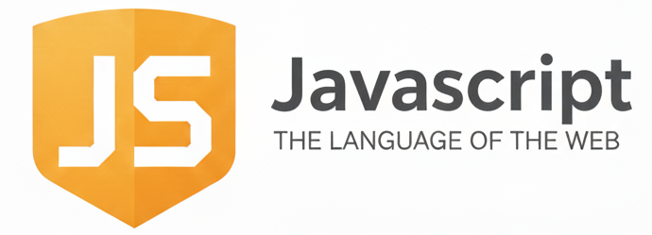
Handling Browser Events:
What does “handling an event” mean?
Handling an event means:
- Detecting when something happens (click, key press, mouse move, etc.)
- Running code in response.
Example:
“User clicks a button → show a message”
Three Ways to Handle Events
In JavaScript, events can be handled in 3 ways:
Method 1 → HTML Event Attribute (old method)
You put the event directly in HTML.
Example:
<button onclick="alert('Button clicked!')">Click</button>
Cons: Not recommended now. Mixes HTML & JS.
Method 2 → Assign event to element property
Simple and clean.
Example:
<button id="btn">Click</button>

<script>
document.getElementById("btn").onclick = function () {
alert("Clicked!");
};
</script>
Limitation:
You can assign only ONE function to .onclick.
Method 3 → addEventListener (best method)
Most modern and flexible method.
Example:
<button id="btn">Click</button>
<script>
document.getElementById("btn").addEventListener("click", () => {
alert("Button clicked using addEventListener!");
});
</script>
Advantages:
- You can attach multiple event handlers
- Works with all event types
- Better for real projects

Also,
Removing Event Listeners
You can remove an event only if it is stored in a function.
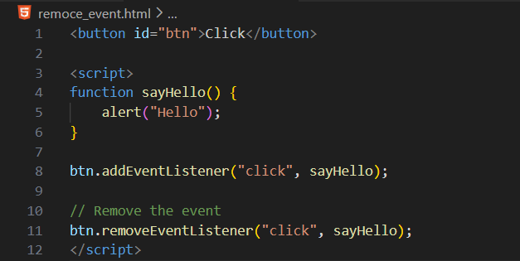
--The End--

