Day 19

Matches(), Closest() and Contains():
What Are innerHTML, outerHTML, and Other Properties?
These properties are used to get or change HTML content of an element.
1. innerHTML
- It gives the HTML content inside an element.
- You can read it or change it.
2. outerHTML
- It gives the entire element itself, including its own tags.
- Changing it replaces the element.
3. textContent
- It gives only the text inside the element (no HTML tags).
- Use it when you just want to handle text safely.
4. innerText
- Similar to textContent, but respects visible text only (ignores hidden ones and CSS styles).

Property | What it Returns | Can Modify? | Includes Tags?
innerHTML | Inside HTML | ✅ | ✅
outerHTML | Element + Inside | ✅ | ✅
textContent | Inside Text | ✅ | ❌
innerText | Visible Text | ✅ | ❌

Example: innerHTML
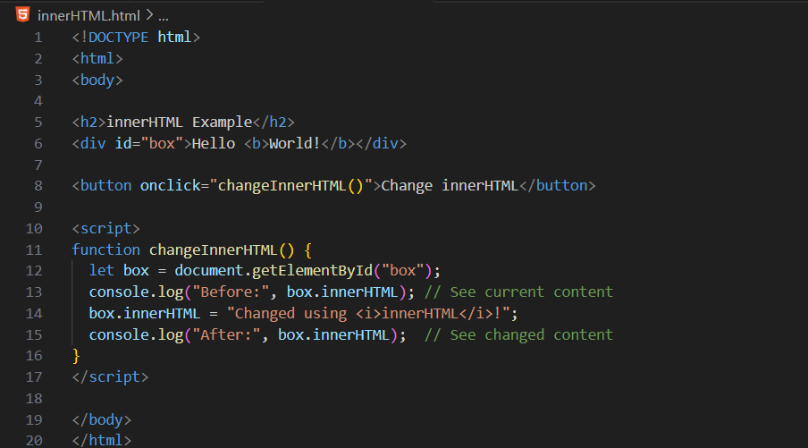
Output: at start
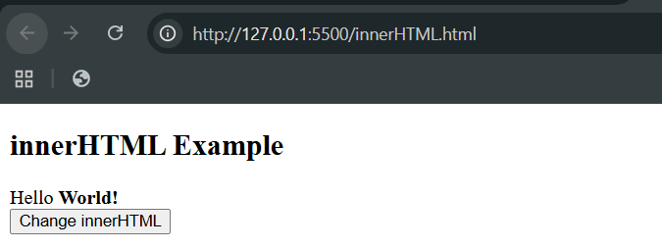
Output: when button was clicked
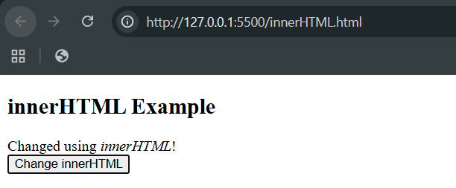
Example: outerHTML
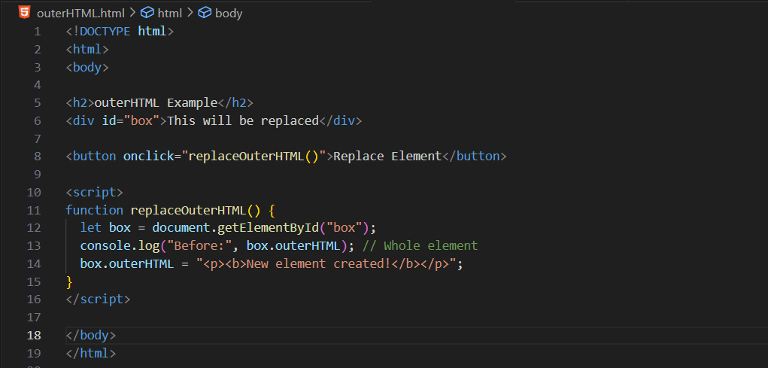
Output: when loaded
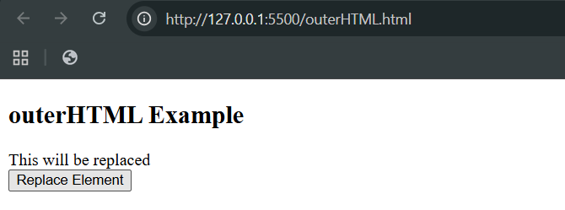
Output: when button was clicked
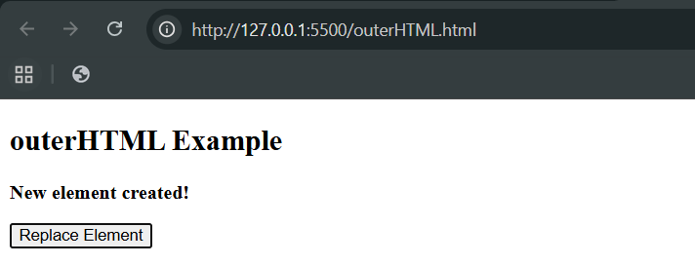

Example: textContent
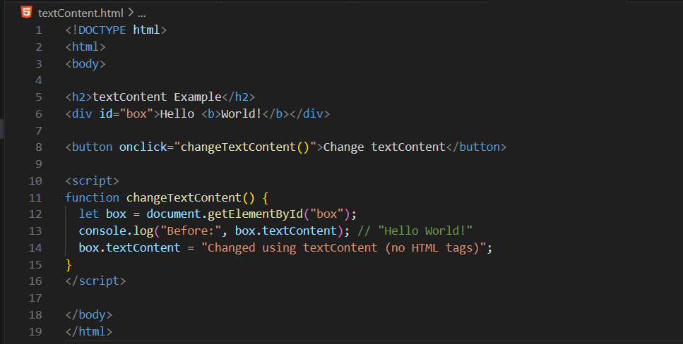
Output: when loaded
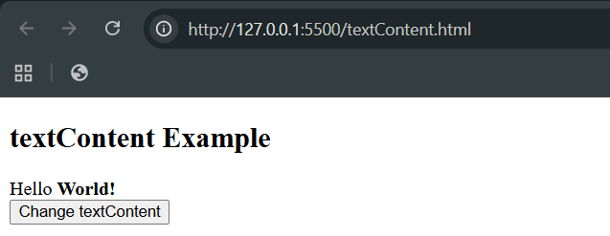
Output: when button was clicked
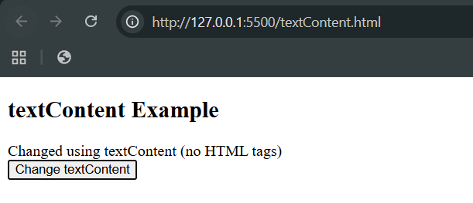
Example: innerText
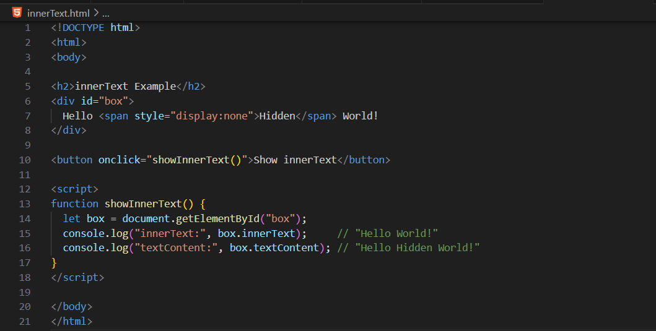
Output: when loaded
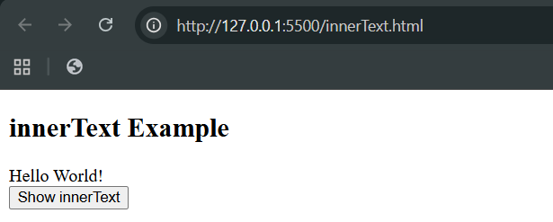
Output: when button was clicked
