Day 29

Introduction to Promises:
What is a Promise?
A Promise in JavaScript is an object that represents a value that will be available now, later, or never.
It’s used to handle asynchronous operations (things that take time).
A Promise can be in 3 states:
- pending → still running
- fulfilled → completed successfully
- rejected → failed
Other Important Details About Promises
- A Promise represents something that takes time, like fetching data from a server.
- .then() handles successful results.
- .catch() handles errors.
- .finally() runs no matter what (optional).
- Promises help avoid callback hell.
- Very commonly used with fetch() and async/await.
Syntax of promise:
let promise = new Promise(function(resolve, reject) {
// Do some work...
// If successful:
resolve(value);
// If an error happens:
reject(error);
});

Example: a basic example where the “World” will be printed 2 seconds after everything else is printed.
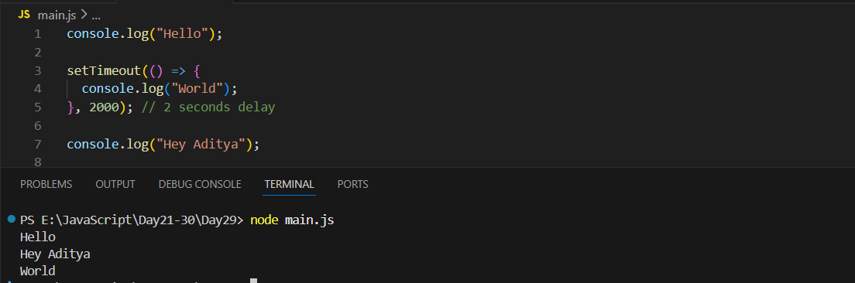
Example: introducing promise in the code, basically we are saying that if the promise is fulfilled then resolve it as 59, later we printed it as well.
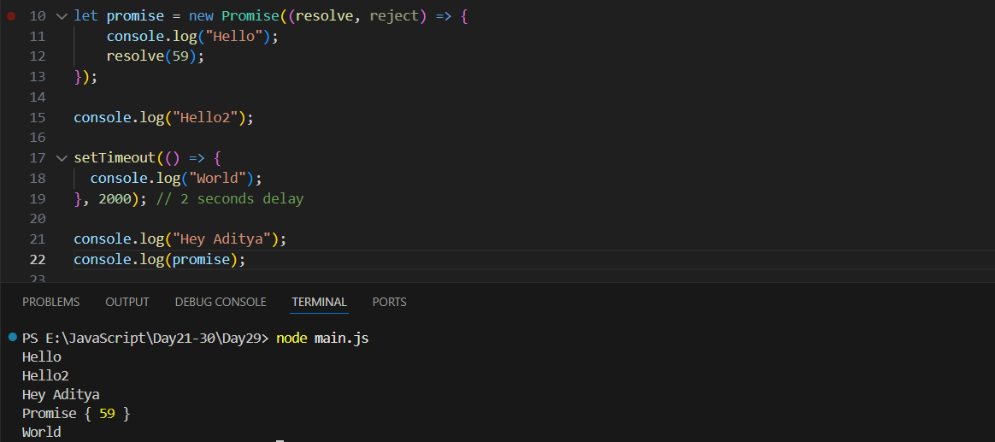

When the code runs, the Promise is created and the function inside it runs immediately, so the first thing printed is “Hello.” The Promise is then resolved with the value 59. After that, the next line prints “Hello2.” The setTimeout schedules the message “World” to be printed after 2 seconds, but it does not run immediately. The script continues, printing “Hey Aditya,” and then it prints the Promise object itself, which shows Promise { 59 } because it was already resolved. Finally, after a 2-second delay, the scheduled message “World” is printed.

Promise .then() and .catch():
What is .then()?
.then() is used to run some code when a Promise is successfully resolved.The value passed to resolve() becomes the value received by .then().

What is .catch()?
.catch() is used to run some code when a Promise is rejected (when something goes wrong). The value passed to reject() becomes the error received by .catch().

Example: a basic code to understand the promise use case
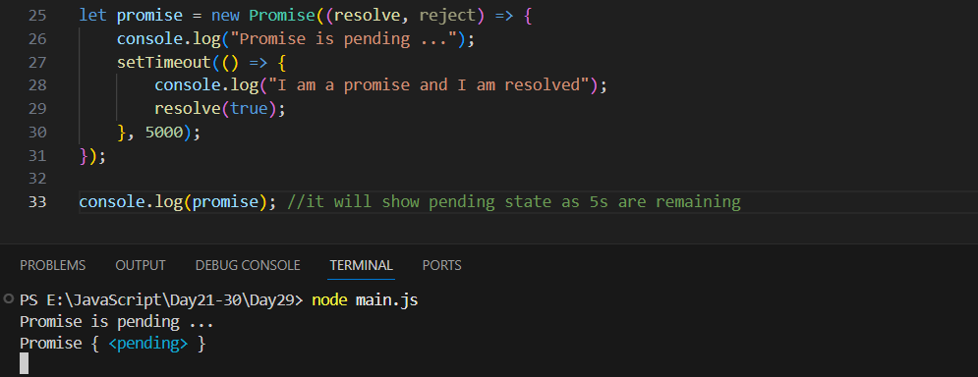
After 5 seconds:
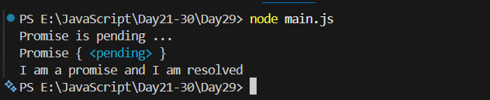

When the code starts running, a new Promise is created, and the message “Promise is pending ...” is printed immediately because the code inside a Promise runs right away. The setTimeout schedules the promise to resolve after 5 seconds, but it does not run yet. Then the line console.log(promise) is executed, and since the 5 seconds have not passed, it prints the Promise in its pending state: Promise { <pending> }. After 5 seconds, the function inside setTimeout runs, printing “I am a promise and I am resolved”, and the Promise finally becomes resolved with the value true.

Example: a promise which has been fulfilled and rejected. (Note: Fulfilled then it can either be resolved or rejected)
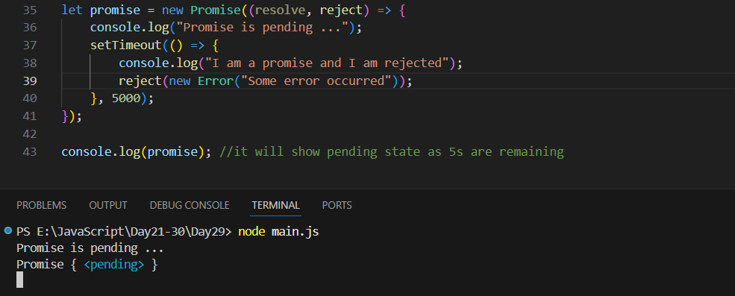
After 5 seconds: error occurred as we wrote in the reject().
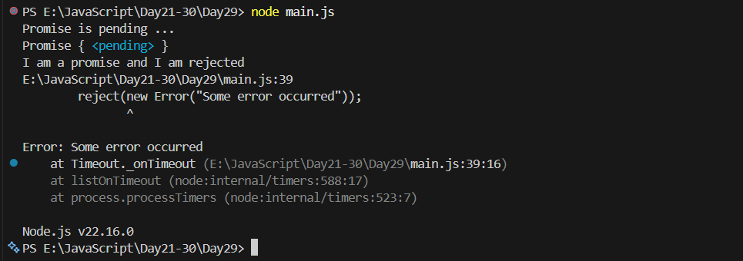

Also, promises executes parallelly. It means if we have multiple promises, either getting resolved or rejected, they all can work in parallel. As shown below:
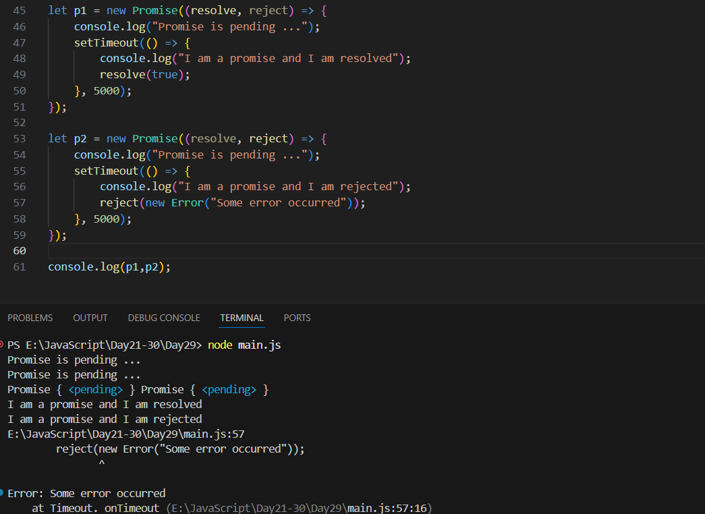

Now, introducing the .then() and .catch():
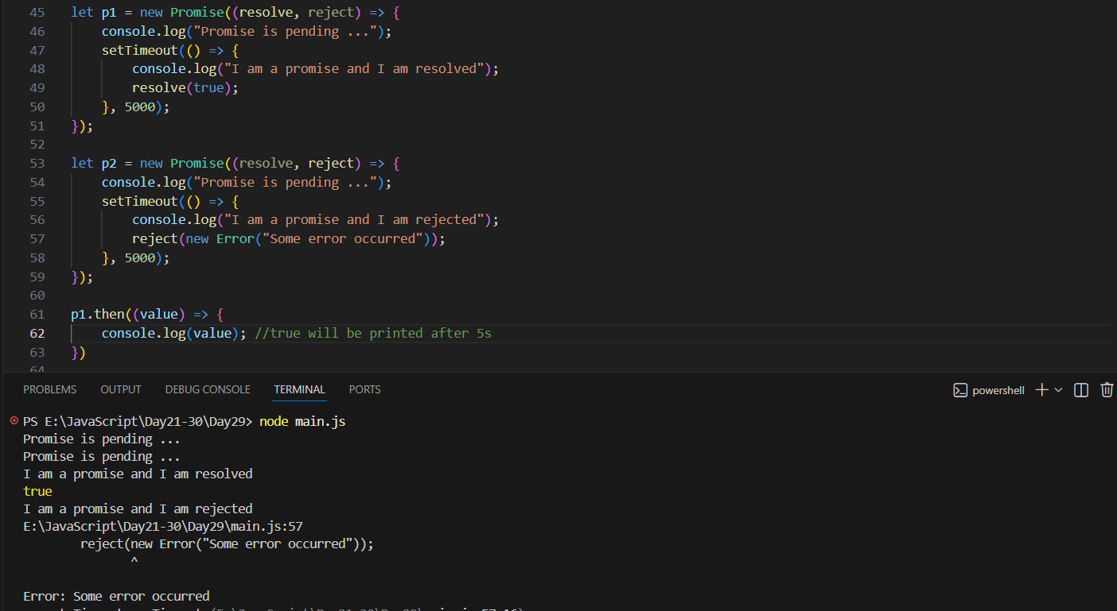

Similarly, we are introducing .catch():
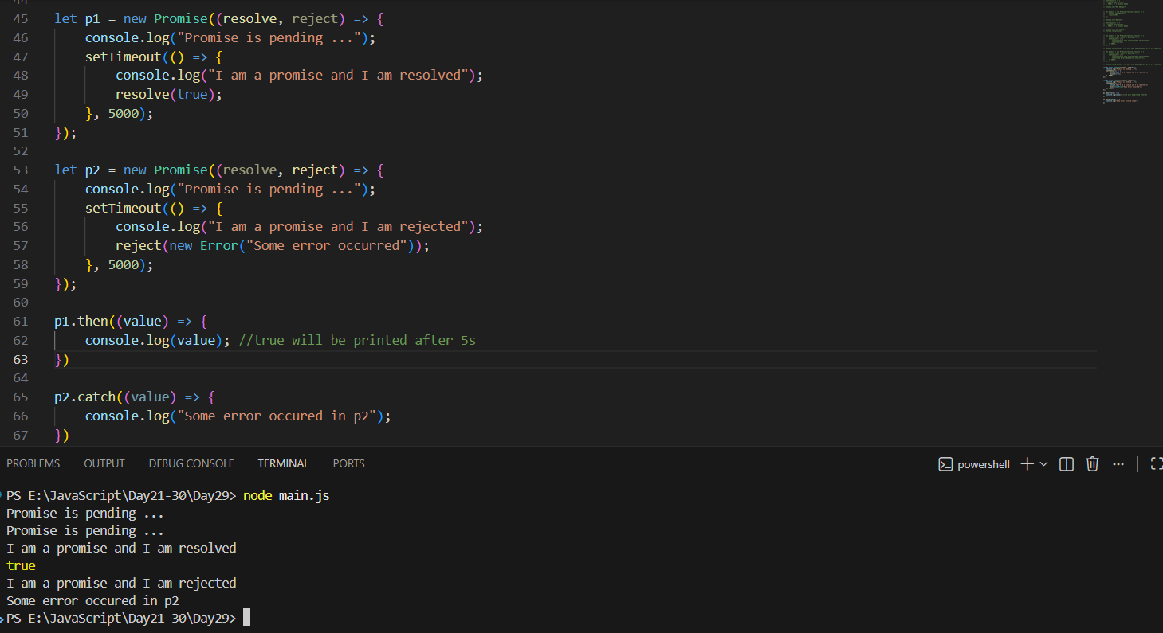

--The End--

