Day 48

Arrow Functions Revisited:
Arrow functions are a shorter and cleaner way to write functions in JavaScript. They are written using the => (arrow) syntax.
They are mostly used for:
- short functions
- callbacks
- array methods
- improving readability
Example: both add and add2 are same.
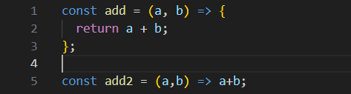
Example: arrow function with argument
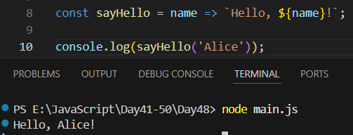

Example: passing two arguments to the arrow function
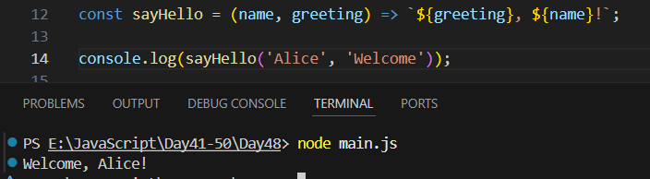

Example: no parameters
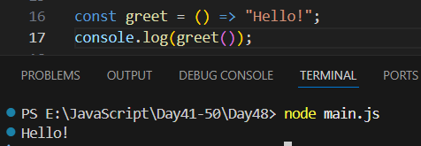
Example: one arguments
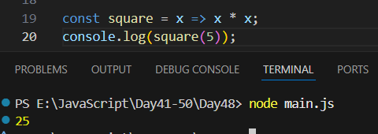

Example: arrow function don’t have their own ‘this’, They use the this of the outer scope (lexical this). If we used a normal function inside setTimeout, it would NOT print the name correctly.
Arrow functions fix that.
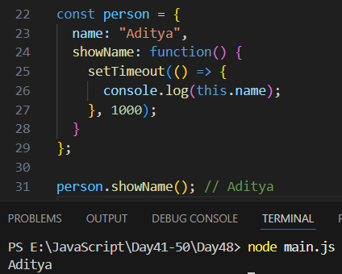

--The End--

