Day 18

Matches(), Closest() and Contains():
What Are matches(), closest(), and contains()?
These three are DOM element methods used to check relationships between elements or find related elements in the document.
They help you:
- Check if an element fits a selector (matches)
- Find the nearest matching ancestor (closest)
- Check if one element is inside another (contains)
Now, to understand this, we will create a simple file:
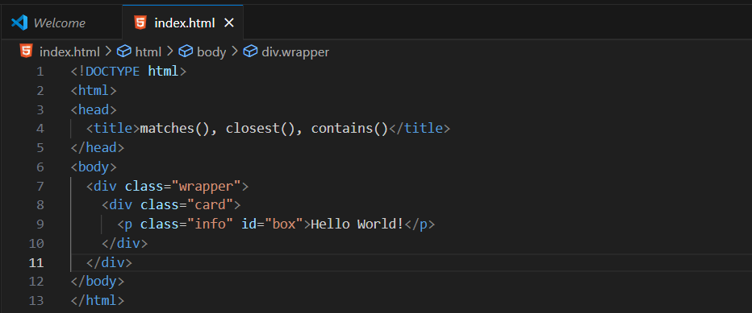
Output:
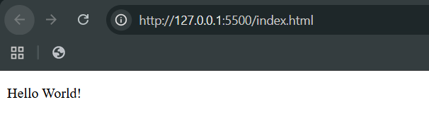

Now, using the matches():
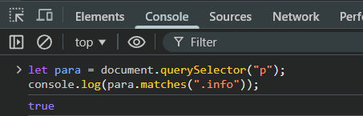
Now, if doesn’t matches:
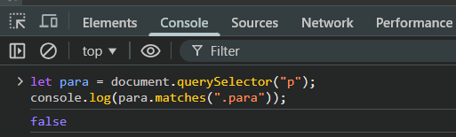
Now, to understand the closest(), let’s create another file: index2.html
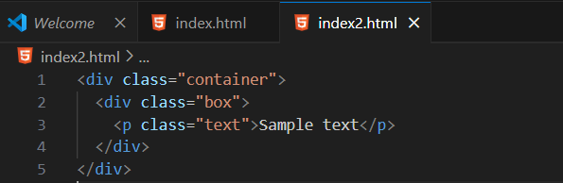
Output:
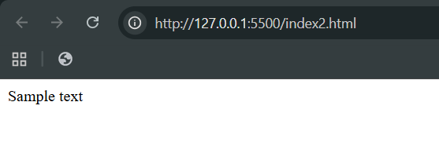
Now, 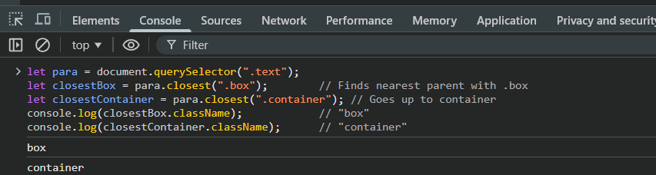
Now, to understand the contains(), we will create another file: index3.html
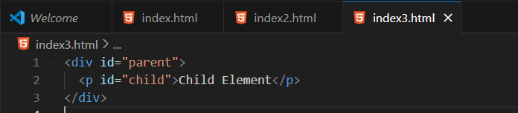
Output:
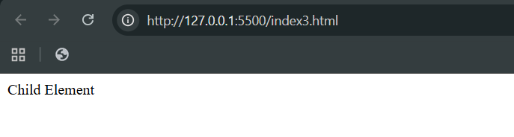
Now,
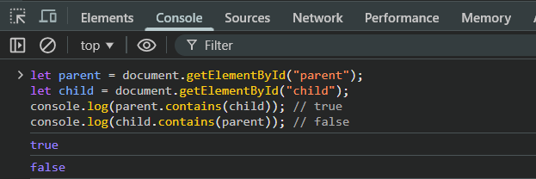
--The End--

