Day 17

Table Navigation:
What is Table Navigation?
Table navigation means accessing and moving through parts of an HTML table using JavaScript. The browser treats table elements (<table>, <thead>, <tbody>, <tr>, <td>, etc.) as nested DOM elements, so you can easily navigate between them.
Why Use Table Navigation?
We use it to:
- Read or modify table data
- Highlight or style specific rows/cells
- Access elements like thead, tbody, tr, td directly
Table Navigation Properties
Property | Description | Example
table.rows | All rows in the table | table.rows
table.tHead | Refers to the <thead> section | table.tHead
table.tBodies | All <tbody> sections | table.tBodies
table.tFoot | Refers to the <tfoot> section (if any) | table.tFoot
table.caption | Refers to <caption> element (if any) | table.caption
tbody.rows | All rows in a specific <tbody> | table.tBodies[0].rows
row.cells | All cells (<td> or <th>) in a row | table.rows[0].cells

Now, to explain this let’s understand this:
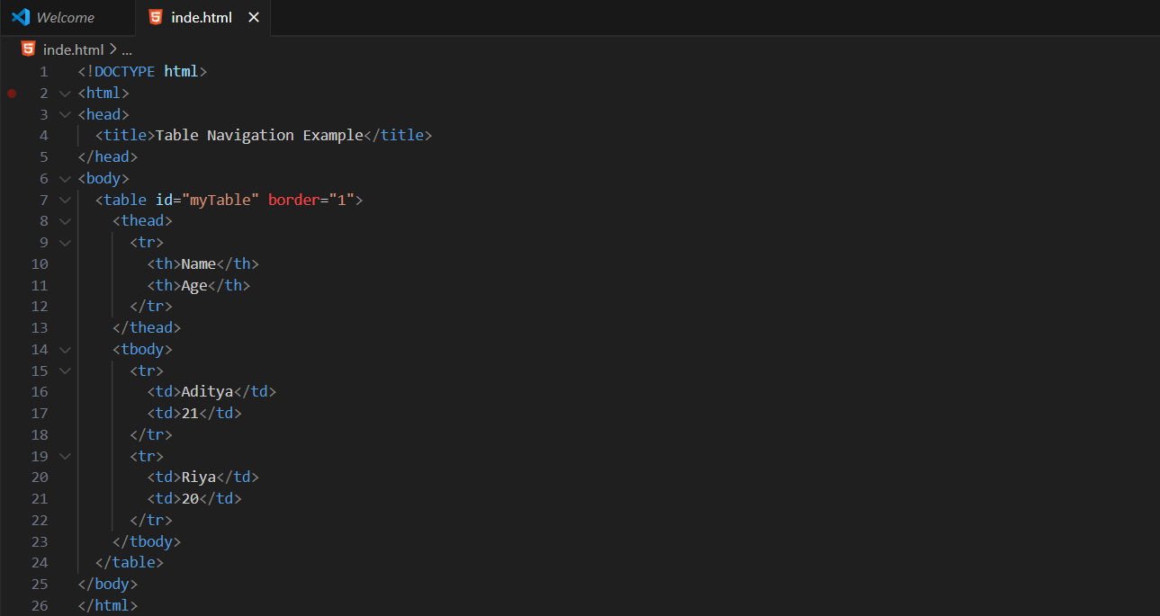
Output:
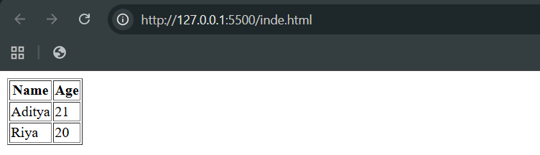
Now, on console:
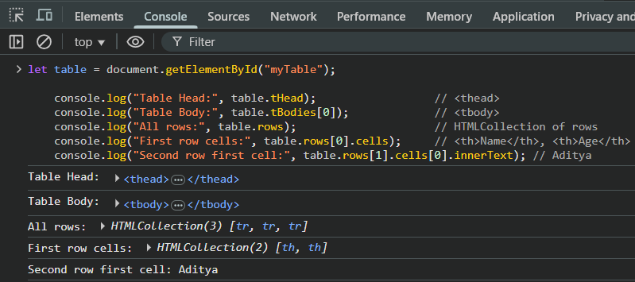

Searching the DOM:
What is “Searching the DOM”?
In JavaScript, searching the DOM means finding elements inside an HTML page using selectors or element properties. The DOM (Document Object Model) represents your web page as a tree of elements, and JavaScript can search through it to access or modify those elements.
Why We Search the DOM
We use DOM searching to:
- Get access to specific HTML elements
- Change text, style, or attributes
- Add interactivity (buttons, inputs, etc.)
Common DOM Searching Methods
Method | Description | Example
getElementById() | Finds element by its id | document.getElementById("header")
getElementsByClassName() | Finds elements by class name | document.getElementsByClassName("item")
getElementsByTagName() | Finds elements by tag name | document.getElementsByTagName("p")
querySelector() | Finds the first element that matches a CSS selector | document.querySelector(".item")
querySelectorAll() | Finds all elements that match a CSS selector | document.querySelectorAll("p.item")

Difference Between Methods
Method | Returns | Live or Static
getElementById() | Single element | —
getElementsByClassName() | HTMLCollection | Live
getElementsByTagName() | HTMLCollection | Live
querySelector() | First match | Static
querySelectorAll() | NodeList | Static

To understand this, take a very basic example:
Index.html:
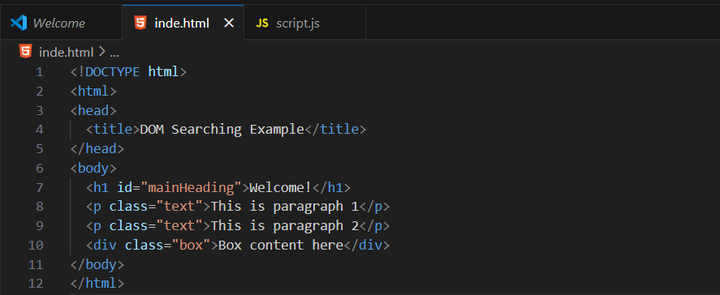
Output:
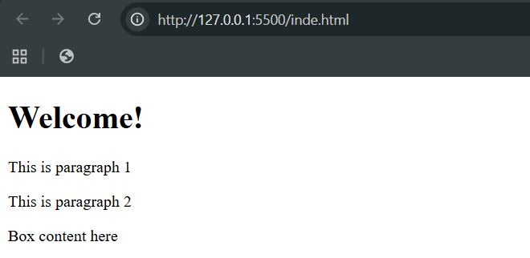
Now, applying the DOM searching and changing the properties: .getElementById
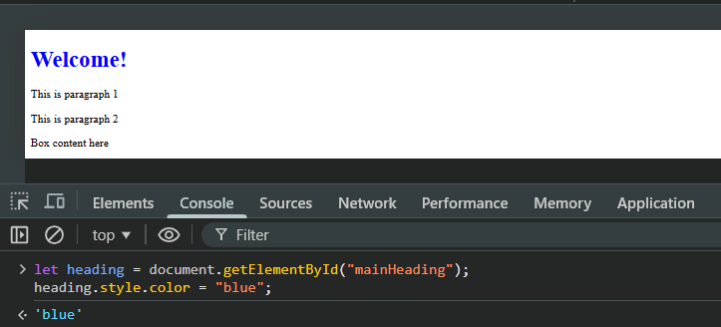

Now, using the .getElementsByClassName:
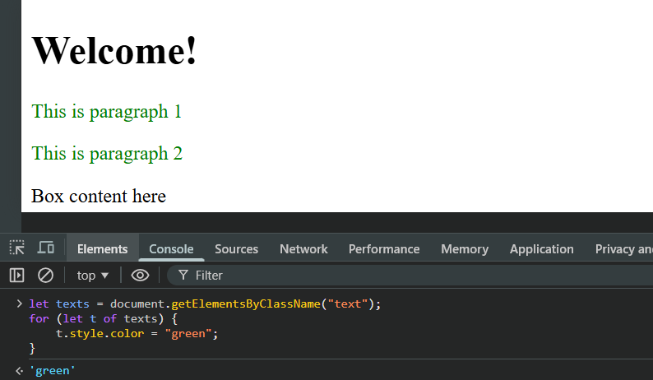
Also, using the .getElementsByTagName:
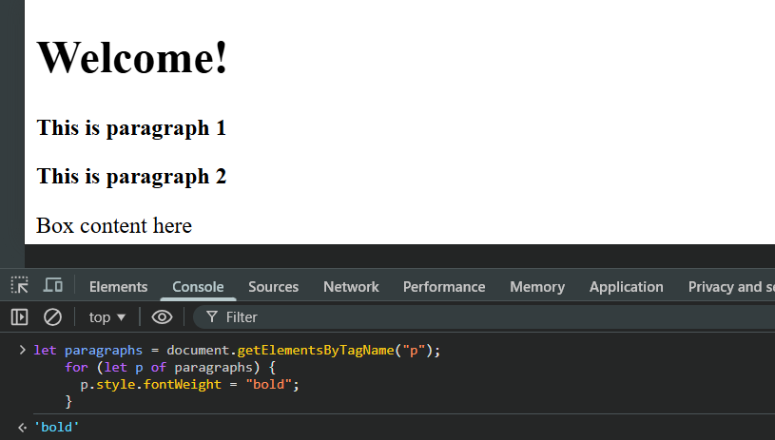
Also, using the .querySelector
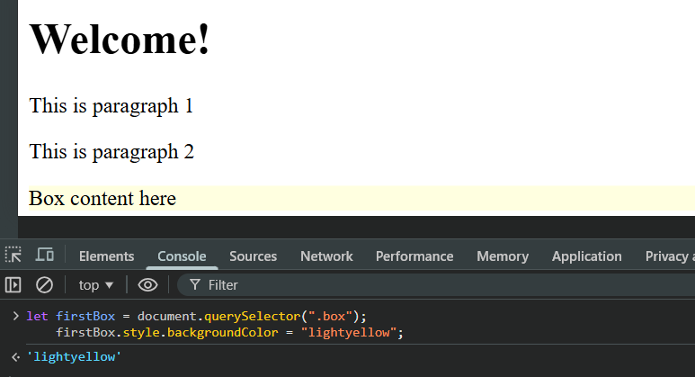

Also, using .querySelectorAll:
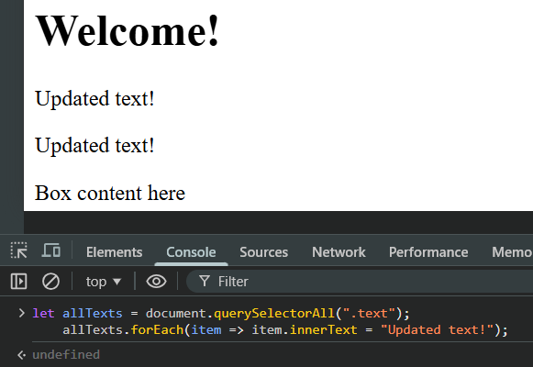
--The End--

