Day 46

Local and Global Scope in JavaScript:
What is Scope?
Scope means where a variable can be accessed in your program. It decides which variables you can use and where.
Global Scope: A global variable is a variable that can be accessed from anywhere in the program.
How created?
- Declared outside any function/block
- Declared without let/var/const (not recommended)
Example: global variable
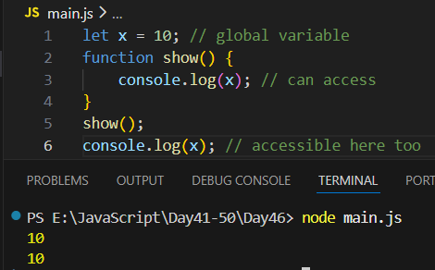
Local Scope: A local variable is only accessible inside the block/function where it is created.
Types:
- Function scope → created inside a function
- Block scope → created inside { } using let or const

Example: function local scope
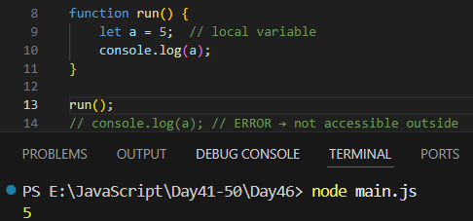
Example: block scope
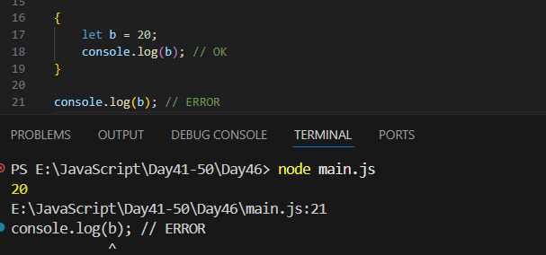

let, const, var Scope Difference (Simple)
Keyword | Scope Type | Important Note
var | function scoped | ignores block scope
let | block scoped | preferred
const | block scoped | cannot be reassigned

Example: Nested Scopes (Scope Chain): Inner scopes can access outer scope, but outer scope cannot access inner scope.
