Day 41

Inheritance & extends Keyword in JavaScript:
What is Inheritance?
Inheritance means one class can take (inherit) properties and methods from another class. It helps avoid writing the same code again.
In simple words: A child class can use everything from a parent class.
What is extends keyword?
The extends keyword is used to create a child class from a parent class.
Example:
class Child extends Parent {}
This means: Child class will automatically have all methods and properties of Parent class (unless overridden).
Example: extends keyword is used to extends the properties of Animal to the Monkey.
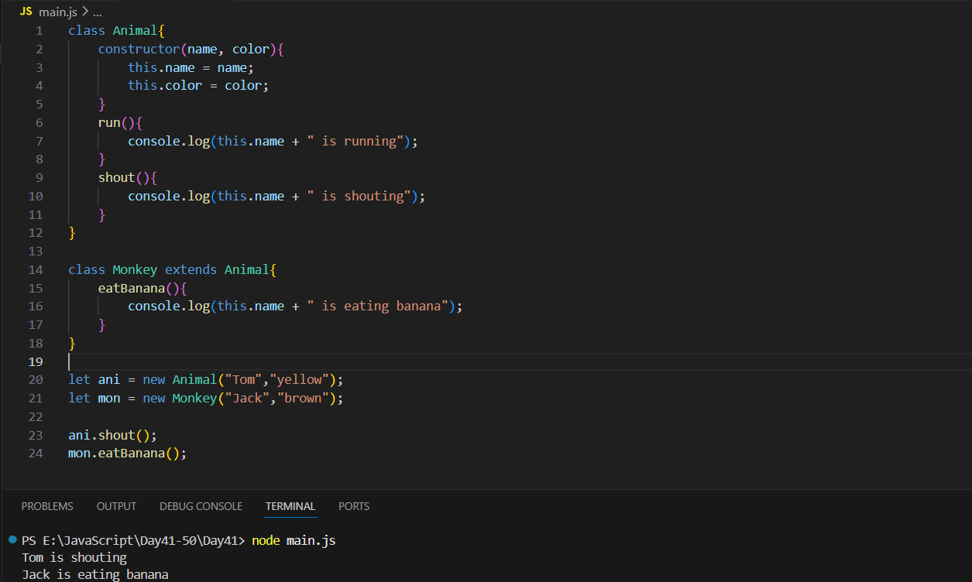

This code defines a base class Animal with properties (name, color) and methods (run, shout). The Monkey class extends Animal, meaning it inherits all its properties and methods while adding its own method eatBanana. Two objects are created: ani (an Animal) and mon (a Monkey). Calling ani.shout() prints that Tom is shouting, and mon.eatBanana() prints that Jack is eating a banana.
Example: another basic example of inheritance
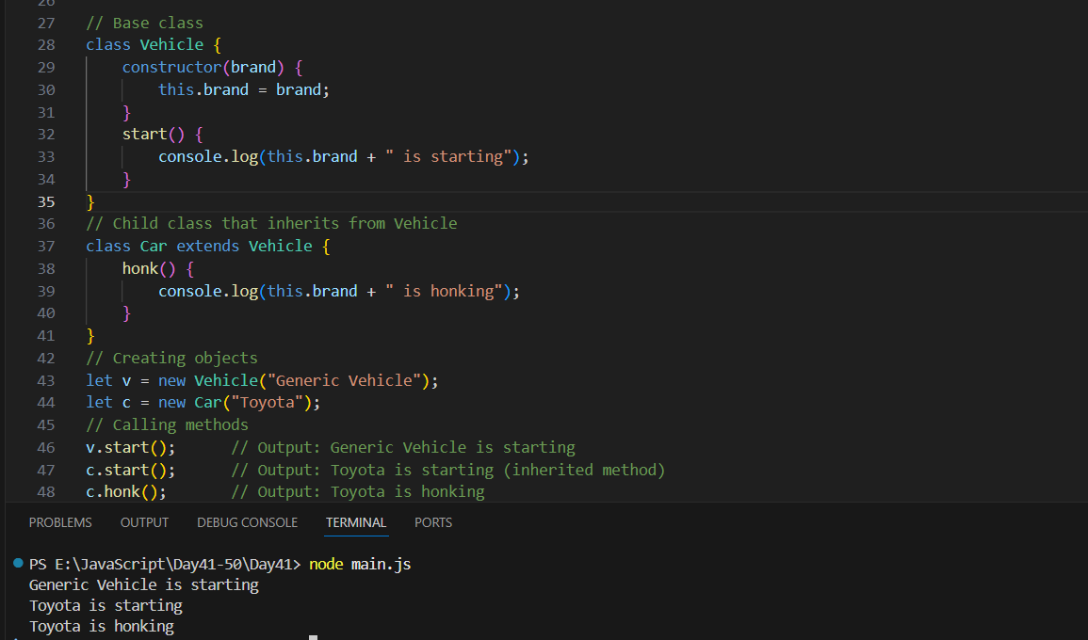
This example shows how a child class can inherit features from a parent class. The Vehicle class has a brand property and a start() method. The Car class extends Vehicle, so it automatically gets these features and also adds its own honk() method. When we create objects from these classes, the Vehicle object can only start, while the Car object can both start (inherited) and honk (its own method).
Example: another example of inheritance.
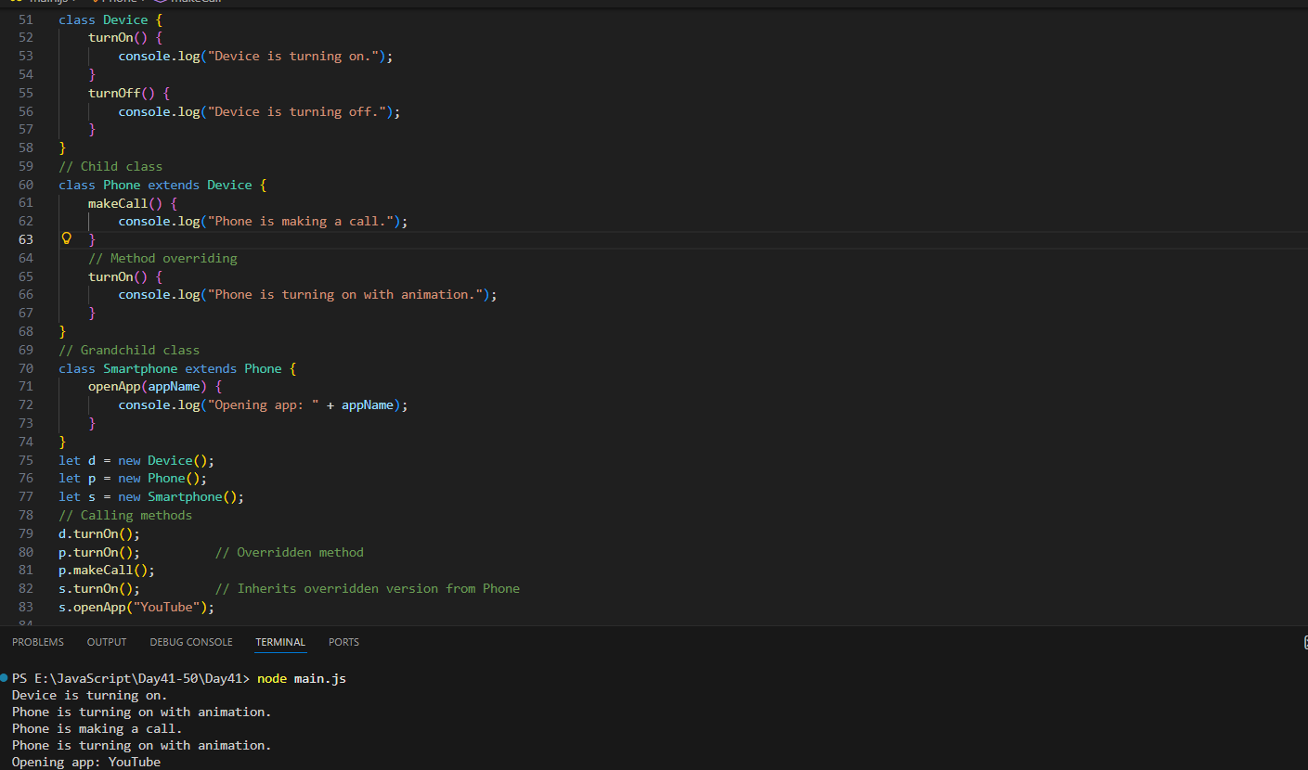
This example has three levels of inheritance:
Device → Phone → Smartphone.
The Phone class overrides the turnOn() method from Device, and the Smartphone class inherits that overridden behavior. Each class adds its own abilities, showing a layered, more advanced structure—all without using super().

Method overriding and Super keyword in JavaScript:
What is Method Overriding?
Method overriding happens when a child class writes its own version of a method that already exists in the parent class.
In simple words: Child class replaces the parent’s method with a new one.
Example idea: Parent has a speak() method → Child creates its own speak().
Why do we use Method Overriding?
- To change or customize the behavior of a parent method.
- To add extra features while keeping the parent functionality.
Example: a basic example of overriding
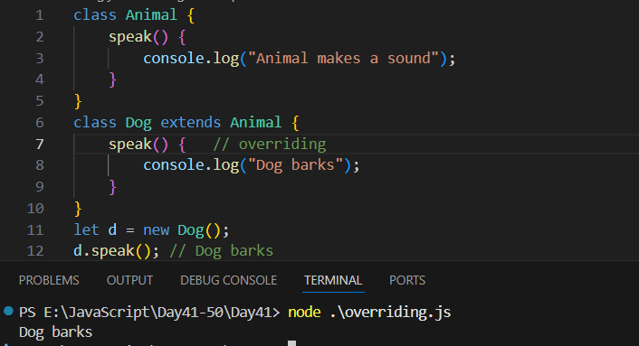
In this example, the Animal class has a method speak() that prints a generic sound. The Dog class extends Animal and overrides the speak() method by providing its own version that prints “Dog barks.” When we create an object d from the Dog class and call d.speak(), the overridden method in Dog is executed instead of the one in Animal, demonstrating how method overriding gives child classes more specific behavior.
What is super Keyword?
super is used to call the parent class’s constructor or methods.
Two places where super works:
1. Inside constructor → calls parent constructor
super(args)
2. Inside child method → calls parent method
super.parentMethodName()

Example: a basic example of super keyword.
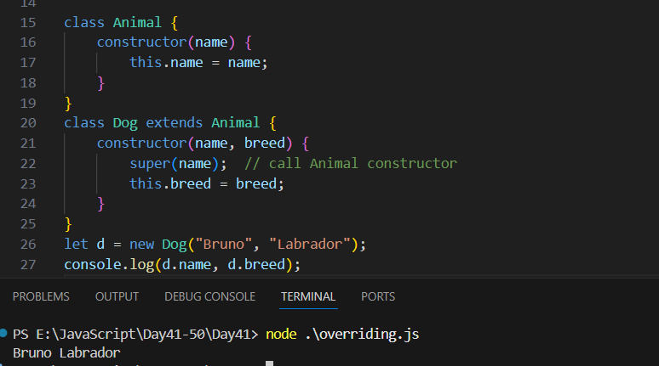
This code shows how the super keyword is used to call a parent class constructor in JavaScript. The Animal class has a constructor that sets the name property. The Dog class extends Animal and adds a new property, breed. Inside the Dog constructor, super(name) calls the Animal constructor so the name property is properly assigned before adding breed. When a new Dog object is created with "Bruno" and "Labrador", it stores both values and prints them as output.
Example: overriding + using super in a method
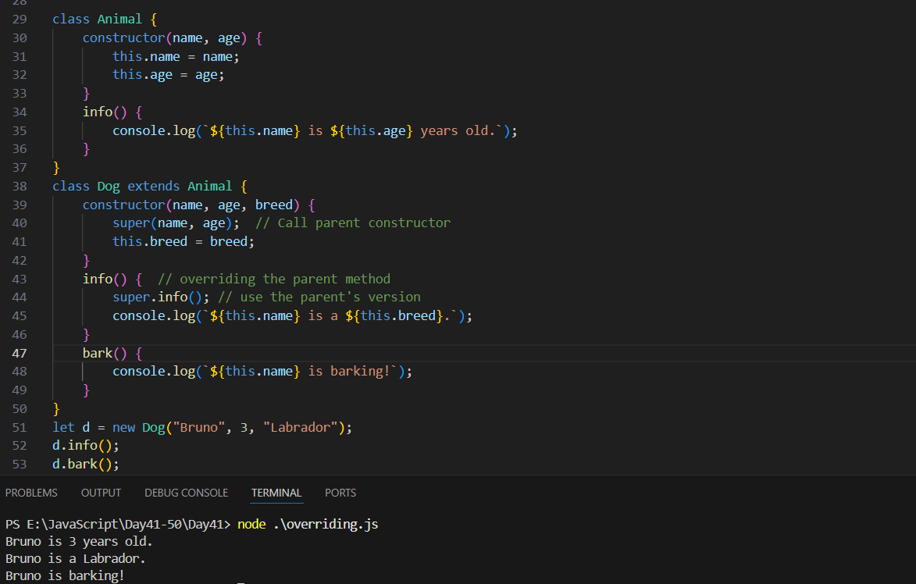
In this example, the Animal class defines common properties like name and age along with an info() method to display them. The Dog class extends Animal, adding a new property breed and overriding the info() method to include breed information. Inside the overridden method, super.info() is used to call the parent class’s version before adding the dog-specific message. The class also includes a bark() method that belongs only to dogs. When a Dog object named Bruno is created, calling d.info() prints both the animal and dog details, and d.bark() shows its barking behavior.
--The End--

