Day 20

HTML Attributes and their methods:
HTML Attributes — Basics
An HTML attribute is extra information added to an HTML tag.
Example:
<p id="message" class="info" title="tooltip">Hello</p>
Attributes here:
- id="message"
- class="info"
- title="tooltip"
JavaScript Methods to Work With Attributes
Method | What it Does | Simple Meaning
elem.getAttribute(name) | Gets the value of attribute | Read attribute
elem.setAttribute(name, value) | Adds/changes an attribute | Write attribute
elem.hasAttribute(name) | Checks if attribute exists | True/False
elem.removeAttribute(name) | Removes attribute | Delete attribute
elem.attributes | Returns all attributes | List of attributes

Summary:
- getAttribute() → read
- setAttribute() → write
- hasAttribute() → check
- removeAttribute() → delete
- attributes → list all

Example: getAttribute()
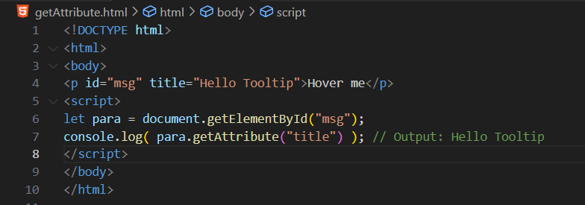
Output:
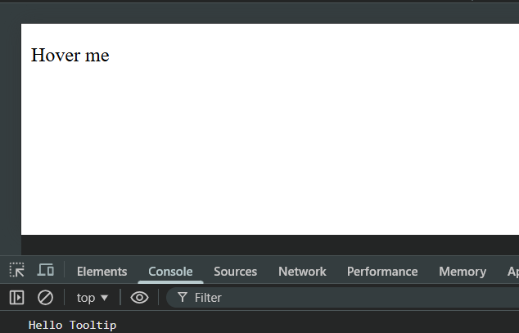
Example: setAttribute()
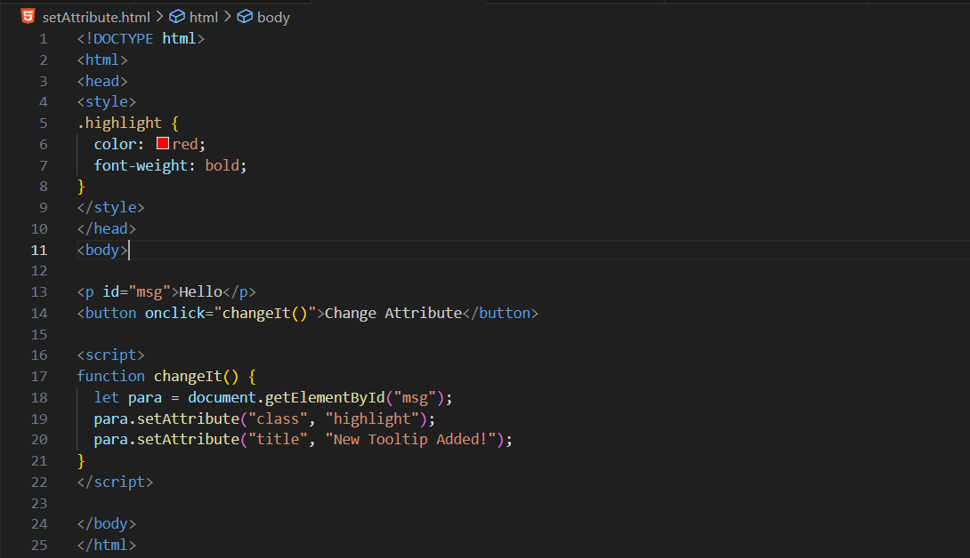
Output: at start
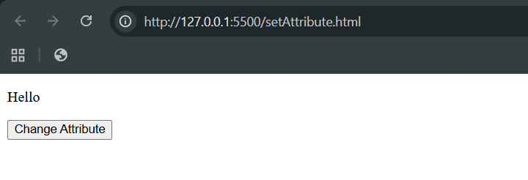
Output: after button is clicked
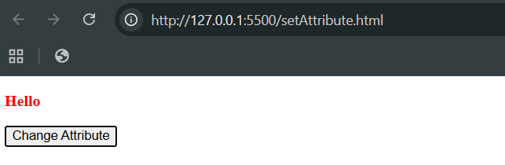
Example: has Attribute()
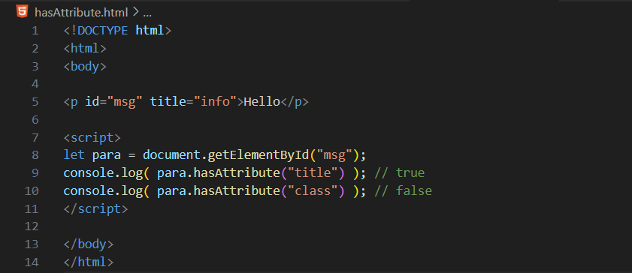

Output:
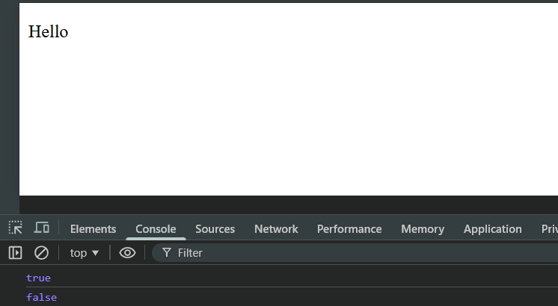
Example: removeAttribute()
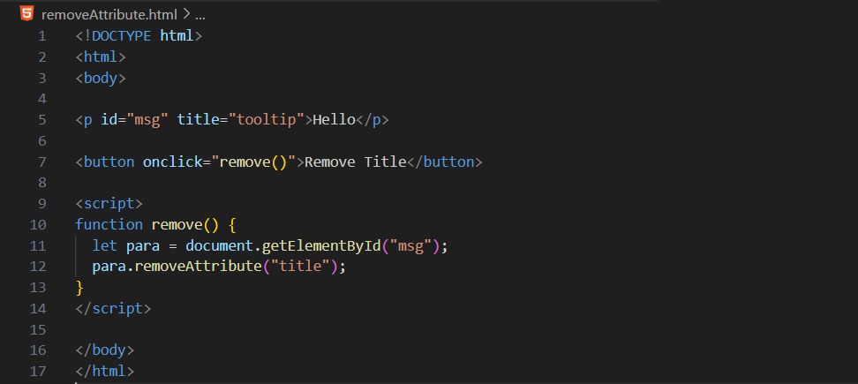
Output:
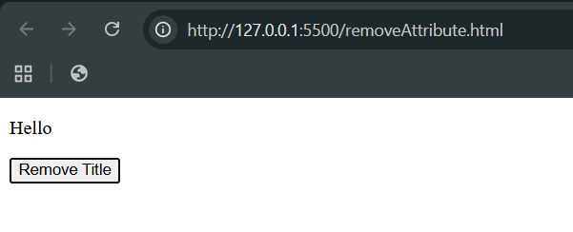

Example: attributes
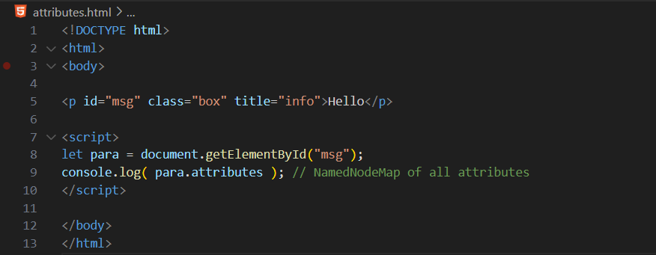
Output:
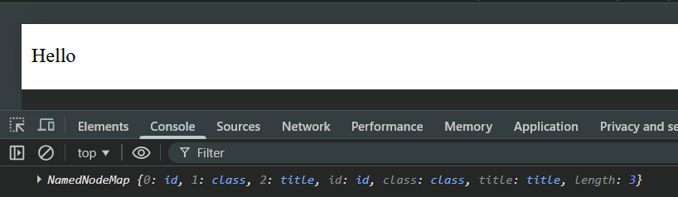
--The End--

