Day 30

Promise Chaining .then() calls:
What is Promise Chaining?
Promise chaining means using multiple .then() one after another, where the output of one .then() becomes the input of the next.
Each .then() returns a new Promise, allowing you to run steps in order.
Why use Promise chaining?
- To perform tasks step-by-step
- To avoid callback hell
- To make async code readable and organised
Example: a very basic example of promise with “.then()”
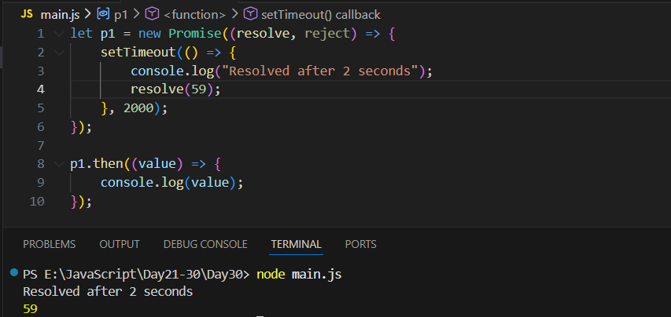
Above code creates a Promise (p1) that waits 2 seconds and then prints "Resolved after 2 seconds" before successfully completing with the value 59. When the promise finishes, the .then() function runs and prints that resolved value (59). In simple terms: “Wait 2 seconds, show a message, return 59, then print 59.”

Example: promise chaining basics
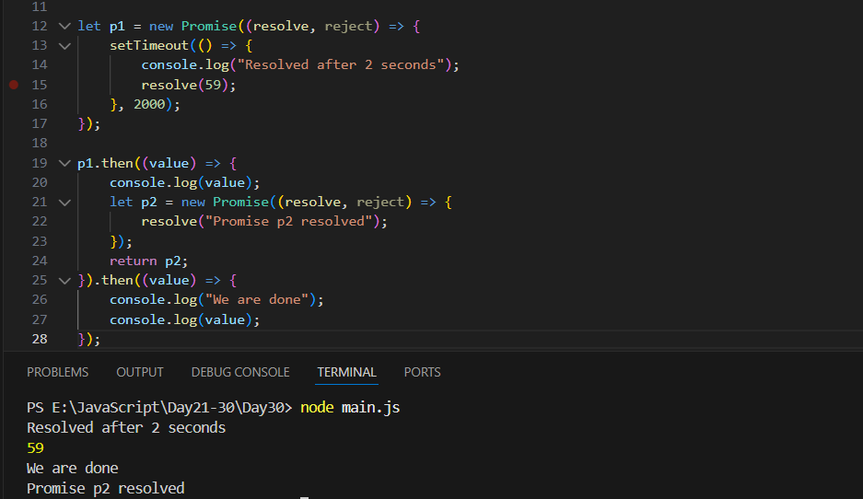
This code shows promise chaining. The first promise (p1) waits 2 seconds, prints "Resolved after 2 seconds", and resolves with 59. The first .then() receives that value, prints 59, and then creates and returns another promise (p2), which immediately resolves with "Promise p2 resolved". Because it returns a promise, the next .then() waits for p2 to finish, then prints "We are done" followed by the message from p2. In short: wait 2 seconds → print 59 → run another promise → print final messages.
Example: another example of promise chaining.
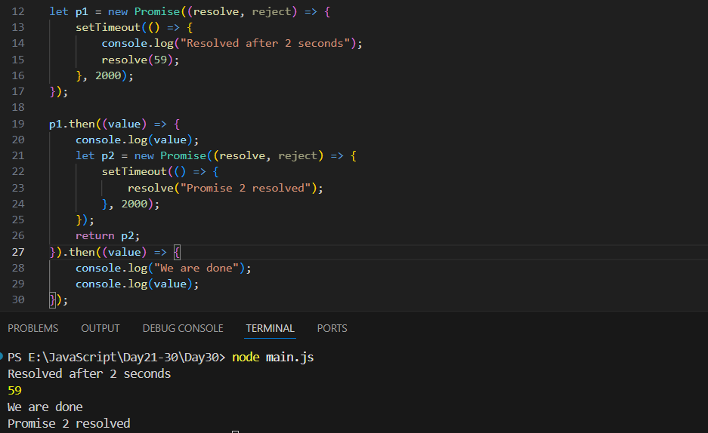
This code shows two promises running one after another. First, p1 waits 2 seconds, prints "Resolved after 2 seconds", and resolves with 59. Inside the first .then(), that value (59) is printed, and a second promise p2 is created. p2 also waits 2 seconds before resolving with "Promise 2 resolved". Because the .then()returnsp2, the next .then()` waits for it to finish, then prints "We are done" and the final message.

Attaching Multiple Handlers to a Promise:
You can attach more than one .then() or .catch() to the same Promise. Each handler will run independently when the Promise is resolved or rejected.
The key point: Every .then() attached to the same Promise runs separately. They do NOT depend on each other.
Example: a very basic promise created in JS
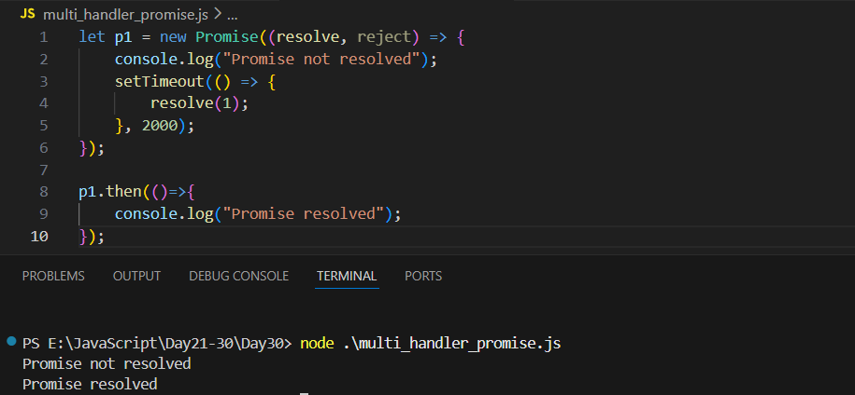
Can we write p1.then() and define a new work? Yes, we can do so, as shown below:
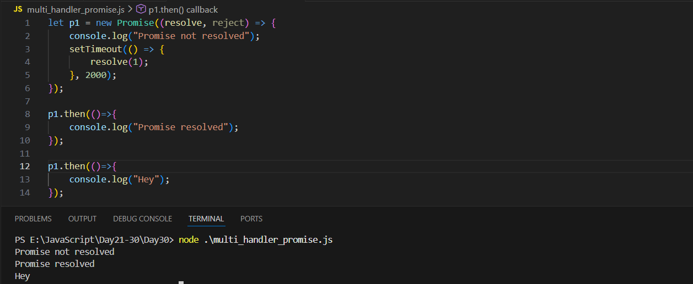
Each p.then() works independently.
--The End--

