Day 15

Parents & Siblings of an Element:
What Are Parent and Sibling Elements?
In an HTML page, elements are arranged in a tree structure (DOM tree). So, each element can have:
- A parent → the element it is inside
- siblings → elements that share the same parent
Example:
<div id="parent">
<h2>Heading</h2>
<p id="para1">Paragraph 1</p>
<p id="para2">Paragraph 2</p>
</div>
Here:
- The <div> is the parent of <h2>, <p>, and <p>.
- <p id="para1"> and <p id="para2"> are siblings.
To understand this, we will use the simple example:
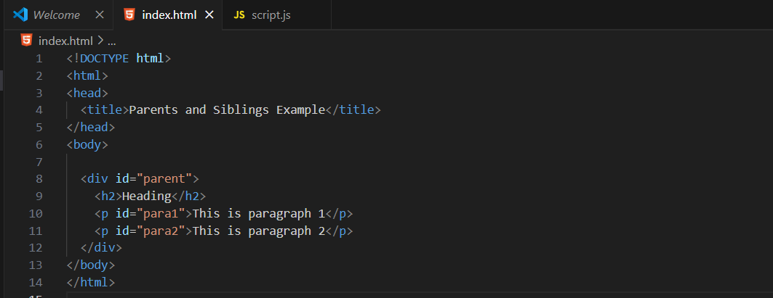

Output:
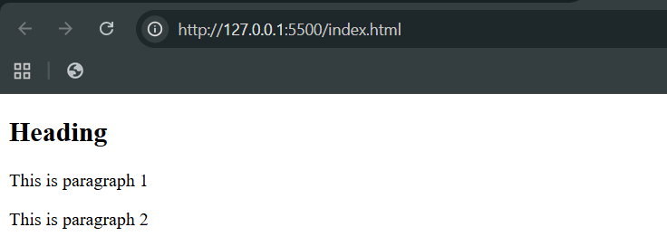
Now, accessing via the console: Accessing the Parent Element
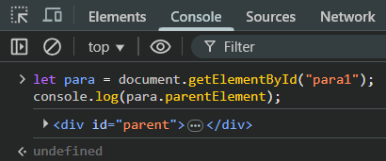
Also, Accessing Sibling Elements:
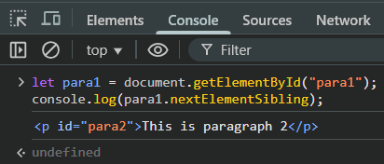
Also,
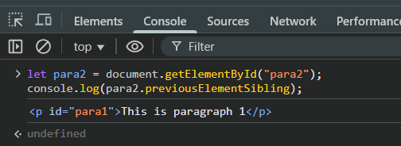

Also,
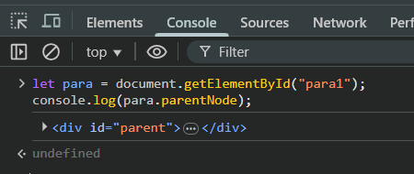
Summary
Property | Description | Example
parentElement | Finds the parent HTML element | child.parentElement
nextElementSibling | Finds the next element in the same parent | element.nextElementSibling
previousElementSibling | Finds the previous element in the same parent | element.previousElementSibling

In short:
- Use parentElement → to go upward
- Use nextElementSibling → to go right
- Use previousElementSibling → to go left
--The End--

