Day 31
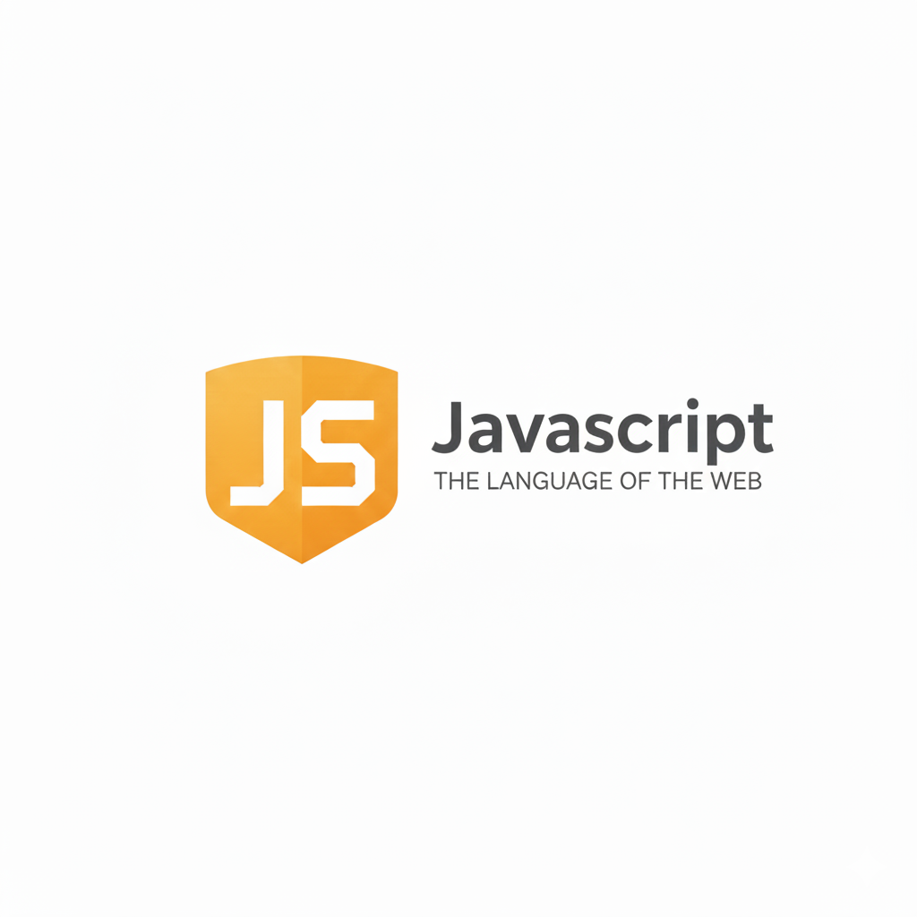
The Promise API:
There are two types of methods:
A) Instance Methods
(Methods used on a promise you created)
Instance Methods
- then() → success
- catch() → error
- finally() → always
B) Static Methods
(Methods used on the Promise class itself, like Promise.all())
Static Methods
- Promise.resolve() → make resolved promise
- Promise.reject() → make rejected promise
- Promise.all() → wait for all (fails if one fails)
- Promise.allSettled() → wait for all (never fails)
- Promise.race() → first finished
- Promise.any() → first successful
Example: basic example to print the resolved value of the promises in the console.
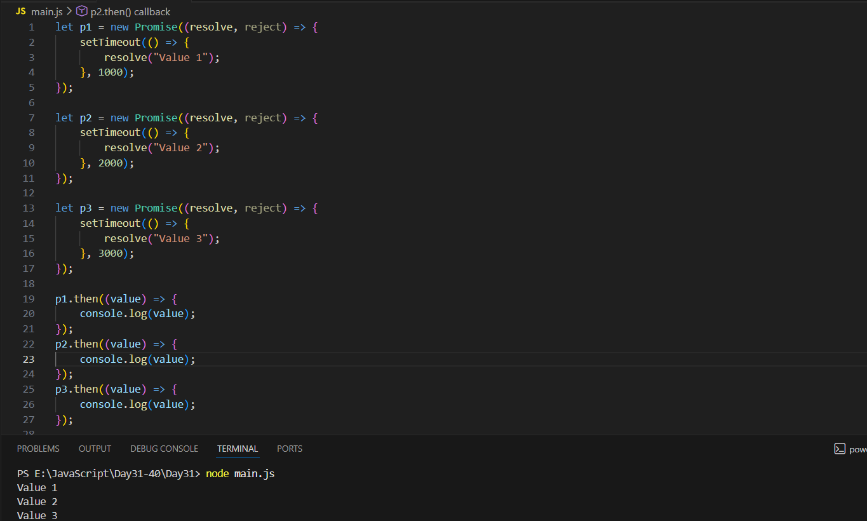
Here, after 1s, Value 1 is printed, after 2s Value 2 is printed and after 3s, Value 3 is printed.
Example: doing the same thing we did above using the promise.all()
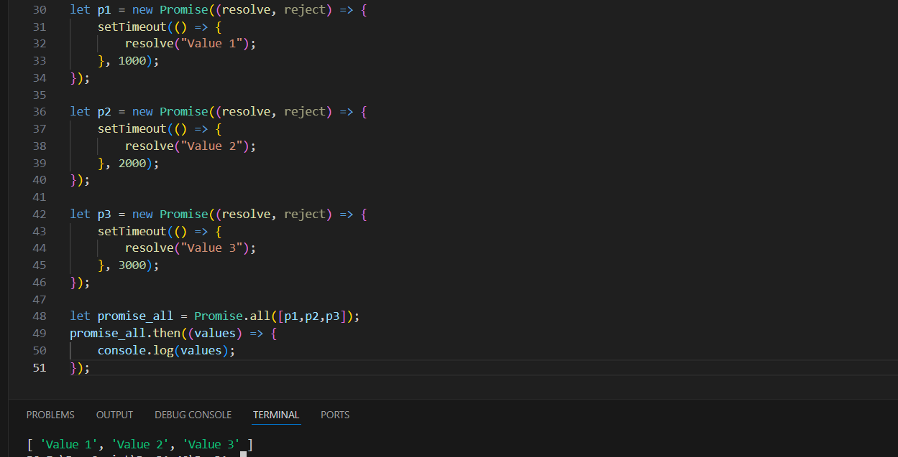
But what if one of the promise get rejected? Will promise.all() still works? No!
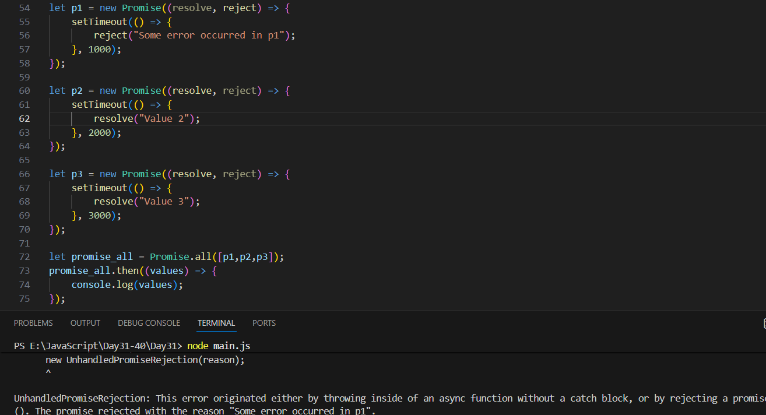

How to deal with this? We can use .catch() or can use Promise.allSettled() as shown below:
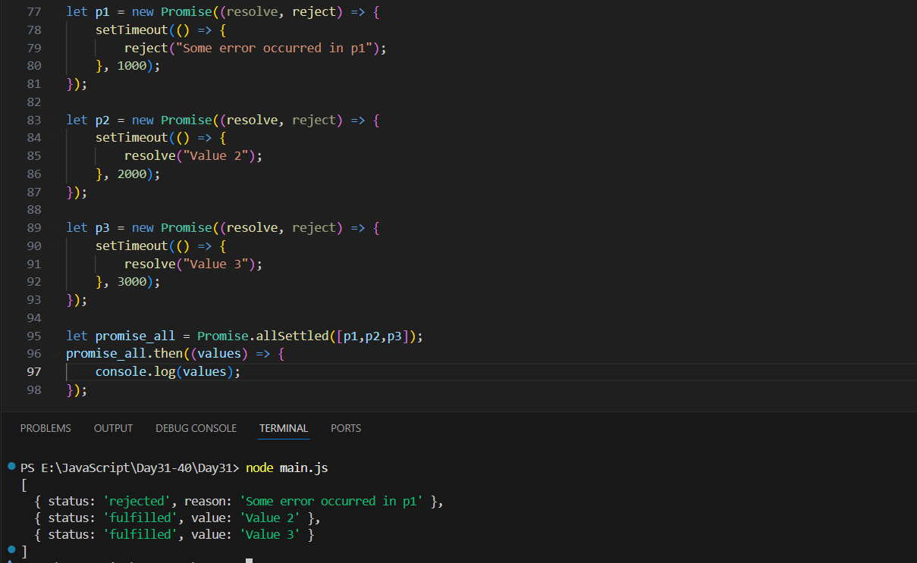
Now, what if we wish that the promise which first get resolved will get printed? Then we can use Promise.race():
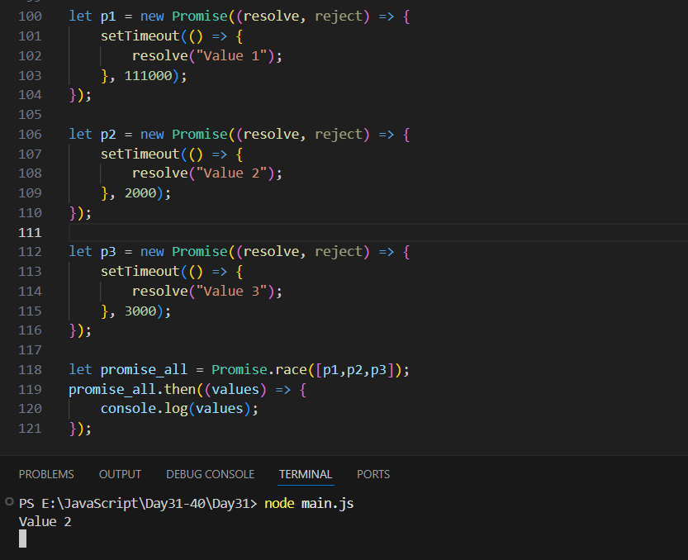
What if the fastest one giving an error? Then .race() will show error. How to deal then? We can use .any():
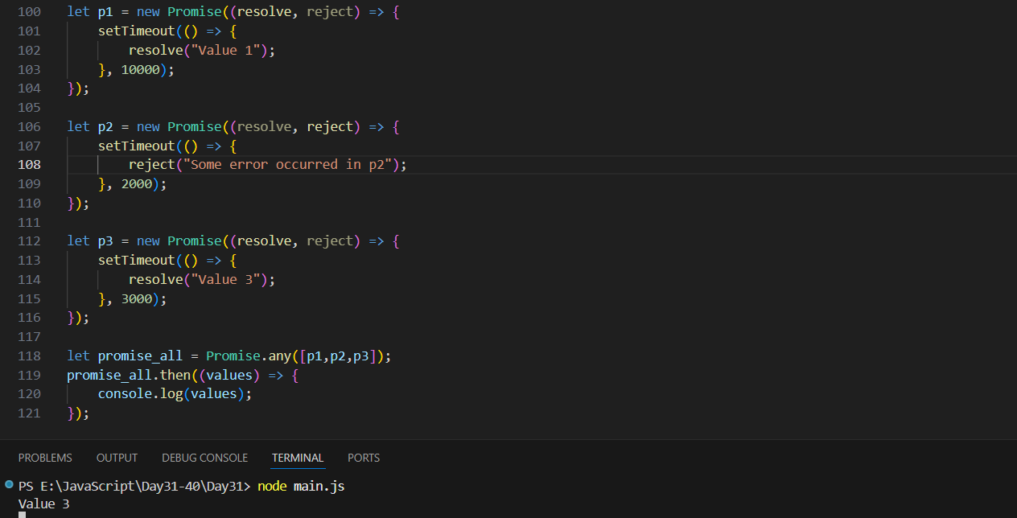
--The End--

