Day 43
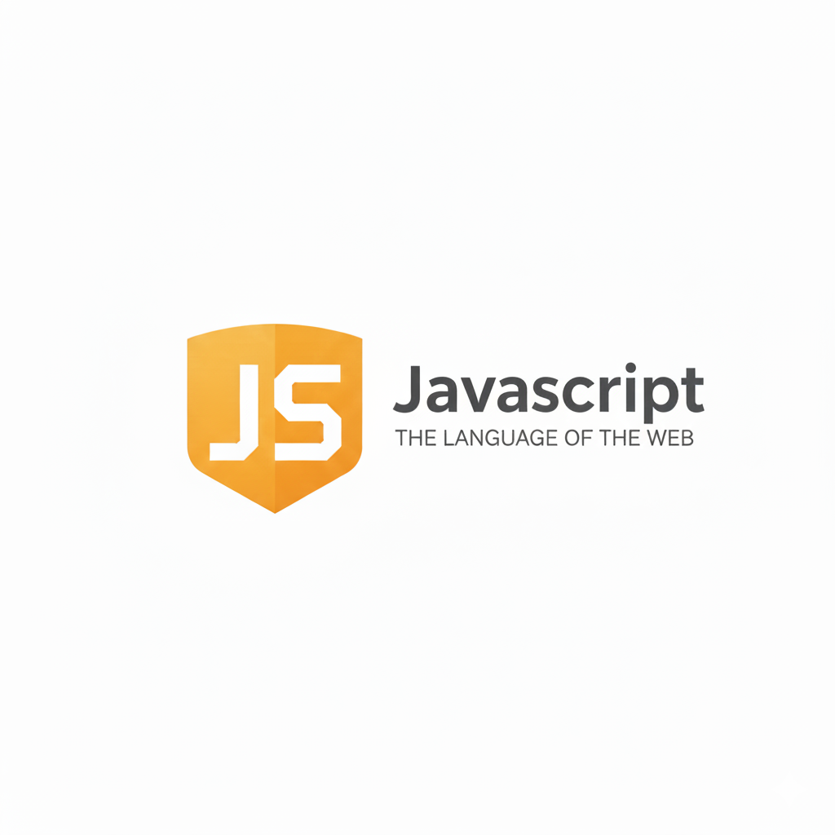
Static Method in JavaScript:
What is a static method?
- A static method is a function defined on the class itself, not on the objects created from the class.
- You call it using the class name, not the object.
Key points:
- You define them using the keyword static.
- You call them using the class name, not the object.
- They are useful for utility functions that don’t depend on instance data.
When to use static methods?
Use a static method when:
- The method does not depend on instance-specific data
- It’s a utility/helper function
- You need a way to create or manage instances
Examples:
- Math.random()
- Date.now()
Example: a very basic example. You created a class, you put a static method in it, and then you called it.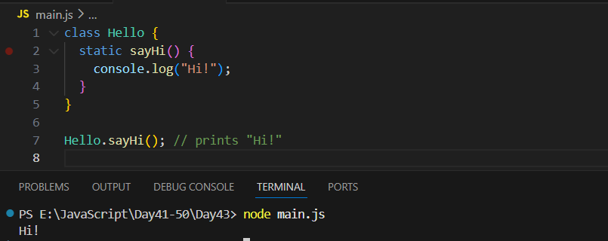

Important Note:
- You must call a static method using the class name, like this:
Hello.sayHi();
- You cannot call it from an object like this:
let h = new Hello();
h.sayHi(); // ❌ This will NOT work
Static means: belongs to the class, not to the object.
Example: static method with parameters
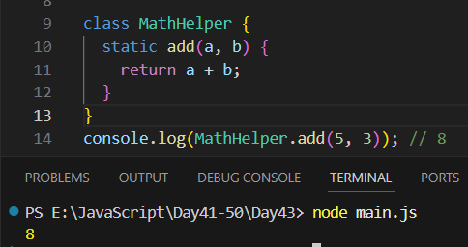
- static add(a, b) is a static method.
- It takes two numbers and returns their sum.
- You call it using the class name, not an object.
Example: compare Static vs Non-Static
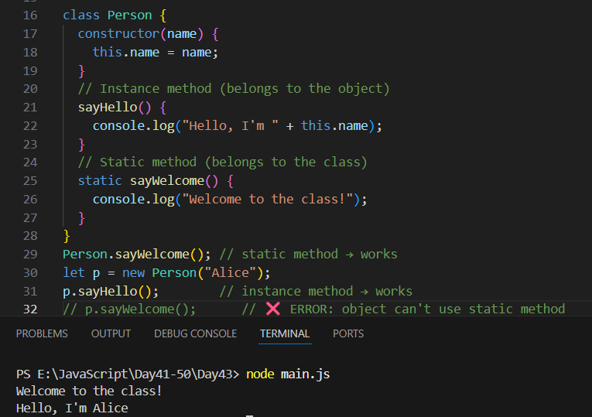
--The End--

