Day 37

Local Storage & related methods:
What is localStorage?
localStorage is a built-in browser storage where you can save data permanently. The data:
- stays even after you close or reopen the browser
- is stored on your computer
- uses key–value pairs
- stores strings only
Why do we use localStorage?
To remember things like:
- theme (dark/light)
- username
- settings
- form data
- cart items
- tokens (not recommended for sensitive data)
Main Methods of localStorage
Method | What it does
setItem(key, value) | Save data
getItem(key) | Read data
removeItem(key) | Delete one item
clear() | Delete all items
key(index) | Get key name by index
length | How many items stored

Where can I find the local storage in the website?
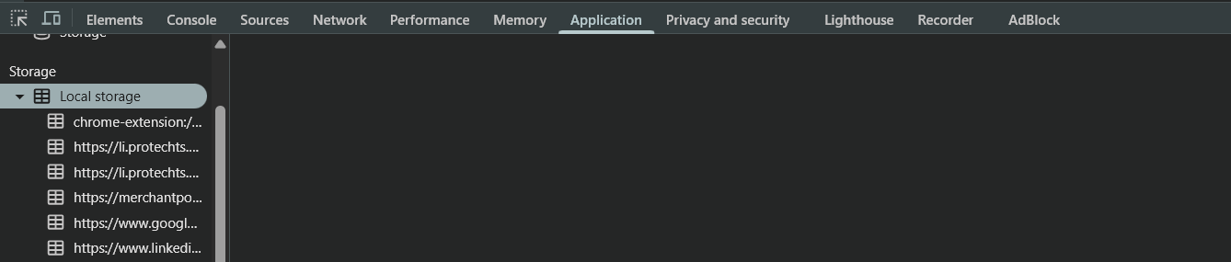
Now, in order to add the items in the local storage we uses “.setItem”:
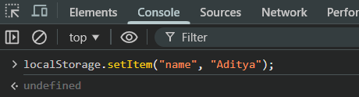
We can see that we did it successfully in the “Application” section:
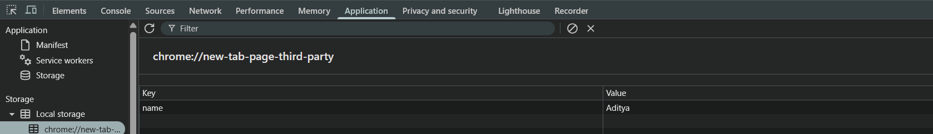
Example: to get the value at the key we use the “.getItem”
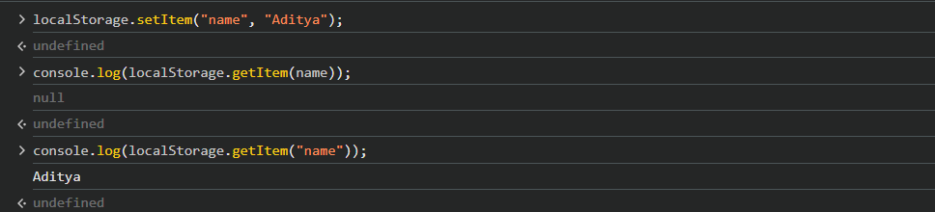
Example: to clear the local storage we can use the “.clear()”:
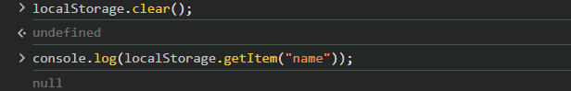

Example: to get the length of the local storage we uses “.length”:
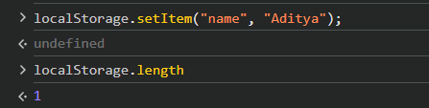

Important Points About localStorage (Short Summary)
- Data stays permanently until manually removed.
- Stores data as key–value pairs.
- Only stores strings, so objects must be JSON stringified.
- Has around 5–10 MB storage limit (much larger than cookies).
- Data is not sent to the server automatically (unlike cookies).
- Accessible only in the same domain.
- Should not store sensitive data (like passwords or tokens).
- Easy to use: setItem(), getItem(), removeItem(), clear().
--The End--

