Day 16

Element only Navigation:
What is Element-only Navigation?
In the DOM (Document Object Model), every part of an HTML page — including tags, text, and comments — is treated as a node. But sometimes, we only want to navigate between element nodes (like <div>, <p>, <h1>) and ignore text nodes (like spaces or line breaks).
This is called Element-only Navigation.
Example HTML
<div id="container">
<h2>Heading</h2>
<p>Paragraph</p>
</div>
Here, inside <div> there are:
- Two element nodes → <h2>, <p>
- Plus some text nodes (spaces and line breaks)
If you use general node navigation (firstChild, nextSibling), those text nodes will also be counted — which can cause confusion.
Why Use Element-only Navigation?
To skip text and comment nodes and only deal with real HTML elements. That’s why we use the Element-only properties.
Element-only Navigation Properties
Property | Description | Example
firstElementChild | First child element | div.firstElementChild
lastElementChild | Last child element | div.lastElementChild
nextElementSibling | Next element in same parent | h2.nextElementSibling
previousElementSibling | Previous element in same parent | p.previousElementSibling
children | All child elements | div.children

Difference Between “Node” and “Element”
Type | Includes | Example Property
Node Navigation | Elements + Text + Comments | firstChild, nextSibling
Element-only Navigation | Only HTML elements | firstElementChild, nextElementSibling

To understand this, we shall start from the basics:
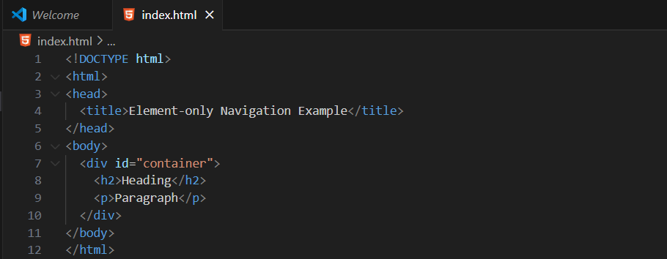
Output:
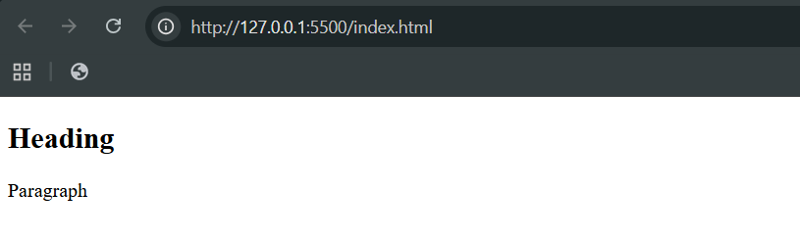
Console:
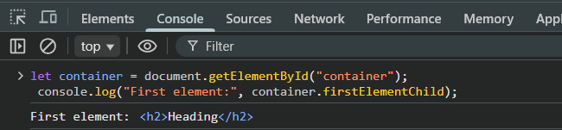

Also,
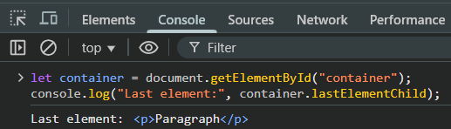
Also,
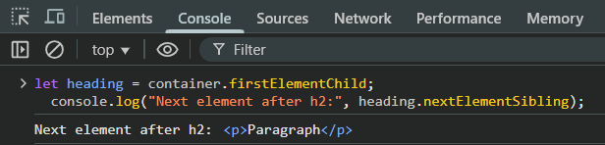
Also,
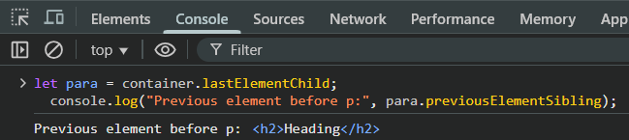
Also,
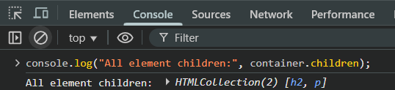
--The End--

