Day 49
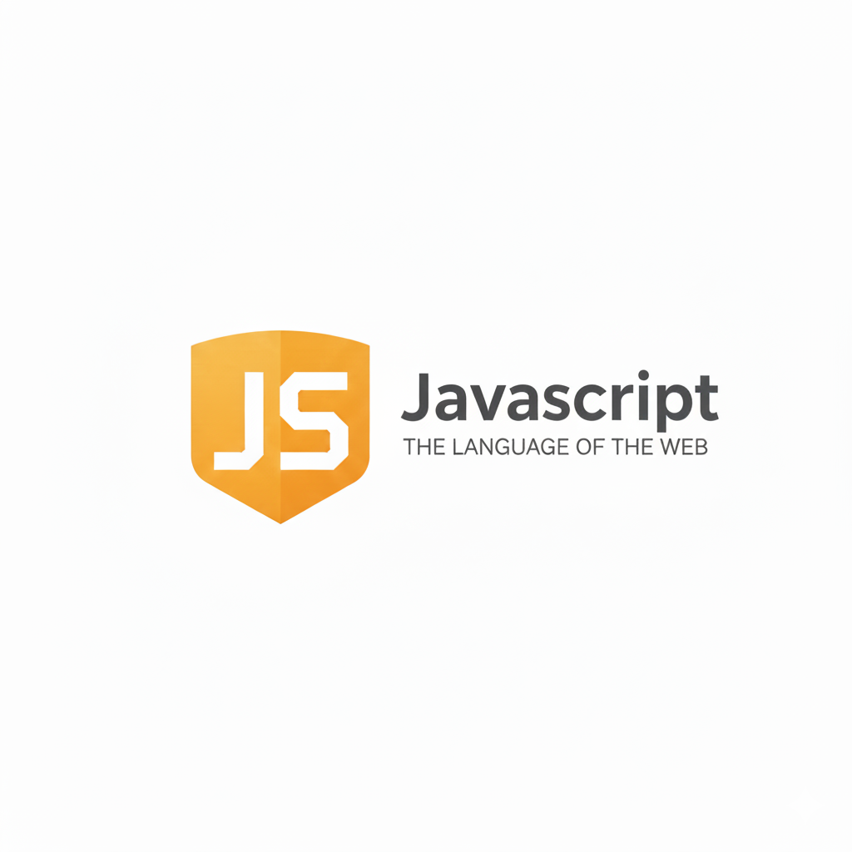
JavaScript on the server:
JavaScript was originally created to run only inside web browsers. But with the introduction of Node.js, JavaScript can now run outside the browser, on a server, just like other backend languages (Python, Java, PHP).
What Does “JavaScript on the Server” Mean?
It means using JavaScript to build the backend part of an application — the side that runs on a server, handles requests, talks to databases, and sends responses to users.
Why Node.js Allows This?
Node.js uses the V8 JavaScript engine (the same engine used in Chrome) and provides extra features:
- Access to computer files
- Ability to create servers
- Handle network requests
- Access to databases
- Manage packages using npm
This makes JavaScript a full-stack language (frontend + backend).
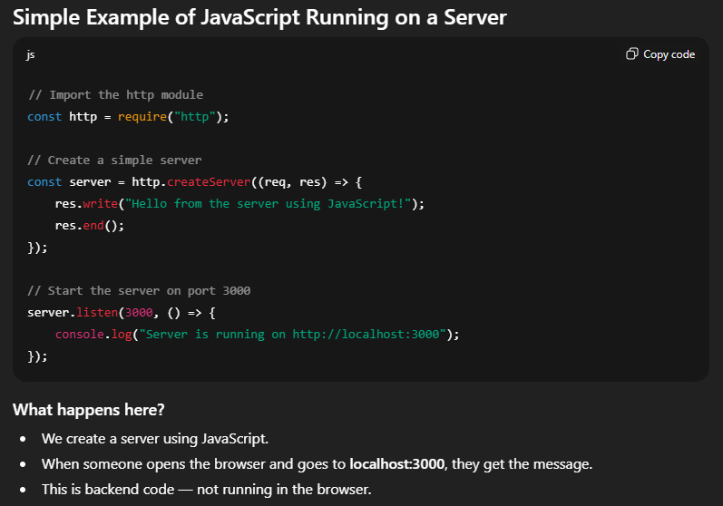
Where Server-Side JavaScript Is Used
- Building APIs
- Making web servers
- Connecting with databases
- Authenticating users
- Sending emails
- Handling files
- Running background tasks
- Building real-time apps (chats, dashboards)
Why JavaScript on the Server Is Popular?
- One language for both frontend and backend
- Very fast because Node.js is event-driven
- Huge ecosystem (npm packages)
- Easy for beginners to start

Npm and Node.js packages:
What is npm?
npm (Node Package Manager) is a tool that comes with Node.js. It helps you install, update, and manage code packages created by other developers.
Think of it like an app store for JavaScript code.
What are Node.js Packages?
A package is a collection of reusable code that someone created for a specific purpose.
Examples:
- A package for sending emails
- A package for connecting to databases
- A package for creating servers
- A package for validating data
You install them using npm.
Why do we use packages?
Because instead of writing everything from scratch, you can use ready-made code.It saves time and reduces errors.

Example: to initialise the project
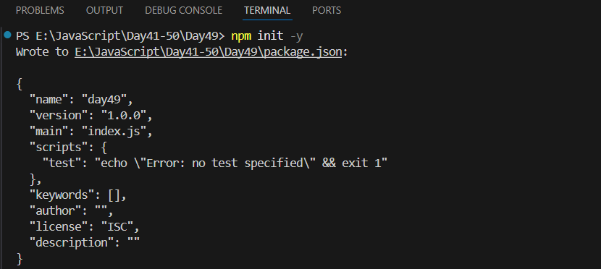
Example: installing a modules
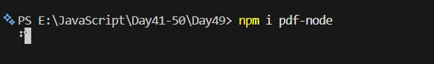
Example: folder created because of installing the third party modules
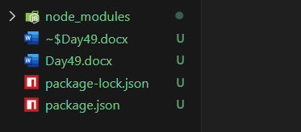
--The End--

