Day 24

setInterval and setTimeout in JavaScript:
setTimeout: Runs a function once after a given time (delay in milliseconds).
Syntax:
setTimeout(function, delay);
setInterval: Runs a function again and again after a fixed time interval.
Syntax:
setInterval(function, interval);
To understand this, let’s take a basic example:
Example: a basic example of creating a alert box
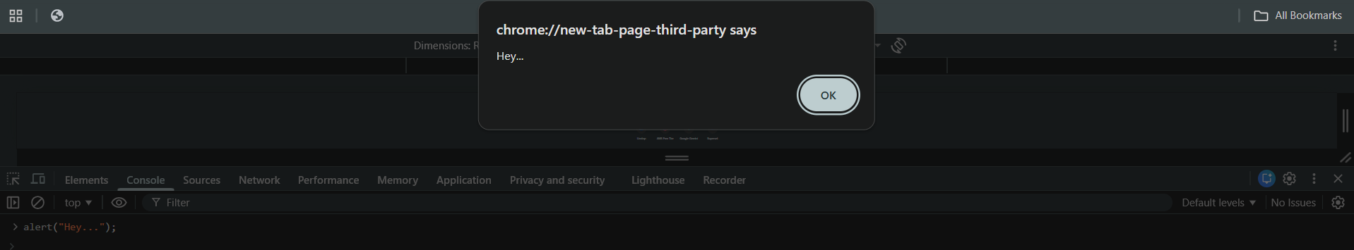
What if we want that this should come 2 seconds later the page loaded, for this we will use setTimeout, as shown below:
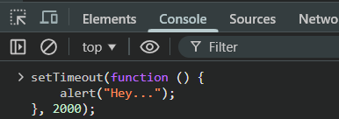

Just after 2 seconds:
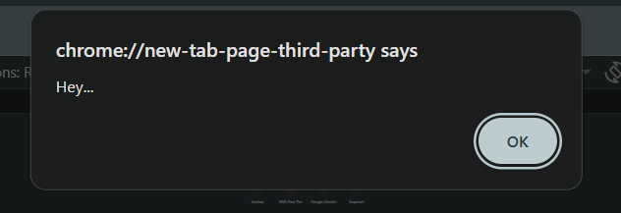
Now, to get the timer id, we will store the setTimeout in the variable and then print it, as shown below:
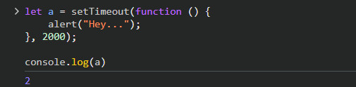
Output: after 2 seconds
Can we also stop this from happening? Yes, we can do so by using the clearTimeout, as shown below:
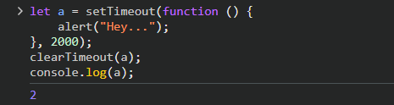
Output: no alert box will come this time.

Now, program to take user entry, where user will say yes or no, in order to use the clearTimeout, as shown below:
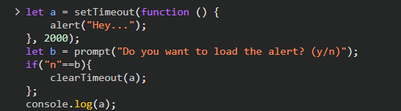
Output:
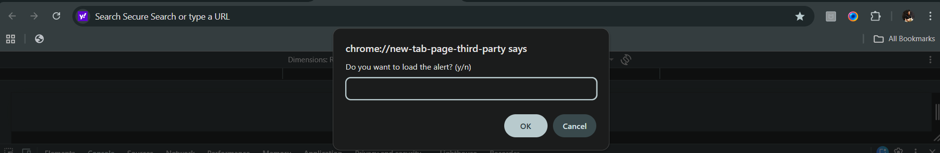
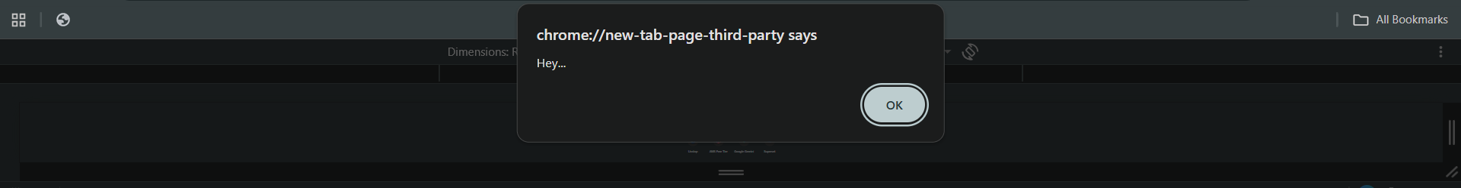

Example: setInterval()
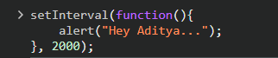
Output: same output after every 2 seconds.
