Day 40

Classes and Objects in JavaScript:
What is a Class?
A class is a blueprint or template for creating objects. It describes what properties (data) and what methods (functions) the objects will have.
Think of a class as a “design” and objects as the “real things” created from that design.
What is an Object?
An object is an actual thing created from a class. Each object has its own copy of properties, but shares methods defined in the class.
Basic Syntax of a Class
class Person {
constructor(name, age) {
this.name = name;
this.age = age;
}
greet() {
console.log("Hello, I am " + this.name);
}
}
let p1 = new Person("Aditya", 21);
p1.greet();

Example: creating a simple class with the methods.
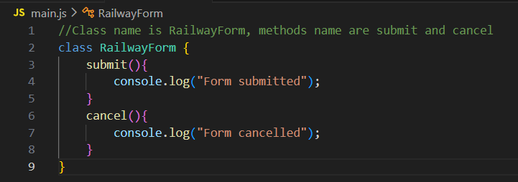
Example: creating two instanced of class
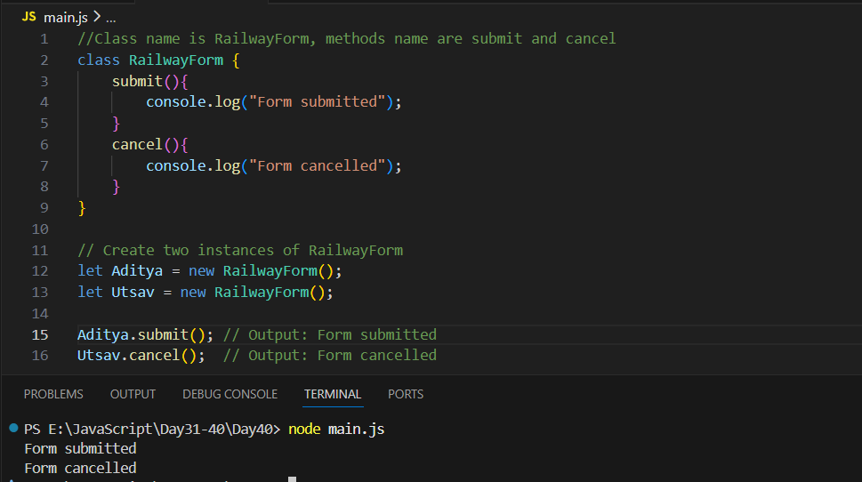
Constructors in JavaScript:
What is a Constructor?
A constructor is a special function inside a class that automatically runs when you create an object.
Its job is to set the initial values of the object.
In simple words:
A constructor prepares the object when it is created.
Constructor Syntax
class Person {
constructor(name, age) {
this.name = name;
this.age = age;
}
}

- constructor() → special function
- this.name / this.age → properties added to the object

Creating an Object
let p1 = new Person("Aditya", 21);
console.log(p1.name);
console.log(p1.age);
When new Person("Aditya", 21) runs:
- constructor is automatically called
- it sets:
  - this.name = "Aditya"
  - this.age = 21

Example: Adding Methods Along with Constructor
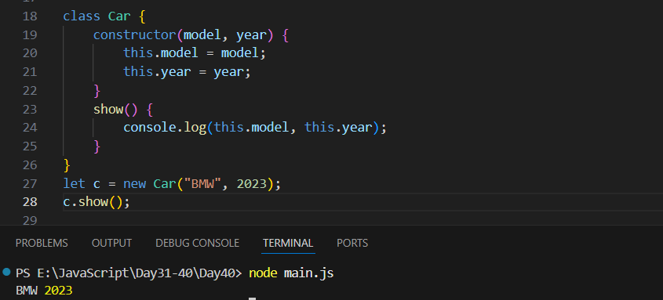
Example: constructor Without Parameters
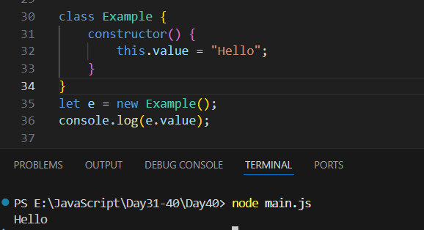
Also, If You Don’t Write a Constructor - JavaScript automatically creates an empty one:
constructor() {}
So, the class still works.

Short Summary
- Constructor = a special function that prepares an object.
- It runs automatically when using new.
- It sets properties using this.
- Child classes use super() to call parent constructor.
- If you don’t write one, JS creates a default constructor.

--The End--

