Day 25
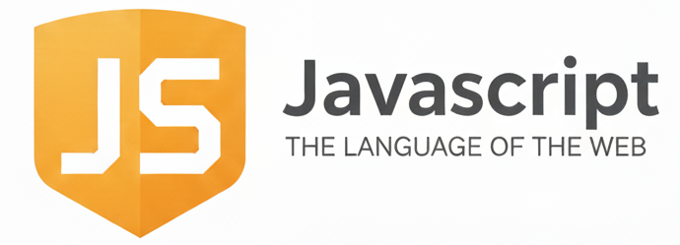
setInterval and setTimeout in JavaScript:
What is an event?
An event is something that happens in the browser.
Example events:
- A button is clicked
- A key is pressed
- A page finishes loading
- Mouse moves
- A form is submitted
Your JavaScript code can listen to these events and react to them.
What is an Event Listener?
An event listener is a function that waits for an event to happen and runs when the event occurs.
Syntax:
element.addEventListener("eventName", function);
Common Browser Events
Event Name | When it happens
click | User clicks an element
dblclick | User double-clicks
mouseover | Mouse moves over element
keydown | Any key is pressed
keyup | Key is released
input | Text in input box changes
submit | Form is submitted
load | Page finishes loading

Example: click event
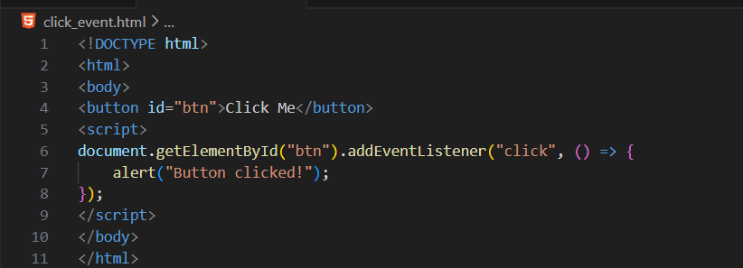
Output:
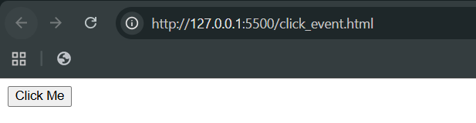
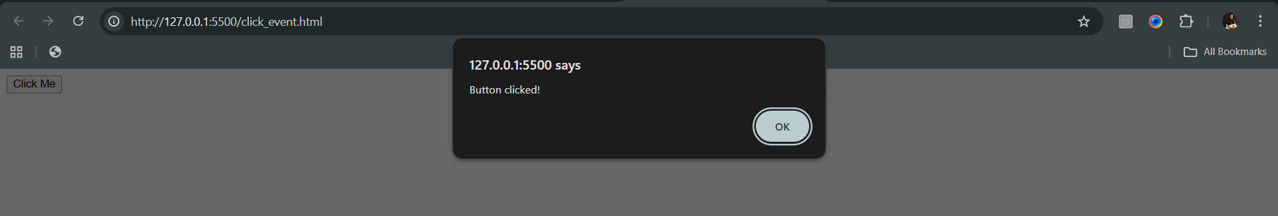
Example: mouse event
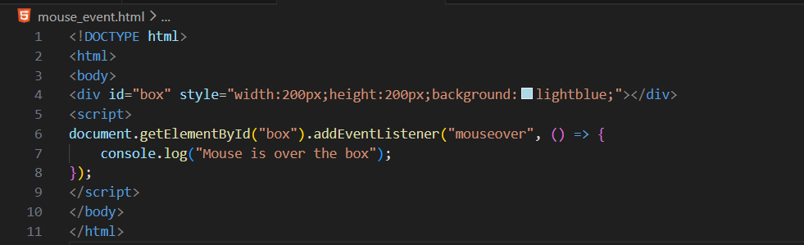

Output: when mouse came over the box
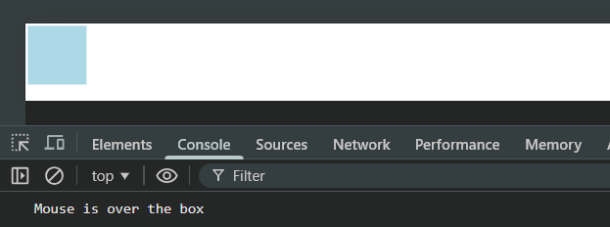
Example: keyboard events
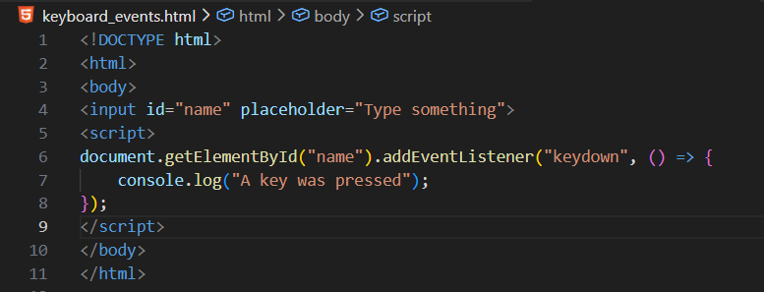
Output:
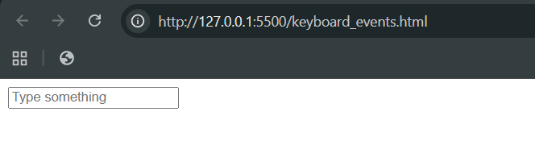
When something was types in the input field:
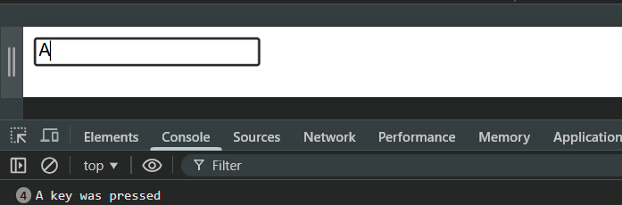
Example: page load event
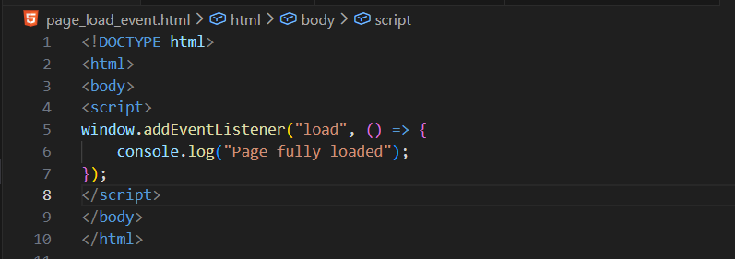
Output: console
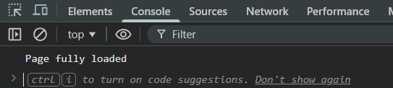
Example: form submit event
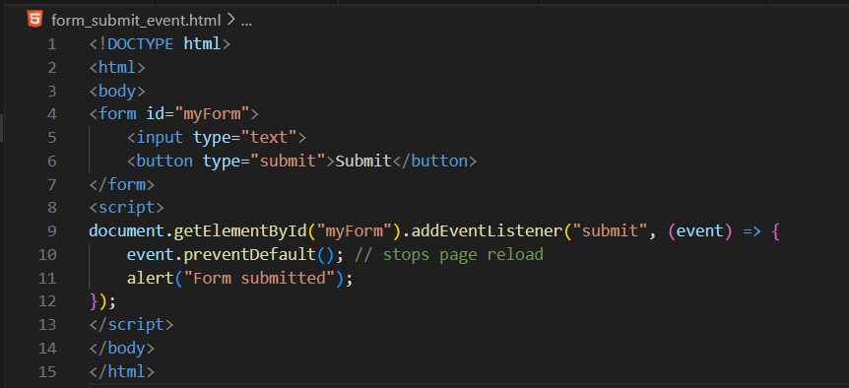
Output:
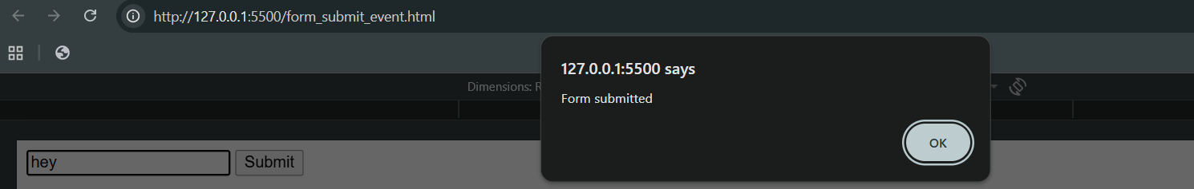
--The End--

