Day 3

Typecasting in Python:
What is Typecasting?
Typecasting means changing one data type into another data type.
Example: Converting "10" (string) into 10 (integer).
Why do we need Typecasting?
- To perform calculations
- To take input from users
- To avoid errors
- To convert data into required format
Types of Typecasting in Python:
- Implicit Typecasting (Automatic): Python converts data automatically.
- Explicit Typecasting (Manual): We convert data manually using functions.
Example: without typecasting we expect the sum, but get the concatenation.
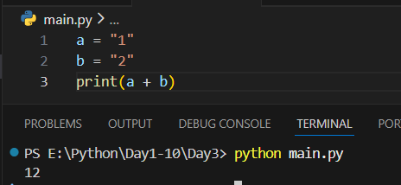
Example: converting the string to the integer.
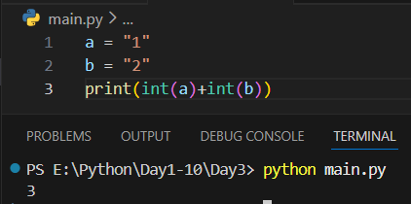
Summary:
- Typecasting means changing data type
- Two types:
- Implicit → done automatically by Python
- Explicit → done by programmer
- Common functions:
- int() → integer
- float() → decimal
- str() → string
- bool() → True/False
- Input is always string, so typecasting is needed

Taking User Input in Python :
What is User Input?
User input means taking data from the user while the program is running. Python uses the input() function to take input.
input() Function:
Basic Syntax:
input("message")
Example: a basic example
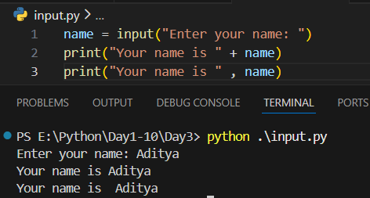
They differ in how the text and the variable are combined:
- In print("Your name is " + name), the + joins (concatenates) the string and the variable. Both must be strings, or it will cause an error.
- In print("Your name is ", name), the comma lets print handle them separately and automatically adds a space between them. It can also print different data types without error.
So, the main difference is that + joins strings manually, while , lets print combine values more safely and easily.

Important Point (Very Important): Input is always taken as a STRING.
Example:
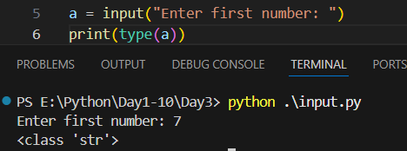
Example: as they are treated as strings, they get concatenated.
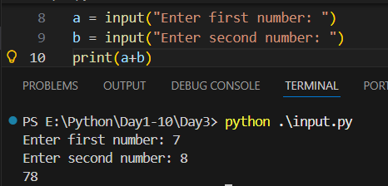
Example: typecasting the taken input
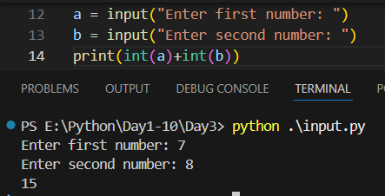

Using User Input with Numbers (Typecasting)
To perform calculations, we must convert input.
Example: another way to typecast
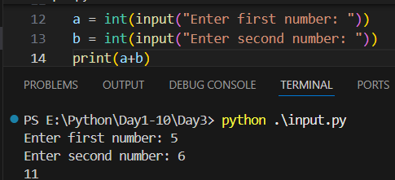
Summary:
- User input means taking data from the user
- Python uses input() function
- Input is always string by default
- Use typecasting (int(), float()) for calculations
- split() and map() help take multiple inputs

--The End--

