Day 21

Dictionary methods in Python:
Example: update()
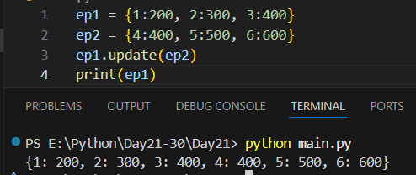
Example: clear()
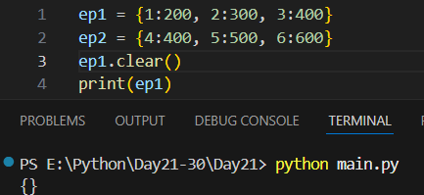
Example: pop()
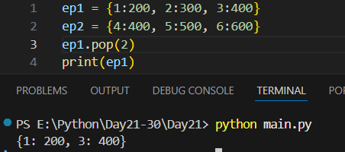

Example: popitem() -> removes the last key-value pair.
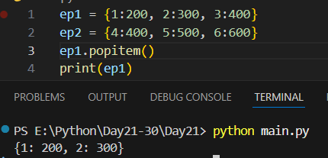
Example: del to delete a key-value or complete dictionary. Here we are deleting the dictionary.
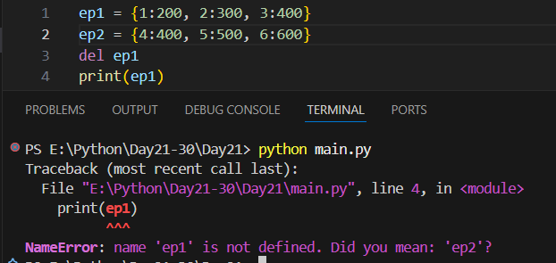
Example: using del to delete the key.
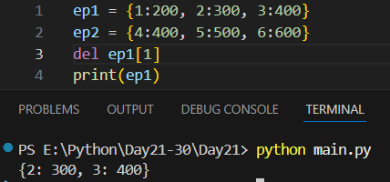

--The End--

