Day 45

Single Inheritance in Python:
What is Inheritance?
Inheritance is an OOP (Object-Oriented Programming) concept where one class acquires properties and methods of another class.
It helps in:
- Code reuse
- Better organization
- Easier maintenance
What is Single Inheritance?
One child class inherits from exactly one parent class
Basic Syntax of Single Inheritance
class Parent:
# parent class code
class Child(Parent):
# child class code

Example:
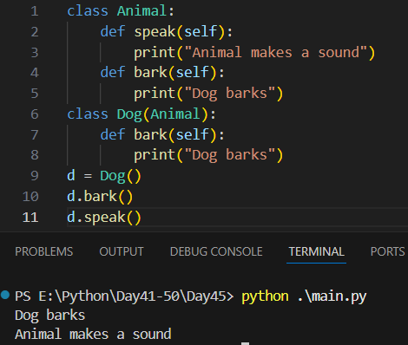
Multiple Inheritance in Python:
What is Multiple Inheritance?
A single child class inherits from more than one parent class.
Parent1 Parent2
\ /
\ /
Child

Syntax of Multiple Inheritance
class Child(Parent1, Parent2):
pass
The order of parent classes matters.

Example: Python checks parent classes from left to right

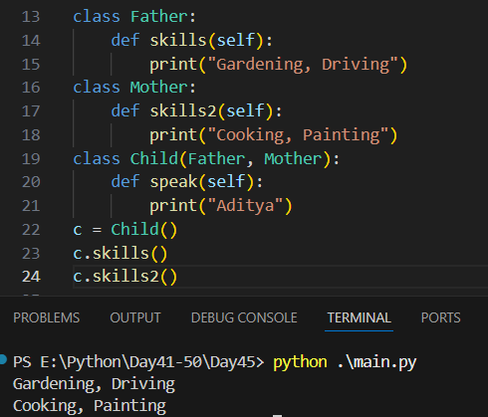
Example: Method Resolution Order (MRO)->MRO defines the order in which Python looks for methods.
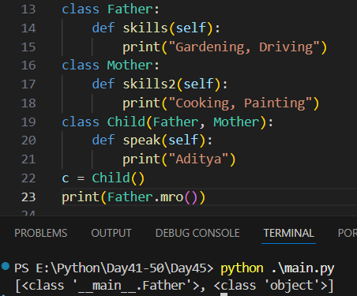

Example: Using super() in Multiple Inheritance-> super() follows MRO, not direct parent.
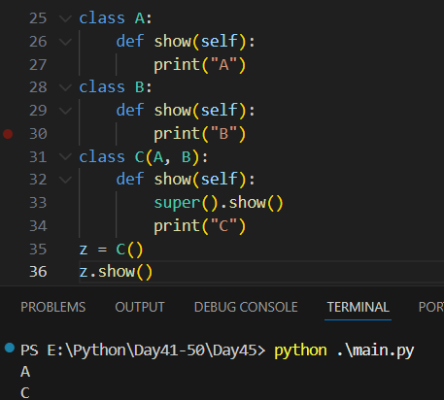

Summary:
✔ One child, multiple parents
✔ Method conflicts resolved by MRO
✔ super() follows MRO
✔ Diamond problem handled safely
✔ Powerful but should be used carefully

Multilevel Inheritance in Python:
What is Multilevel Inheritance?
A class is derived from another derived class.
Syntax of Multilevel Inheritance
class GrandParent:
pass
class Parent(GrandParent):
pass
class Child(Parent):
pass

Example:
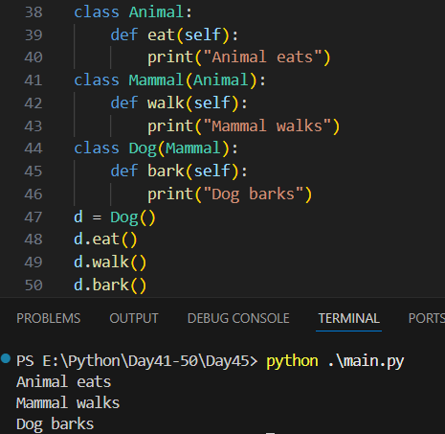
Example: inheriting attributes. Attributes flow through levels.
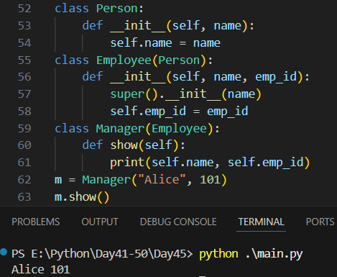

Example: Using super() in Multilevel Inheritance. super() helps call the immediate parent’s method, following the inheritance chain.
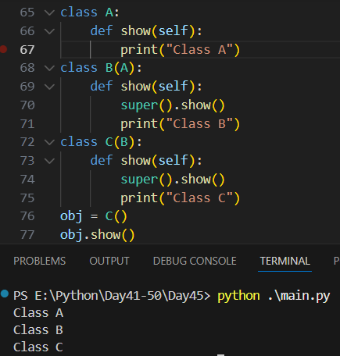
Example: Multilevel Inheritance with Constructors
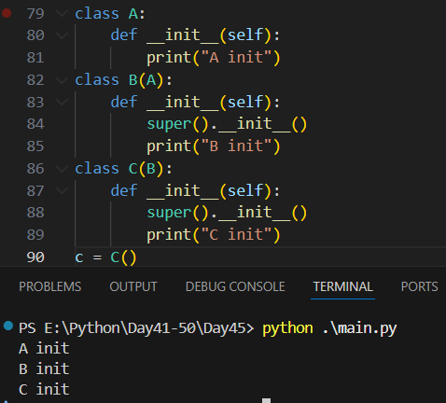

Summary:
✔ Multilevel inheritance forms a chain of classes
✔ Child inherits from parent, parent from grandparent
✔ super() ensures proper method calls
✔ Supports overriding
✔ Best for natural hierarchies

Hybrid and Hierarchical Inheritance in Python:
What is Hierarchical Inheritance?
Hierarchical Inheritance occurs when: One parent class is inherited by multiple child classes

Parent
/ \
Child1 Child2

Syntax:
class Parent:
pass
class Child1(Parent):
pass
class Child2(Parent):
pass

Example:
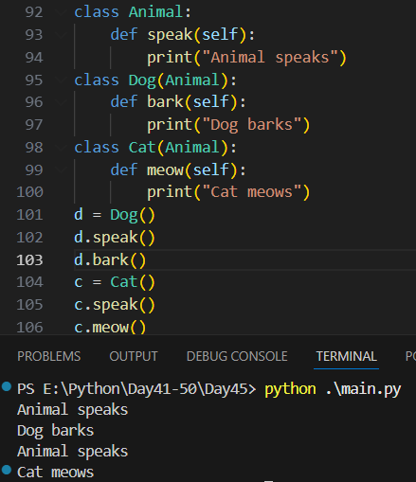

Hybrid Inheritance
Hybrid Inheritance is: A combination of two or more types of inheritance
Usually involves:
- Multiple Inheritance
- Multilevel Inheritance
- Hierarchical Inheritance

Common Hybrid Structure
A
/ \
B C
\ /
D

