Day 2

Comments, Escape Sequences & Print Statement:
What are Comments?
Comments are notes written inside code for humans to understand. Python ignores comments while running the program.
Why are Comments used?
- To explain code
- To make code easy to read
- To remember why we wrote something
Types of Comments
1. Single-line comment
Use #
Example:
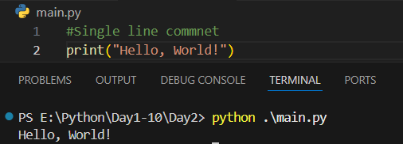
2. Multi-line comment
Python does not have a special syntax, but we use """ """ or multiple #.
Example:
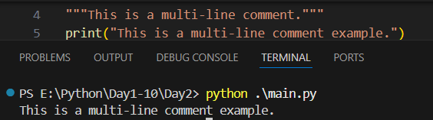

What is the print statement?
print() is used to show output on the screen.
Example:
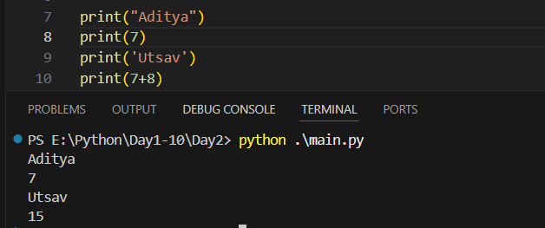
What are Escape Sequences?
Escape sequences are special characters used inside strings to add:
- new line
- tab space
- quotes
- special formatting
They start with a backslash (\).
Example:
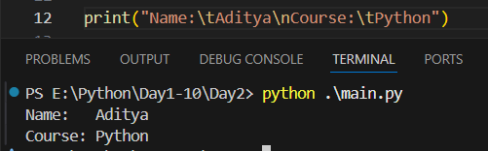
Example: using “sep” with the print.
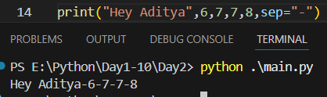
Example: using “sep” and “end” with the print.
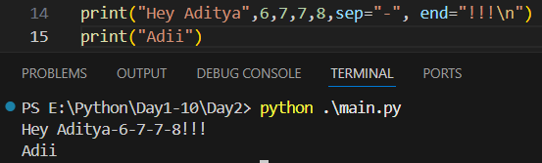
Summary:
- Comments are notes in code and are ignored by Python
- Use # for single-line comments
- print() is used to display output on the screen
- Escape sequences add special formatting in text
- Common escape sequences:
  - \n → new line
  - \t → tab
  - \" → double quote
  - \\ → backslash

Variables and Data Types:
What is a Variable?
A variable is a name that stores a value in memory. You can think of a variable as a container that holds data.
Why do we need Variables?
- To store data
- To reuse values
- To make programs dynamic
How to create a Variable?
In Python, you do not need to declare a type.
Example:
x = 10
name = "Aditya"
Rules for Naming Variables:
- Must start with a letter or _
- Can contain letters, numbers, _
- Cannot start with a number
- Cannot use spaces
Example:
Invalid:
1age = 21
my name = "A"
Valid:
age = 21
_user = "Admin"

Example: using variable and printing that too.
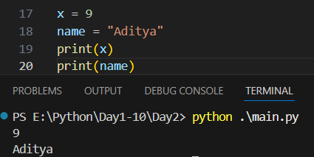

Example: variables can change value.
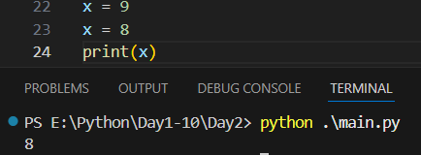
What is a Data Type?
Data type tells Python what kind of data a variable is storing.
Common Data Types:
- int → whole numbers
- float → decimal numbers
- str → text
- bool → True/False
Example:
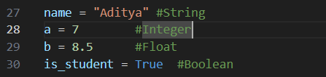
Example: to get the type of the variable.
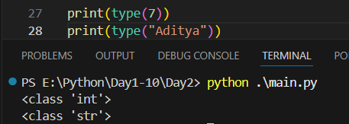

Example: Multiple Variables Assignment
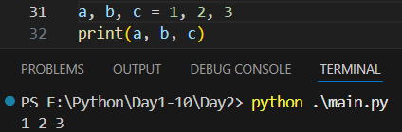
Summary:
- Variable is a container to store data
- Python variables do not need type declaration
- Variables can change values
- Data Types tell the type of data stored
- Common data types:
  - int → whole numbers
  - float → decimal numbers
  - str → text
  - bool → True/False
- type() is used to check data type

--The End--

