Day 29

Local vs Global Variables in Python:
What is a Variable?
A variable is a name that stores a value in memory.
x = 10
What is Scope?
Scope defines where a variable can be accessed in your program.
Python mainly uses:
- Local scope
- Global scope
Local Variables: A local variable is created inside a function and can be used only within that function.
def my_function():
x = 10 # local variable
print(x)
my_function()

Global Variables: A global variable is created outside all functions and can be accessed anywhere in the program.

x = 20 # global variable
def my_function():
print(x)
my_function()
print(x)

Example: local variable.
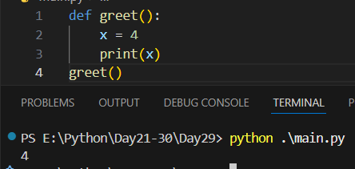
Example: global variable.
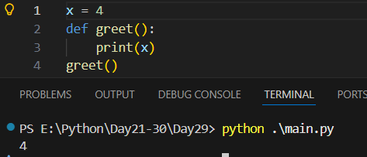
Example: local variable get preference over the global variable if there name be same.
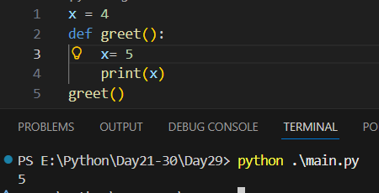\
Example: using ‘global’ keyword
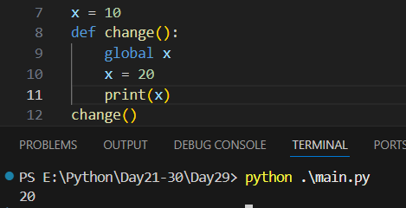
Why Avoid Too Many Global Variables?
Using many global variables can:
- Make code hard to debug
- Cause unexpected changes
- Reduce readability

Feature | Local Variable | Global Variable
Defined | Inside function | Outside function
Scope | Only inside function | Entire program
Memory | Created when function runs | Created at program start
Best practice | ✅ Recommended | ⚠️ Use carefully

--The End--

