Day 18

Recursion in Python:
What is Recursion?
Recursion is when a function calls itself to solve a problem. A big problem is broken into smaller versions of the same problem.
Why do we use Recursion?
- To solve problems that repeat the same logic
- Useful for:
  - factorial
  - Fibonacci
  - tree / file traversal
- Makes code short and clean (for some problems)
Two Important Parts of Recursion (VERY IMPORTANT)
Every recursive function must have:
- Base Case: Condition where recursion stops
- Recursive Case: Function calls itself
Note: Without base case → infinite recursion → error
Example: a basic example of recursion -> factorial.
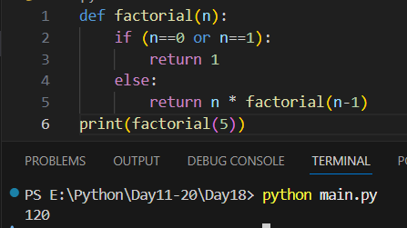
Example: Fibonacci using the recursion.
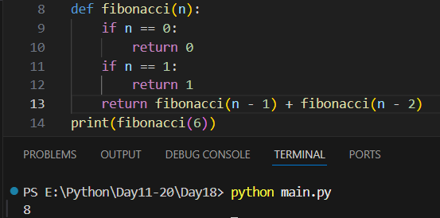
Summary:
- Recursion = function calling itself
- Needs base case to stop
- Breaks problem into smaller parts
- Useful for factorial, Fibonacci, trees
- Loops are better for large inputs

--The End--

