Day 15

Operations on Tuples in Python:
Indexing (Access Elements): Tuples are ordered, so we can access elements using index numbers.
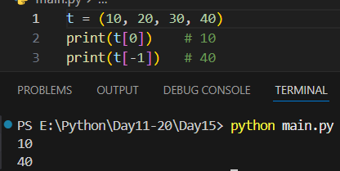
Example: count()
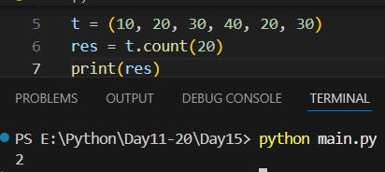
Example: index()
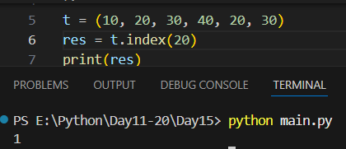
Example: tuple.index(x, start, end)
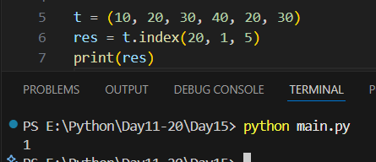
Example: to get the length of the tuple.
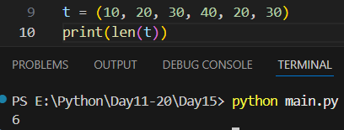
Example: concatenation in the tuples.
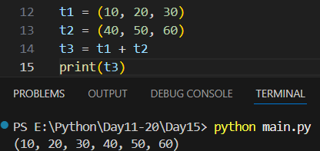

Example: repeating the values of tuple.
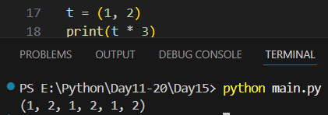
Example: tuple comparison.
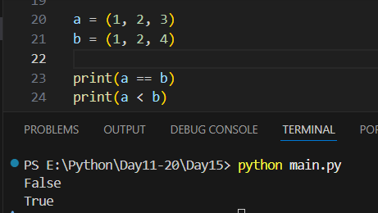
Example: converting a tuple to the list
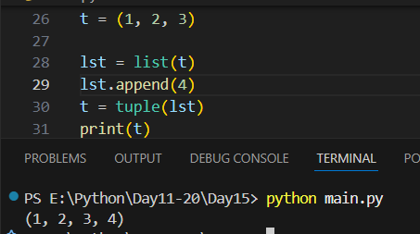

Summary:
- Tuples support indexing & slicing
- Tuples can be concatenated & repeated
- Support in, len(), loops
- Only two methods: count() and index()
- Tuples are immutable (cannot be changed)

--The End--

