Day 6

If Else Conditional Statements in Python:
What is a Conditional Statement?
A conditional statement is used to make decisions in a program.
Python checks a condition:
- If it is True, some code runs
- If it is False, some other code runs
if–elif–else Statement: Used for multiple conditions
Syntax
if condition1:
# code
elif condition2:
# code
else:
# code

if Statement
Syntax
if condition:
# code runs if condition is True
if–else Statement
Syntax
if condition:
# runs if True
else:
# runs if False

Example: taking user age as the input and printing on the screen.
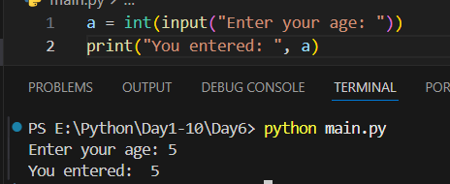

Example: using the “if”
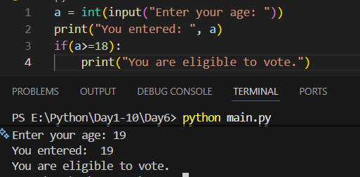
Example: using the “if-else”
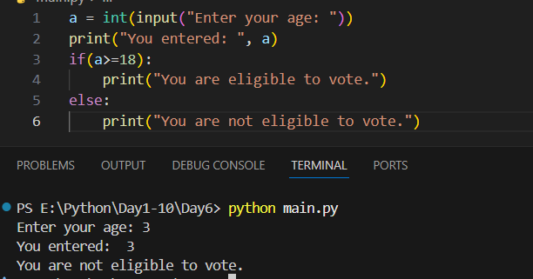
Example: using “if-elif-else”
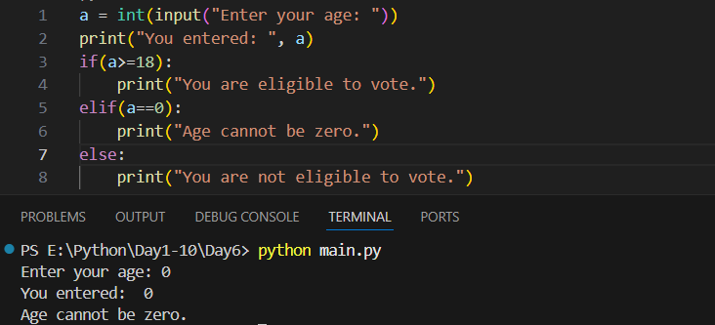

Example: nested if-else
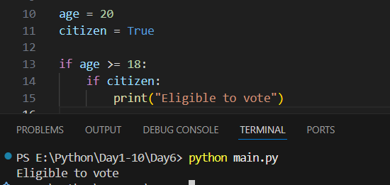
Example: Short-Hand if–else (Ternary Operator)
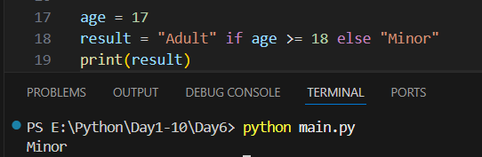
Conditions & Comparison Operators:
Operator | Meaning
== | equal
!= | not equal
> | greater than
< | less than
>= | greater or equal
<= | less or equal

Summary:
- if–else is used for decision making
- if runs when condition is True
- else runs when condition is False
- elif is used for multiple conditions
- Use comparison and logical operators
- Indentation is very important
- Ternary operator is short form of if–else
--The End--

