Day 7

Match Case Statements in Python:
What is match–case?
match–case is a conditional statement used to compare one value with many possible values. It is similar to switch–case in other languages (like C, Java).
Why use match–case?
- Makes code clean and readable
- Avoids writing many if-elif-else
- Best when checking one variable against many values
Basic Syntax
match variable:
case value1:
# code
case value2:
# code
case _:
# default case
_ works like else (default)
Example: a basic example
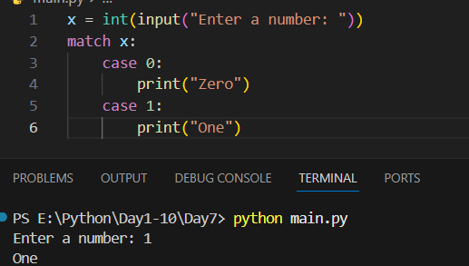

Example: “_” is used as default.
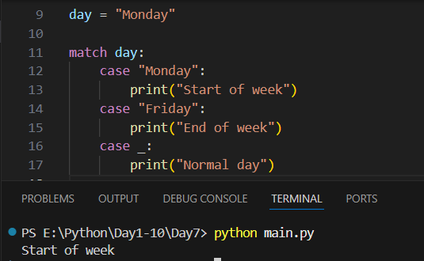
Example:
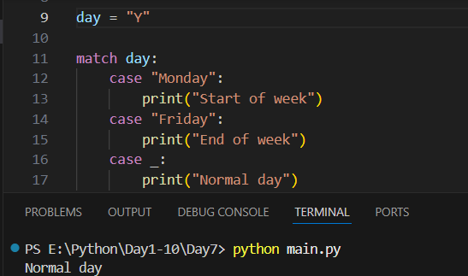
Summary,
- match–case is used to match one value with many cases
- Works like switch-case
- Introduced in Python 3.10
- _ is the default case
- Supports:
- Numbers
- Strings
- Multiple values
- Conditions (guards)
- Makes code cleaner than many if-elif

--The End--

