Day 34

Constructors in Python:
What is a Constructor?
A constructor is a method named __init__() (double underscore before and after init).
Syntax
class ClassName:
def __init__(self):
# constructor body
pass
- __init__ runs automatically when an object is created.
- self refers to the current object.
Example: till now we know.
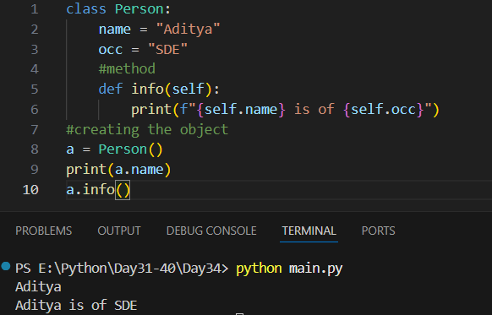

Example: creating a constructor.
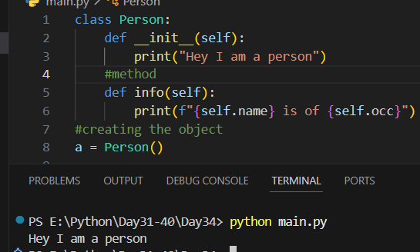
Example: whenever a new object is created, the constructor is called. Since, two objects are there, two time “Hey I am a person” is printed.
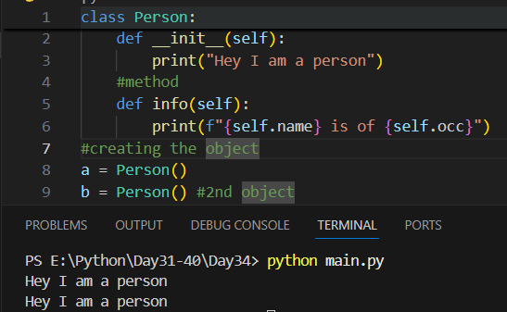
Example: passing multiple arguments in the constructor.
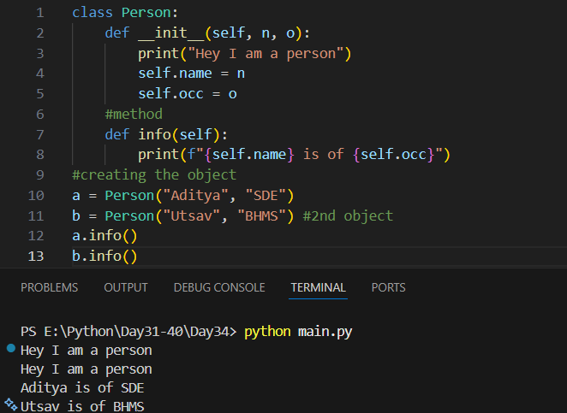
Example: passing only one argument instead of two.
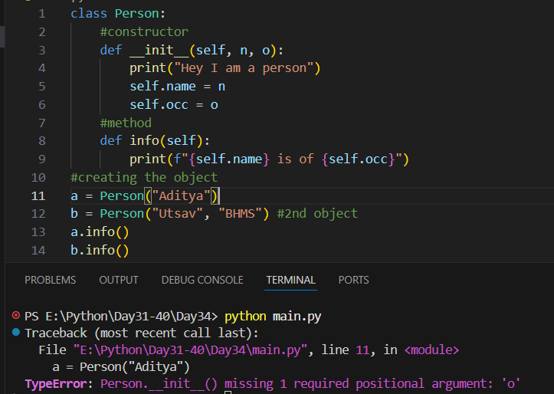
Example: default constructor.
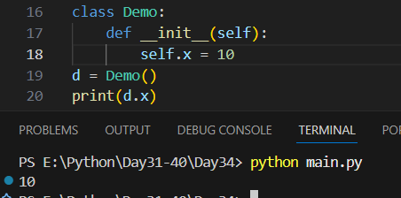

Example: parameterizes constructor.
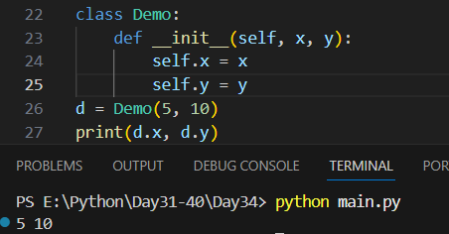

Summary:
- A constructor is a special method that is automatically executed when an object is created.
- In Python, a constructor is defined using __init__().
- The main purpose of a constructor is to initialize instance variables.
- self represents the current object of the class.
- Constructors are not mandatory, but commonly used.
Key Points
- Constructor name must be __init__ (with double underscores).
- It runs automatically when an object is created.
- Used to assign initial values to object data members.
- A class can have only one constructor (method overriding applies).
- Python does not support constructor overloading directly.
Types of Constructors
- Default Constructor
  - Has no parameters (except self)
- Parameterized Constructor
  - Accepts parameters to initialize data members
Special Notes
- Constructor overloading can be simulated using default arguments.
- Constructors improve code readability and structure.
- If no constructor is defined, Python provides a default constructor.
--The End--

