Day 43

Method Overriding in Python:
What is Method Overriding?
Method Overriding occurs when:
- A child class provides its own implementation of a method
- The method already exists in the parent class
- The method name and parameters are the same
The child’s method overrides the parent’s method.
Why Method Overriding is Needed?
- To change or extend parent class behavior
- To implement runtime polymorphism
- To customize functionality in derived classes
Example: a basic example.
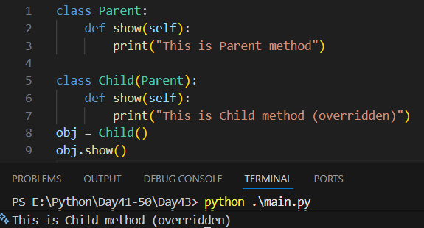

Example: Calling Parent Method Without super() (Not Recommended)
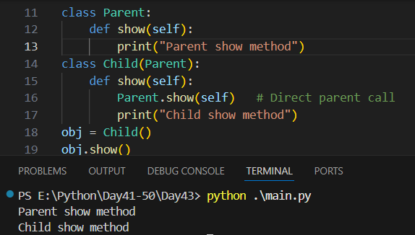
Example: Calling Parent Method With super() (Recommended)
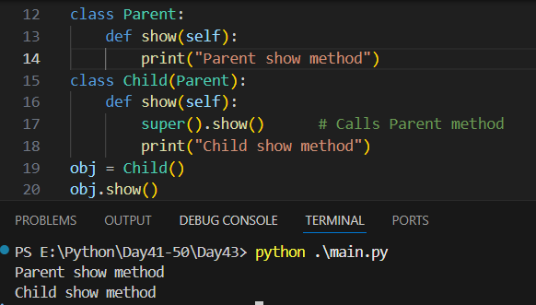
Example: Overriding __init__() Method
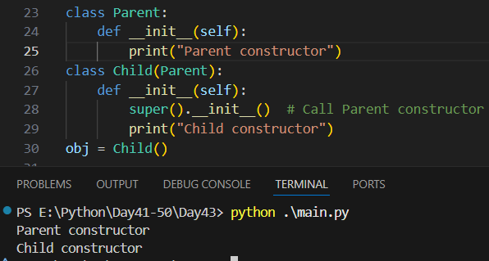

Example: Overriding with Arguments
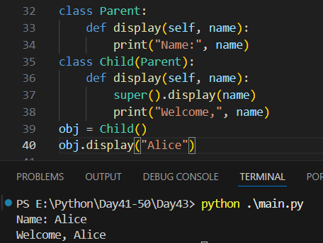
Example: runtime polymorphism (method overriding)
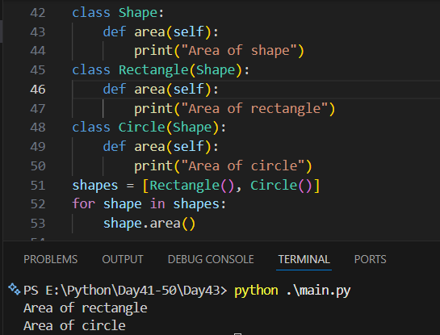
Summary:
- Method overriding allows child classes to change parent behavior
- Supports runtime polymorphism
- super() is the best way to call parent method
- Common in real-world OOP designs

--The End--

