Day 39

Class Methods in Python:
What is a Class Method?
A class method is a method that:
- Belongs to the class, not to an individual object
- Works with class-level data
- Uses @classmethod decorator
- Takes cls (class itself) as the first parameter
Think of it as a method that knows about the class, not a specific object.
Why Do We Need Class Methods?
We use class methods when:
- We want to access or modify class variables
- We want alternative ways to create objects (factory methods)
- The logic is related to the class as a whole
Syntax of a Class Method
class MyClass:
@classmethod
def my_class_method(cls):
print(cls)
- @classmethod → tells Python this is a class method
- cls → refers to the class itself
Example:
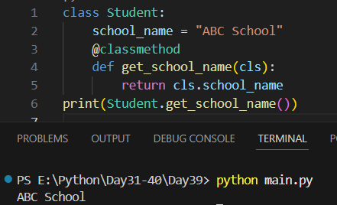
Example: Modifying Class Variables Using Class Method
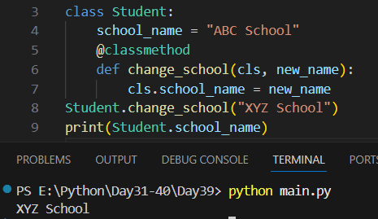
Example: Factory Method (Very Important Use Case) -> Class methods are often used to create objects.
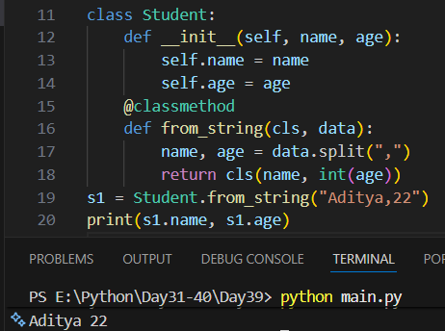

Difference Between @staticmethod and @classmethod
Feature | Class Method | Static Method
Decorator | @classmethod | @staticmethod
First parameter | cls | None
Access class variables | ✅ Yes | ❌ No
Knows class info | ✅ Yes | ❌ No

Real-Life Analogy
- Class → School
- Class Method → School rules
- Instance Method → Student behavior
Summary:
- Class methods belong to the class, not objects
- Defined using @classmethod
- Use cls instead of self
- Used to access/modify class variables
- Commonly used as factory methods

Class Methods as Alternative Constructors in Python:
What is a Constructor?
A constructor is a special method that:
- Creates an object
- Initializes data
- In Python, it is __init__()
class Student:
def __init__(self, name, age):
self.name = name
self.age = age
This is the main (default) constructor.
What is an Alternative Constructor?
An alternative constructor is:
- Another way to create an object
- Uses class methods
- Useful when input data is in a different format
Python does not support multiple constructors directly. So we use class methods instead.
Why Use Class Methods as Alternative Constructors?
We use them when:
- Data comes as string / file / list / dict
- We want clean and readable code
- Object creation logic differs

Example:
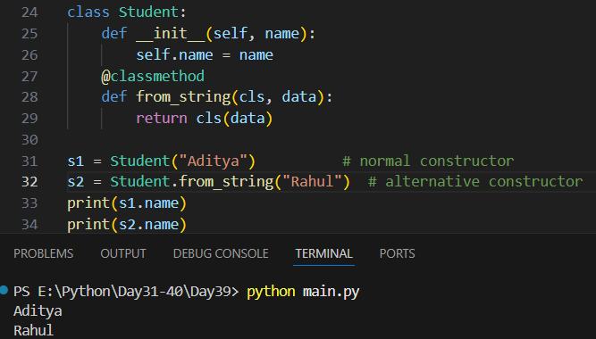
--The End--

