Day 47

Walrus Operator in Python:
What Is the Walrus Operator? Walrus has very low precedence, so use parentheses.
The walrus operator is written as:
:=
Its official name is the assignment expression operator. It assigns a value to a variable AND returns that value at the same time.
Think of it as: “assign while using.”
Why Is It Called “Walrus”?
Because := looks like a walrus face 🦭 (eyes + tusks)
Basic Syntax
(variable := expression)

Example: without any operator.
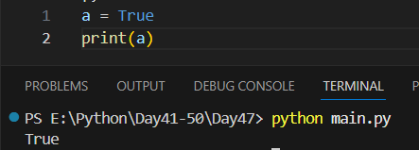
Example: problem comes when we try to change it.
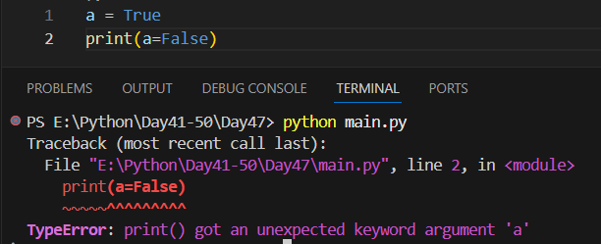
Example: Solution? Use walrus operator.
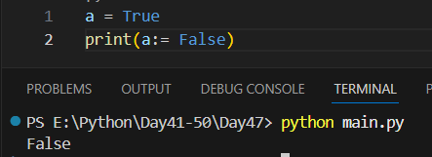
Example: Before Walrus Operator (Traditional Way) Normally, assignment and usage are separate:
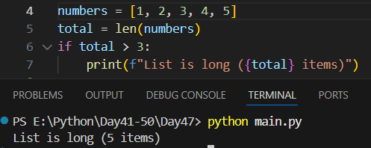
Example: with walrus operator.
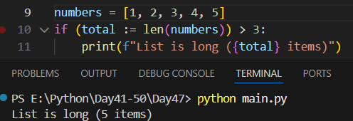
Example: if and :=
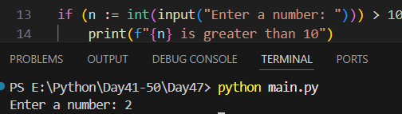
Example: if without :=
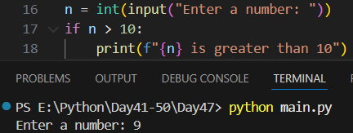
--The End--

