Day 28

os Module in Python:
What Is the os Module?
- os is a built-in Python module for interacting with the operating system
- Lets you perform tasks like:
  - File and directory management
  - Environment variables
  - Process management
Importing the module:
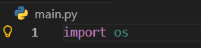
Example: Creating a folder using the os module.
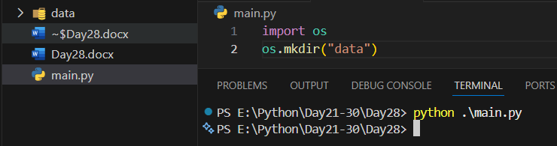
Example: code to check if a folder exists in our folder or not.
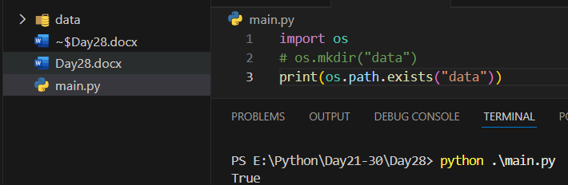

Example: to rename
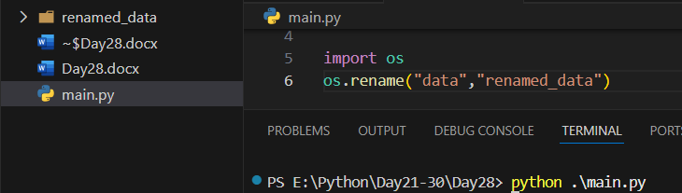
Example: to print the list of the folders in a specific folder.
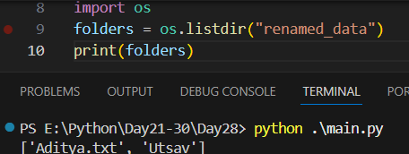

Example: Current Working Directory
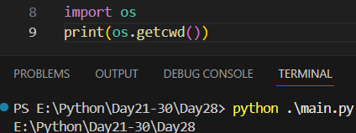
Example: Creating and Removing Directories
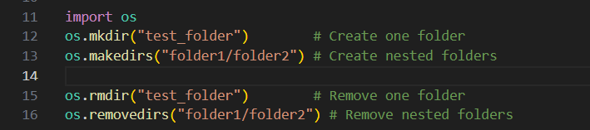
--The End--

