Day 25

Short hand if else statements:
What Is Shorthand if–else?
A shorthand if–else (also called ternary operator) allows you to write an if–else condition in one line.
Basic Syntax
value_if_true if condition else value_if_false

Example: a basic example.
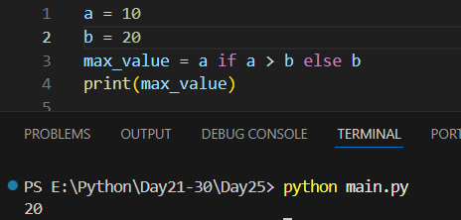
Example: multiple conditions
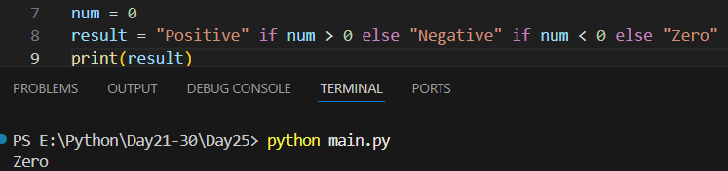

Enumerate Function in Python:
What is enumerate()?
enumerate() is a built-in Python function used to loop over an iterable while keeping track of the index. Instead of manually counting indexes, enumerate() does it automatically.
Basic Syntax
enumerate(iterable, start=0)
- iterable → list, tuple, string, etc.
- start → starting index (default is 0)
Example: old way
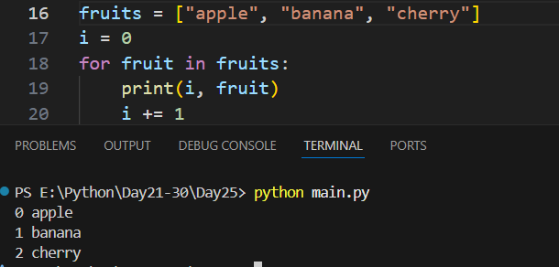
Example: a basic example printing the index number and the text at that index.
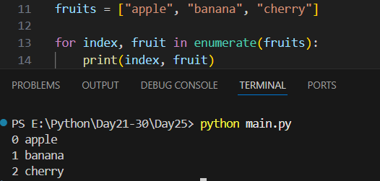
Example: enumerating with custom start index
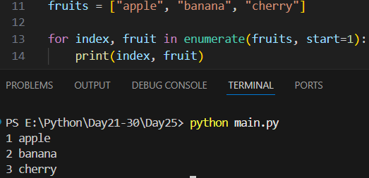

Example: enumerate with the string.
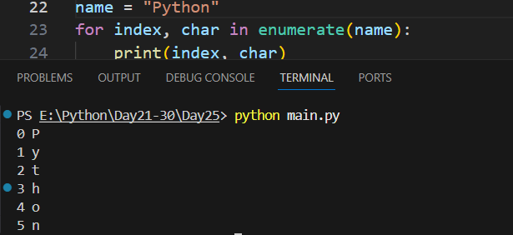

Example:
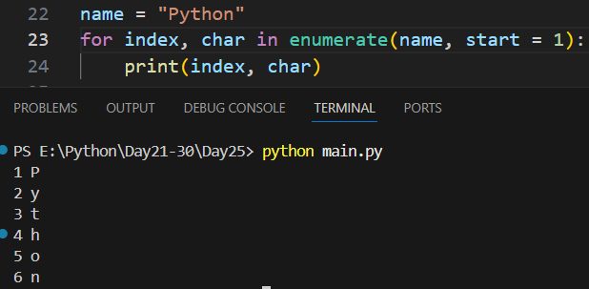
Summary:
- enumerate() is a built-in Python function
- It returns index and value while looping
- Used with lists, tuples, strings, and other iterables
- Default starting index is 0
- start parameter can change the starting index
- Makes code cleaner than manual indexing
- Returns pairs as (index, item) tuples
- Commonly used in for loops
--The End--

