Day 36

Getters and Setters in Python:
What are getters and setters?
- Getter: A method used to access the value of a private attribute.
- Setter: A method used to modify the value of a private attribute.
In Python, we usually make an attribute private by prefixing it with an underscore _ (convention) or double underscore __ (name mangling).
Example: without using getter and setter. Here, nothing prevents setting age to a negative number. That’s why we use getters and setters.
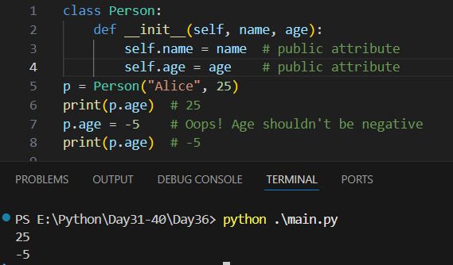
This example shows a problem with public attributes. The Person class allows direct access to age, so after creating p = Person("Alice", 25), you can freely change p.age to -5. Python does not stop this, even though a negative age doesn’t make sense. This is why properties (getters and setters) are useful—they let you add validation and protect data while still keeping the code easy to use.

Example:
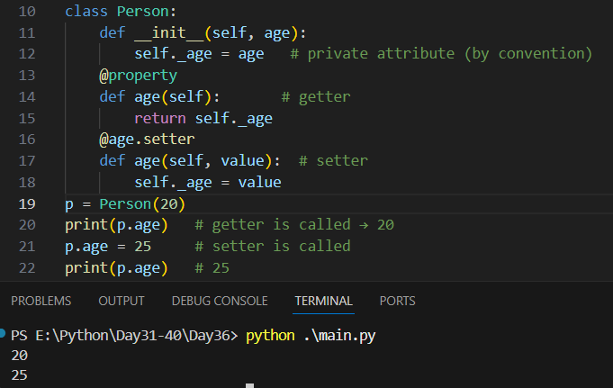
This code shows how properties work in Python to control access to class attributes. The Person class stores the age in a “private” variable _age. The @property decorator makes the age() method act like a normal attribute, so p.age calls the getter and returns the value. The @age.setter decorator lets you update the value using p.age = 25, which calls the setter method. This way, you can safely get and set values while still using simple attribute-style access.
Summary:
A getter returns a value, a setter changes a value — and @property lets you use them like normal variables.
--The End--

