Day 48

Shutil Module in Python:
What Is shutil?
shutil stands for shell utilities. It provides high-level file and directory operations, such as:
- Copying files
- Moving files
- Deleting directories
- Archiving (zip, tar)
- Checking disk usage
It works on top of lower-level modules like os and pathlib.
Importing shutil
import shutil
Copying Files: shutil.copy() Copies file contents and permissions.
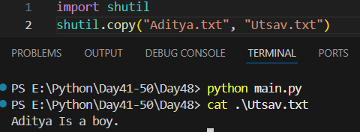
shutil.copy2() : Copies file with metadata (timestamps).
shutil.copyfile() : Copies only file contents (no metadata).
Moving Files and Directories: shutil.move()
Deleting Directories: shutil.rmtree() : Deletes a directory and everything inside it.

Requests Module in Python:
What Is requests?
requests is a popular Python library used to make HTTP requests easily.
With it, you can:
- Fetch data from APIs
- Send data to servers
- Download files
- Work with JSON responses
- Authenticate requests
It replaces complex built-in modules like urllib.
Installing requests
requests is not included by default.
Pip install requests

Example: basic GET request.
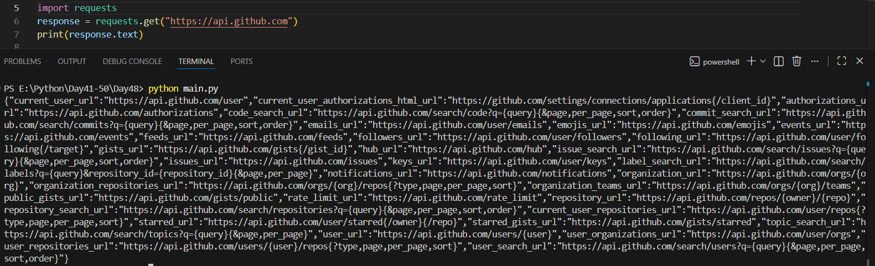
Key attributes:
Attribute | Meaning
response.status_code | HTTP status
response.text | Response body (string)
response.json() | JSON → Python dict
response.headers | Response headers
response.url | Final URL

Example: working with JSON data.
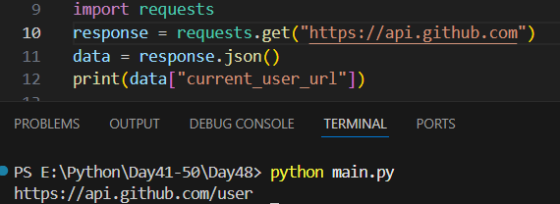
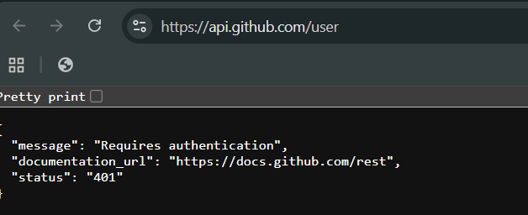
Example: making the POST requests.
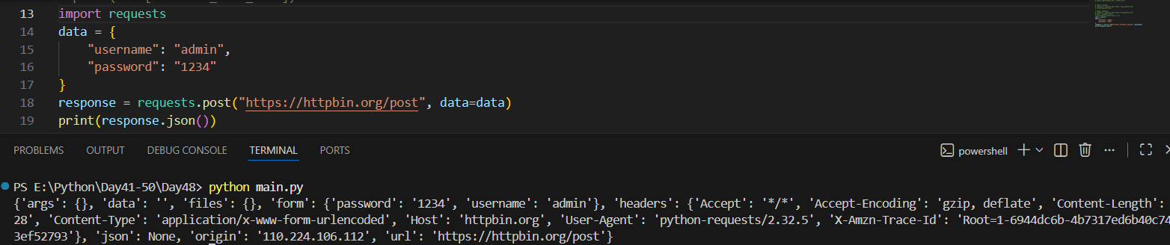
Summary:
- requests makes HTTP easy
- Clean syntax & readable code
- Industry standard for API work
- Essential Python skill
--The End--

