Day 24

Raising custom errors in Python:
What Is a Custom Error?
A custom error (custom exception) is a user-defined error that you create to represent specific problems in your program.
Why Raise Custom Errors?
- To make errors more meaningful
- To improve code readability
- To handle application-specific rules
- To separate logic errors from system errors
Using raise (Basics)
You can raise a built-in exception manually.
age = -5
if age < 0:
raise ValueError("Age cannot be negative")
Example: a basic example.
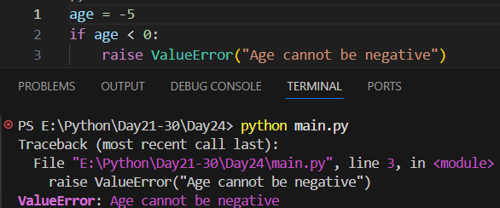

Example: Handling Custom Exceptions with try–except
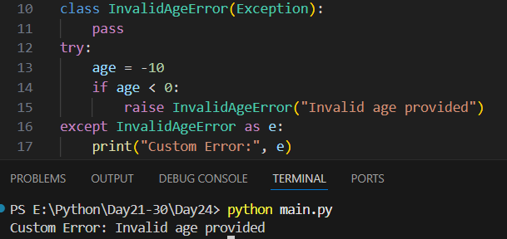

Summary:
- Custom errors are user-defined exceptions created for specific problems
- They are created by inheriting from Exception
- Use raise to trigger a custom error
- Custom errors make code clearer and more meaningful
- They must be defined before use
- Use try–except to handle custom errors gracefully
- Unhandled custom errors show a traceback (expected behavior)
- Name custom errors clearly (e.g., InvalidAgeError)

--The End--

