Day 30

File IO in Python:
What is File I/O?
File I/O means:
- Input → Reading data from a file
- Output → Writing data to a file
Files allow data to be stored permanently, unlike variables (temporary).
Types of Files
Python mainly works with:
- Text files → .txt, .csv, .log
- Binary files → .jpg, .pdf, .exe
Operation | Method
Open file | open()
Read | read(), readline(), readlines()
Write | write(), writelines()
Close | close()
Best practice | with open()

Example: opening the file.
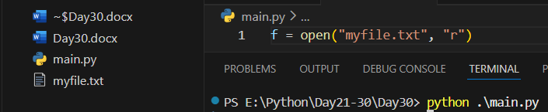

Example: reading the content of myfile.txt
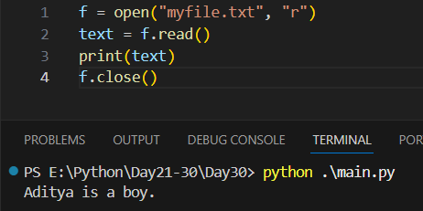

Common File Modes
Mode | Meaning
r | Read (default)
w | Write (overwrite)
a | Append
x | Create new file
r+ | Read + Write
b | Binary mode
t | Text mode (default)

Example: if we open a file which doesn’t exists in ‘w’ mode, then that file automatically get created.
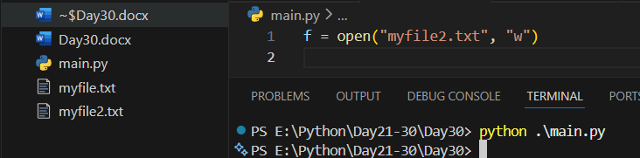

Example: writing in the file.
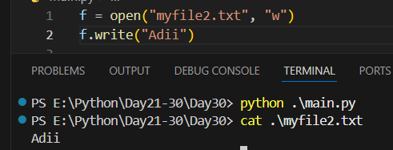
Example: appending in the file.
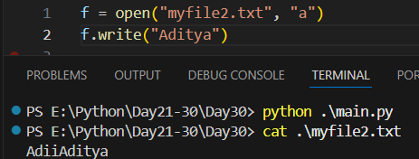

Example: the number of times we run the code, the number of times it get appended.
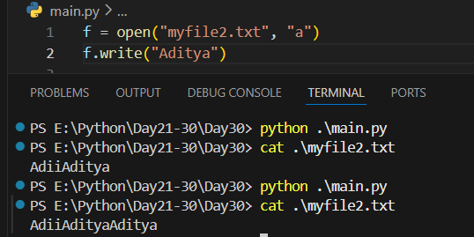
Example: Using with Statement (Best Practice): Automatically closes the file.
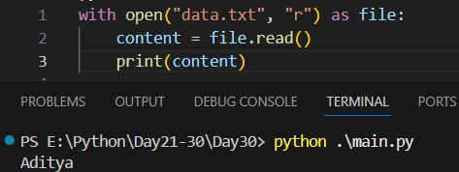
read(), readlines() and other methods:
Before reading, a file must be opened in read mode (r).
read()
- Reads entire file content as one single string
- Can also read a specific number of characters
Example: basic reading of the file.
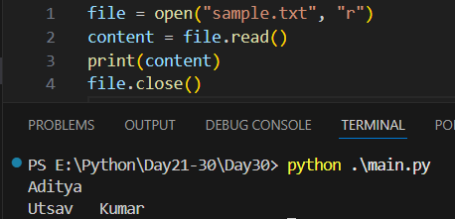

Example: reading the first ten characters.
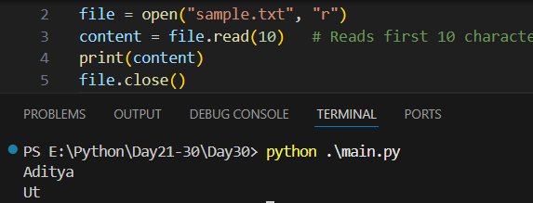

readline()
- Reads one line at a time
- Cursor moves to the next line automatically

Example: basic use of readline()
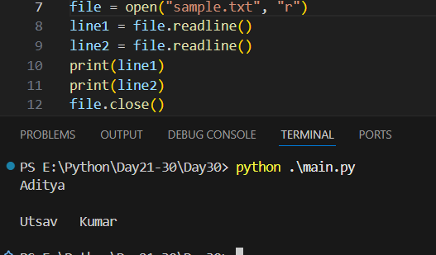

readlines()
- Reads all lines at once
- Returns a list of strings
Example: a basic example of readlines()
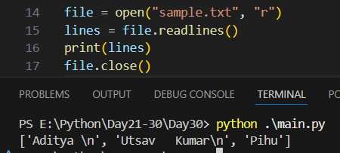
Example: File Cursor Methods: tell() - Returns current cursor position.
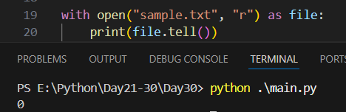

Example: seek() -> Moves cursor to a specific position.
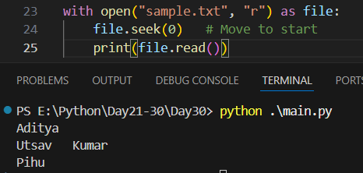

Comparison Table
Method | Returns | Reads | Memory Usage
read() | String | Entire file | High
read(n) | String | n characters | Low
readline() | String | One line | Low
readlines() | List | All lines | High
File iteration | String | One line | Very Low

Summary:
- read() → Reads the entire file (or given number of characters) and returns a single string.
- readline() → Reads one line at a time and returns it as a string.
- readlines() → Reads all lines at once and returns them as a list of strings.
- File iteration (for line in file) → Reads the file line-by-line efficiently using minimal memory.
- tell() → Returns the current position of the file cursor.
- seek(pos) → Moves the file cursor to the specified position.
- write() → Writes a string to the file and returns the number of characters written.
- writelines() → Writes a list of strings to the file without adding newlines automatically.
- close() → Closes the file and frees system resources.
- with open() → Automatically opens and closes the file safely (best practice).
--The End--

