Day 26

Virtual Environment in Python:
What Is a Virtual Environment?
A virtual environment (venv) is an isolated Python environment where you can install packages without affecting the global Python installation.
Why Use a Virtual Environment?
- Avoids package version conflicts
- Keeps projects independent
- Makes projects portable
- Prevents breaking system Python
Example Problem (Without venv)
- Project A needs Django 2.2
- Project B needs Django 4.x
- Installing one breaks the other
Creating a Virtual Environment:
Step 1: Open Terminal / Command Prompt
python -m venv myenv
myenv = environment name


To activate:
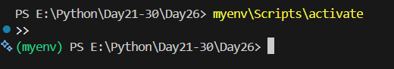

Deactivating the Virtual Environment
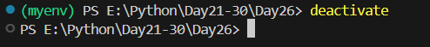
Installing the module named ‘requests’:
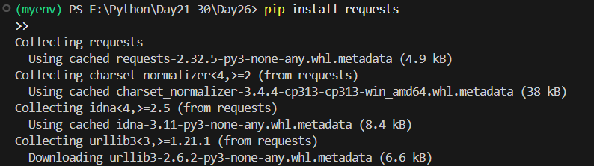
Checking installed packages:
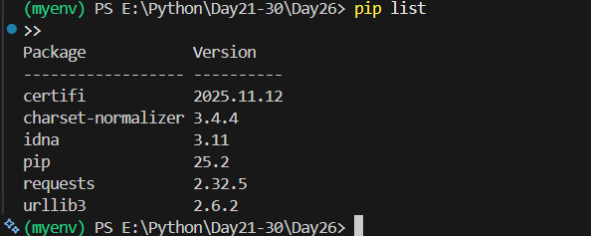
Sharing a Virtual Environment (requirements.txt)
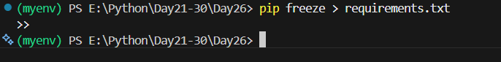
Deleting a Virtual Environment: Just delete the folder:
Myenv/

Summary:
- A virtual environment is an isolated Python workspace
- It prevents dependency and version conflicts
- Each project should have its own virtual environment
- Created using python -m venv env_name
- Must be activated before installing packages
- Packages installed inside venv do not affect global Python
- Deactivate using deactivate
- Use requirements.txt to share dependencies
- Virtual environment folders should not be committed to Git
--The End--

