Day 44

Operator Overloading in Python:
Why Operator Overloading?
Built-in types already overload operators:
print(2 + 3) # 5
print("Hi" + "!") # Hi!
print([1, 2] + [3]) # [1, 2, 3]
Same + operator, different behaviour. Operator overloading lets your own objects behave like built-in types.
Basic Idea
Operators call special methods internally.
Operator | Method
+ | __add__()
- | __sub__()
* | __mul__()
/ | __truediv__()
== | __eq__()
< | __lt__()
> | __gt__()

Example: overloading the + operator.
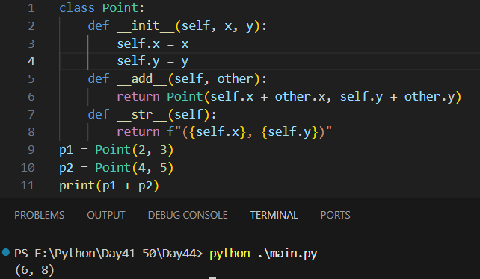

Example: - and *
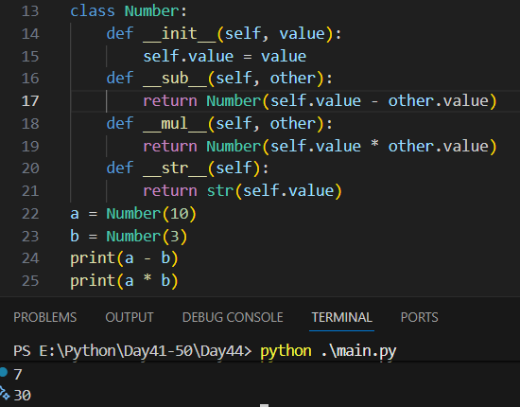
Summary
- Operator overloading lets objects behave like built-in types
- Achieved using magic methods
- Makes code cleaner and more expressive
- Should be used thoughtfully

--The End--

