Day 40

dir, __dict__ and help method in Python:
dir() – “What’s inside this object?”What it does
dir() returns a list of names (attributes & methods) that belong to an object.
Think of it as: Open the box and list everything inside.
Syntax
dir(object)
Example: to see the methods
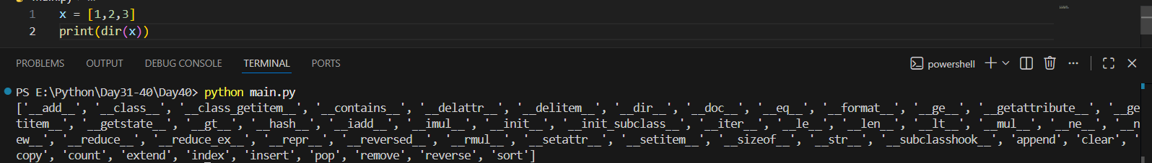
Example: to print information about any method.
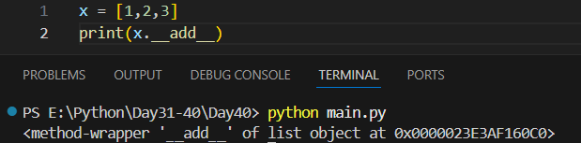
Example:
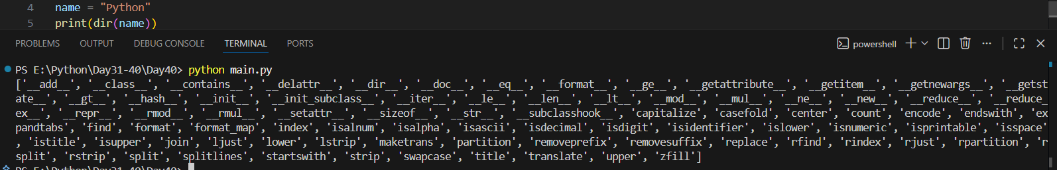

__dict__ – “Show me the actual data stored”
__dict__ is a dictionary that stores an object’s attributes.
Think of it as: The object’s internal record book
Example:
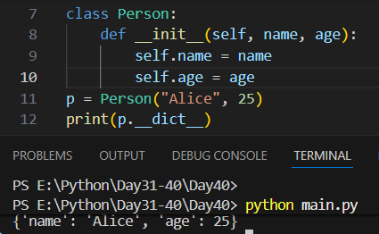

help() – “Explain this to me”
help() displays documentation for an object, function, class, or module.
Think of it as: Open the user manual
Syntax
help(object)
Example:
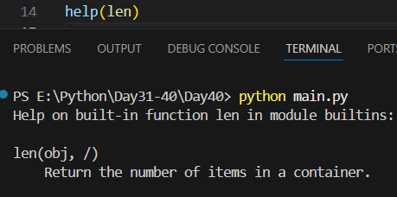

Quick Comparison Table
Feature | Purpose | Output Type | Best For
dir() | Lists attributes & methods | list | Exploration
__dict__ | Shows stored attributes | dict | Internal data
help() | Shows documentation | Text | Understanding usage

