Day 5

String Methods in Python:
What are String Methods?
String methods are built-in functions used to perform operations on strings like:
- changing case
- finding text
- replacing text
- removing spaces
String methods do not change the original string (strings are immutable).
Case-Related String Methods: upper(), lower(), title(), capitalize()
Example: basic example of upper() and lower()
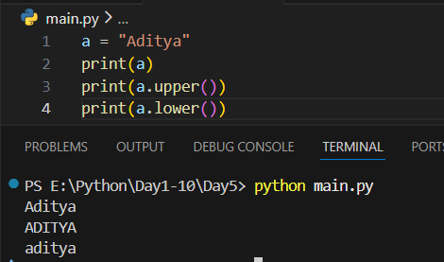
Example: example of title() and capitalize()
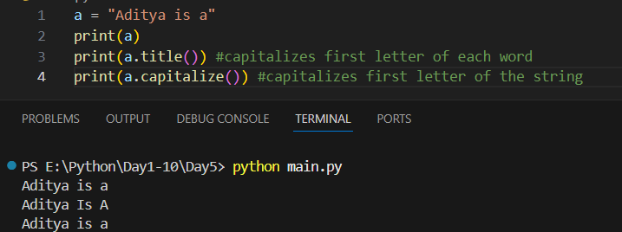
Removing Spaces: strip(), lstrip(), rstrip()
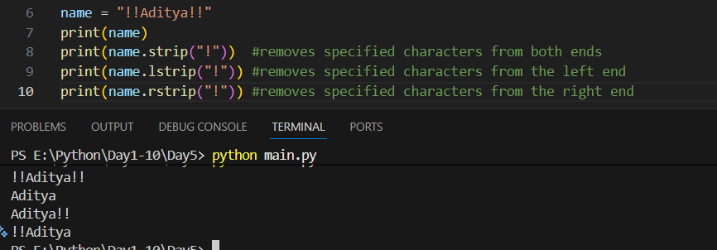
Replacing Text: replace()
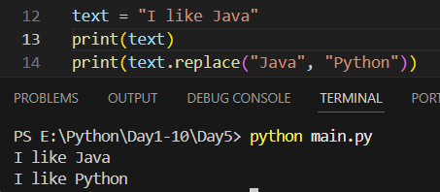
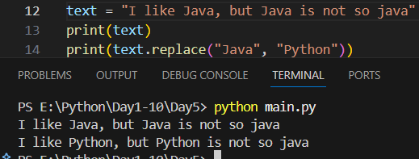

Finding and Checking Text: find(), index(), count()
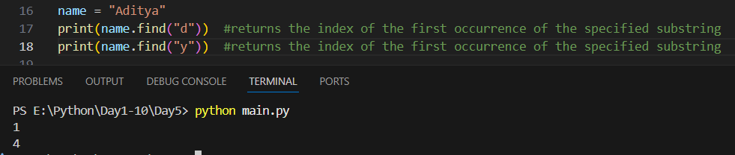
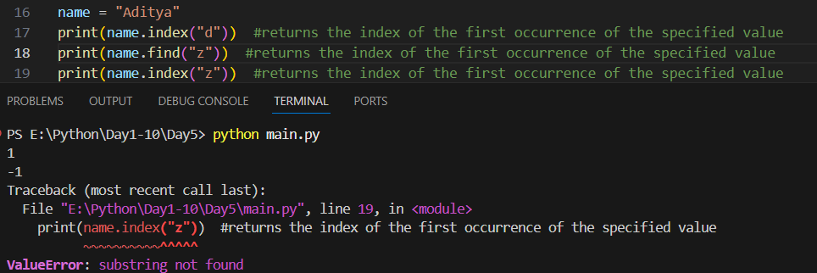
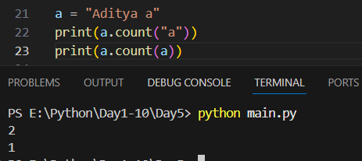

Splitting and Joining Strings: split(), join()
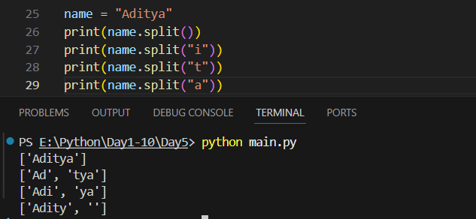
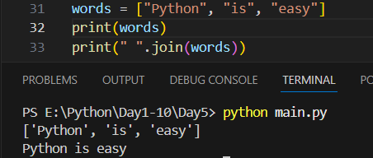
startswith() and endswith():
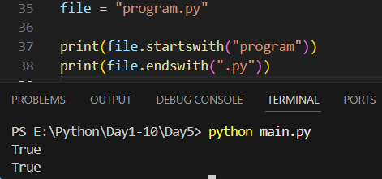

String length method: length()
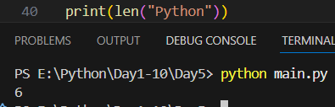
Checking string type: isalpha(), isdigit(), isalnum(), islower(), isupper(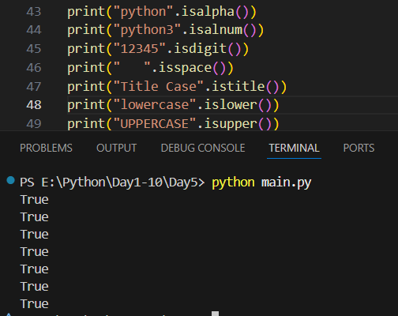
Summary, String methods are built-in functions for strings
- Strings are immutable (original string doesn’t change)
- Common methods:
  - Case: upper(), lower(), title()
  - Spaces: strip(), lstrip(), rstrip()
  - Search: find(), count()
  - Replace: replace()
  - Check: isalpha(), isdigit()
  - Split & Join: split(), join()

--The End--

