Day 1

Introduction to Programming and Python:
Programming is a way for us to tell computers what to do. Computer is a very dumb machine and it only does what we tell it to do. Hence, we learn programming and tell computers to do what we are very slow at - computation.
What is Python?
- Python is a dynamically typed, general purpose programming language that supports an object-oriented programming approach as well as a functional programming approach.
- Python is an interpreted and a high-level programming language.
Features of Python:
- Python is simple and easy to understand.
- It is Interpreted and platform-independent which makes debugging very easy.
- Python is an open-source programming language.
- Python provides very big library support. Some of the popular libraries include NumPy, TensorFlow, Selenium, OpenCV, etc.
- It is possible to integrate other programming languages within python.
What is Python used for?
- Python is used in Data Visualization to create plots and graphical representations.
- Python helps in Data Analytics to analyse and understand raw data for insights and trends.
- It is used in AI and Machine Learning to simulate human behaviour and to learn from past data without hard coding.
- It is used to create web applications.
- It can be used to handle databases.
Example: a basic example
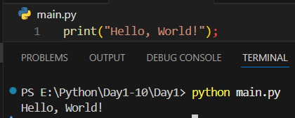

Modules and Pip:
What are Modules?
Module is like a code library which can be used to borrow code written by somebody else in our python program. There are two types of modules in python:
- Built in Modules - These modules are ready to import and use and ships with the python interpreter. There is no need to install such modules explicitly. e.g., hashlib
- External Modules - These modules are imported from a third-party file or can be installed using a package manager like pip or anaconda. Since this code is written by someone else, we can install different versions of a same module with time. e.g., TensorFlow
The pip command:
It can be used as a package manager pip to install a python module. To install a module name 'pandas' we will write:


First python program:
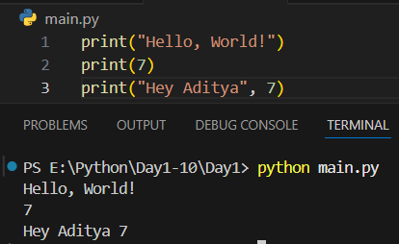
--The End--

