Day 16

f-strings in Python:
What is an f-string?
An f-string (formatted string) is a simple way to put variables inside a string.
- Introduced in Python 3.6.
- Uses f before the string
Example: string formatting earlier.
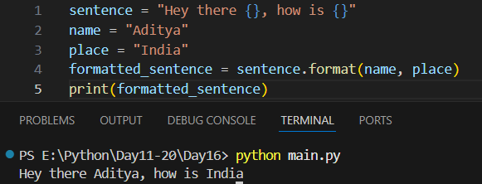
Example: another example of old format, now with index specified.
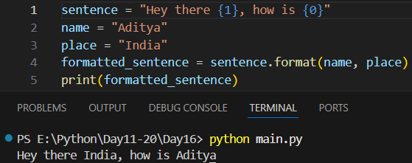

Example: using the f-strings
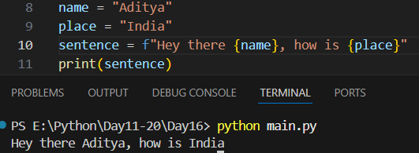
Example: calculating inside the f-string
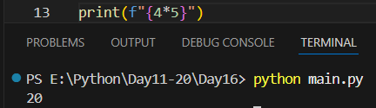
Example: Something interesting …
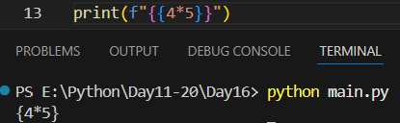
Summary:
- f-strings are used to format strings
- Use f"..." before string
- Variables go inside { }
- Can use expressions & functions
- Cleaner and better than old methods
--The End--

