Day 4

Strings in Python:
What is a String?
A string is a collection of characters (letters, numbers, symbols) written inside quotes. Strings are used to store text data.
How to Create a String?
You can use:
- Single quotes ' '
- Double quotes " "
- Triple quotes ''' ''' or """ """
Example:
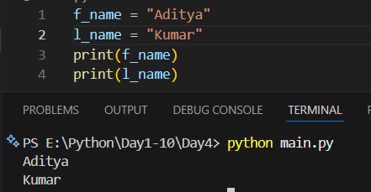
Example: printing double quotes using the single quote.
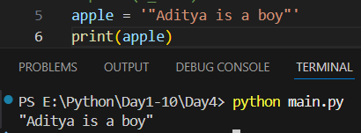
Example: using triple quotes for strings in multiple line.
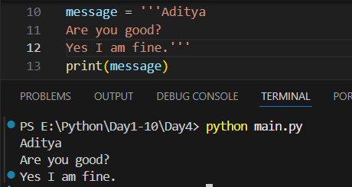
Example: accessing characters in the string.
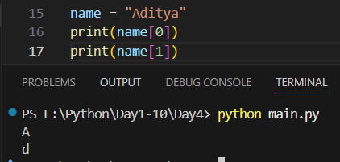
Example: printing the index which doesn’t exists.
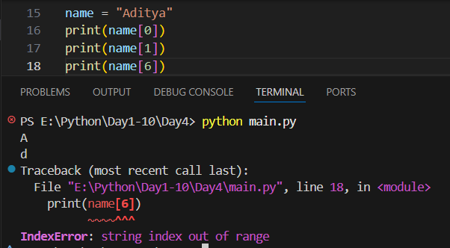

Example: printing the character of the string using the for…in loop.
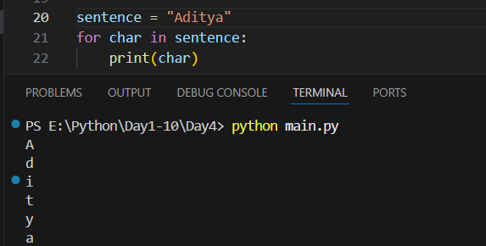

String Slicing in Python:
What is String Slicing?
String slicing means getting a part of a string.
Syntax:
string[start : end]
- start → starting index (included)
- end → ending index (excluded)
Example: [0:]
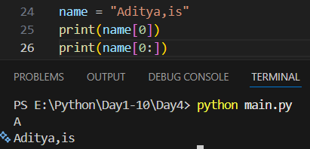

Example: [0:4]
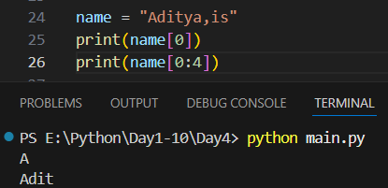
Example: [:4]

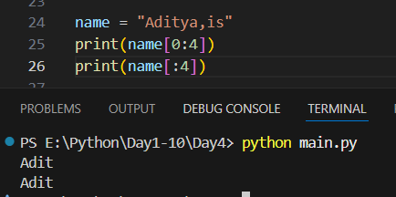
Example: [:-1]
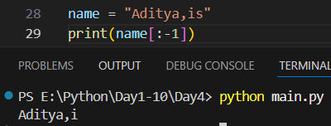
--The End—

