Day 22

for Loop with else in Python:
Example: a basic example of for loop with else.
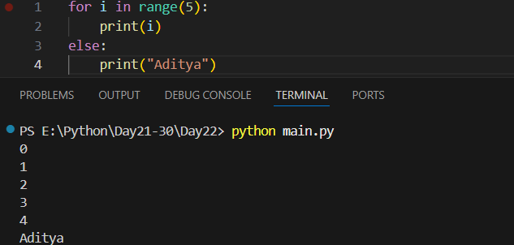
Example: another example.
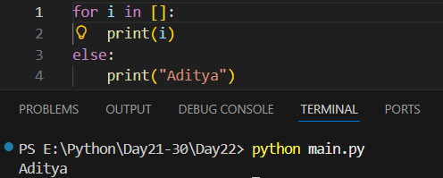
Example:
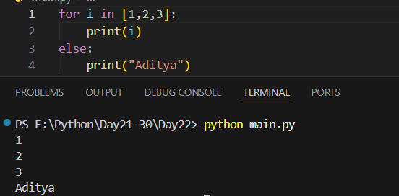
Example: using for … if … else. Clearly, else will execute only when the for loop completed successfully.
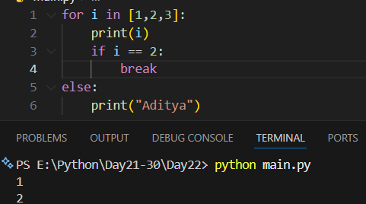

--The End--

