Day 23

Exception Handling in Python:
What is an Exception?
An exception is an error that occurs while the program is running, which stops the normal flow of execution.
Example:
x = 10 / 0 # ZeroDivisionError
Output:
ZeroDivisionError: division by zero
Why Exception Handling?
Without handling exceptions:
- The program crashes
- Remaining code does not execute
With exception handling:
- Program continues gracefully
- Errors are managed properly
Basic try–except: Use try to write risky code and except to handle errors.
try:
x = 10 / 0
except:
print("An error occurred")

Example:
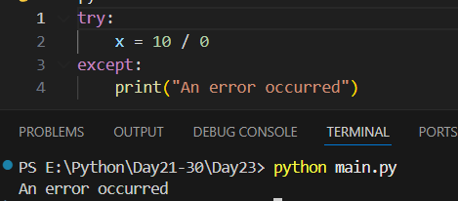
Example: code to print the multiplication table.
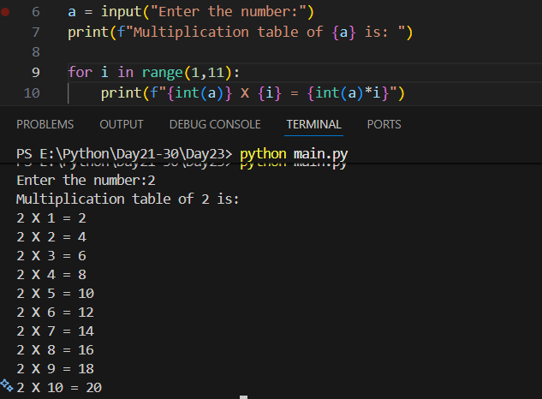
Example: what if we give string as the input in the above example? The program will show an error.
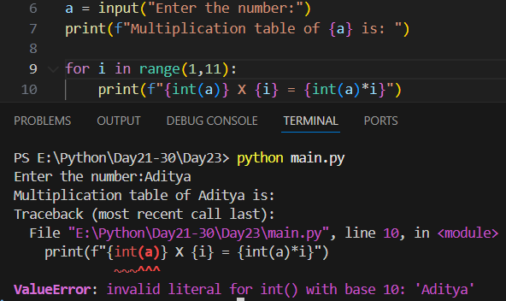

Example: using try…except to handle the error.
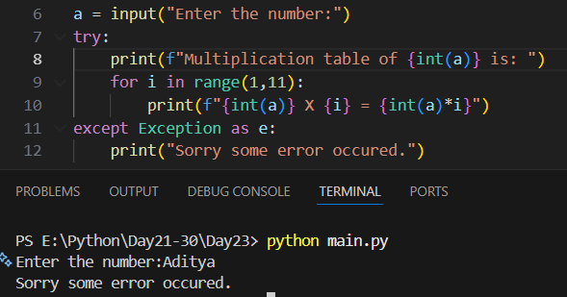
Example: we can omit the “exception as e”/
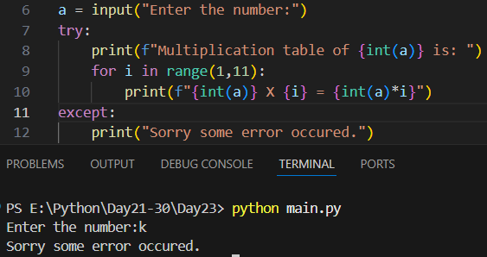
Example: catching specific exceptions
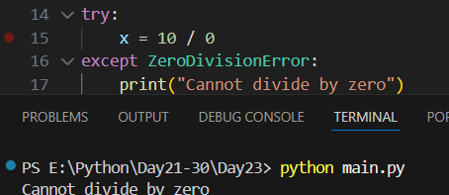

Example: we can add multiple “except”.
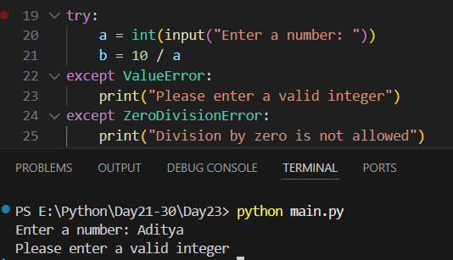

Summary:
- try block contains code that may cause an error
- except block handles the error if it occurs
- Program does not crash when exception is handled
- Always catch specific exceptions, not generic ones
- Multiple except blocks can handle different errors
- else runs only if no exception occurs
- finally runs whether an exception occurs or not
- Use Exception as e to get error details
- raise is used to create custom errors
- Keep try blocks short and focused

Finally Keyword in Python:
What is finally?
The finally block is used with try–except and always executes, whether:
- an exception occurs
- no exception occurs
- an exception is handled or not
Basic Syntax
try:
# risky code
except:
# error handling
finally:
# cleanup code (always runs)

Example: a basic example.
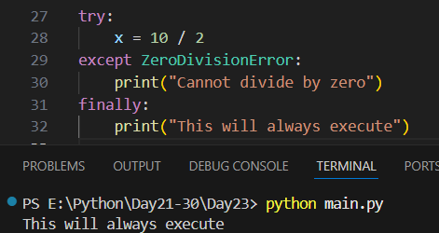
Example: finally is always executed even if try or except executed.
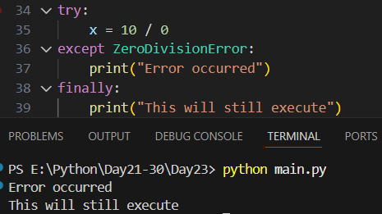
Why Use finally?
- To close files
- To release resources
- To disconnect databases
- To ensure cleanup code always runs
Important Points
- finally executes even if return is used
- finally executes even if an exception is not handled
- Only skipped if the program forcibly terminates
- finally is used to run cleanup code that must execute no matter what happens in try or except.

--The End--

