Day 37

Inheritance in Python:
What is Inheritance?
Inheritance allows one class (child / subclass) to reuse and extend another class (parent / base class).
Think of it like:
- Parent class: common features
- Child class: uses those features + adds its own
Why use inheritance?
- Code reusability
- Avoid duplication
- Easy maintenance
- Logical relationship between classes
Basic inheritance syntax
class Parent:
def show(self):
print("This is the parent class")
class Child(Parent):
pass

Example: a basic example without any inheritance.
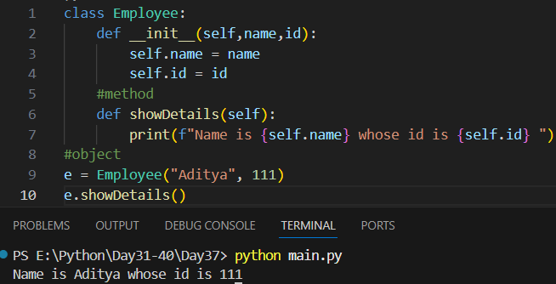
Example: introducing the inheritance, where the programmer class inherits the properties of the employee class.
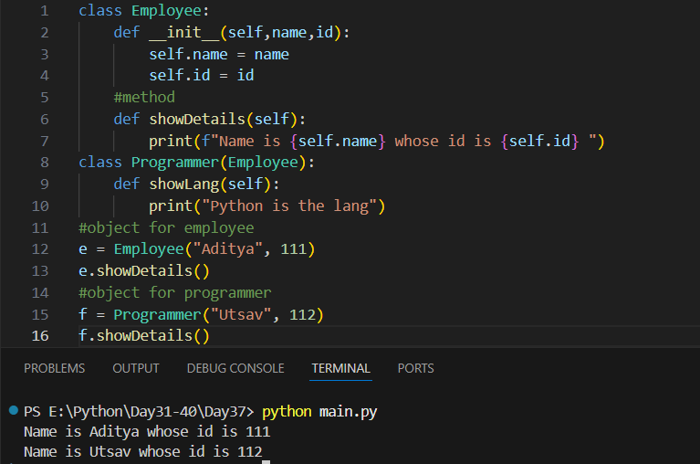
Example:
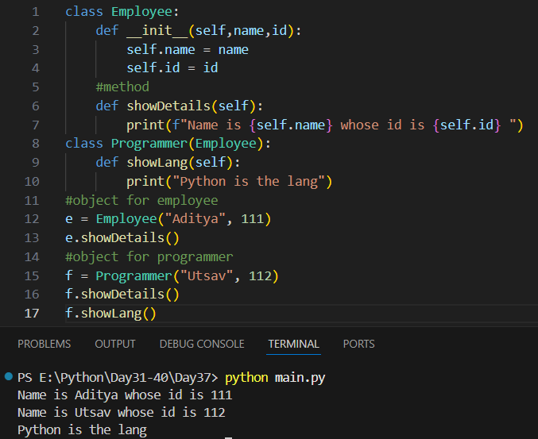

Access Modifiers in Python:
What are Access Modifiers?
Access modifiers control who can access variables and methods of a class.
Python has three types (by convention):
Modifier | Syntax | Meaning
Public | name | Accessible everywhere
Protected | _name | Accessible within class & subclasses
Private | __name | Accessible only inside the class

Note: Python does not enforce access modifiers like Java or C++. Instead, it uses naming conventions to indicate access level.
Example: Public Access Modifier - Public members are accessible everywhere
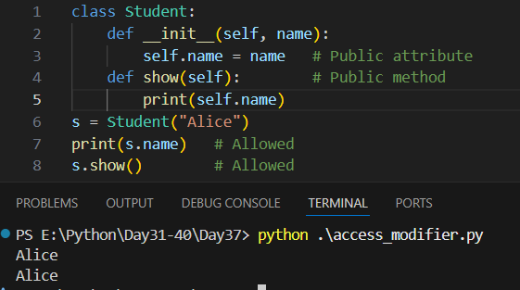

Protected Access Modifier (_): Single underscore _name
- Indicates internal use
- Accessible in subclasses
- Still accessible outside (not enforced)

Example:
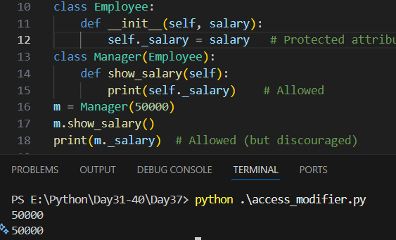
Private Access Modifier (__): Double underscore __name
- Triggers name mangling
- Prevents accidental access
- Strongest form of encapsulation
Exampel:
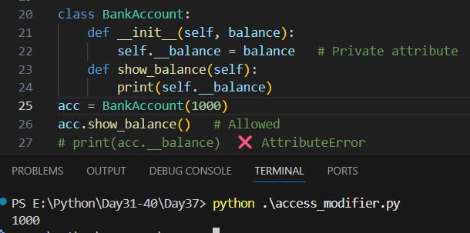
Name Mangling (Important Concept)
Python internally renames:
__balance → _ClassName__balance
So this works (but NOT recommended):
print(acc._BankAccount__balance) # 1000
This exists to avoid accidental access, not to provide true privacy.

Key Takeaways:
- Python access modifiers are conventions, not strict rules.
- _ = protected (internal use)
- __ = private (name mangling)
- Use getters/setters with @property for controlled access.

--The End--

