Day 8

For Loops in Python:
What is a for loop?
A for loop is used to repeat a block of code multiple times. It is mainly used to loop through sequences like:
- string
- list
- tuple
- range of numbers
Basic Syntax:
for variable in sequence:
# code to repeat

Example: a basic example of iterating the characters of the string using the for loops.
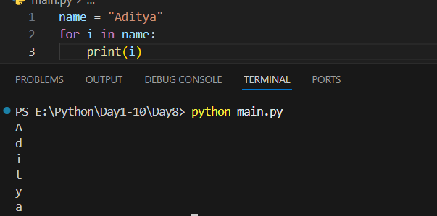

Example: using the for loop and if statement together
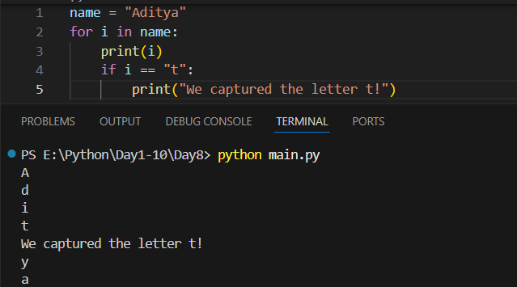
Example: iterating over a list
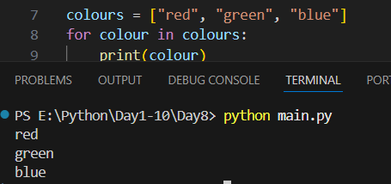
Example: printing the characters of the colours.
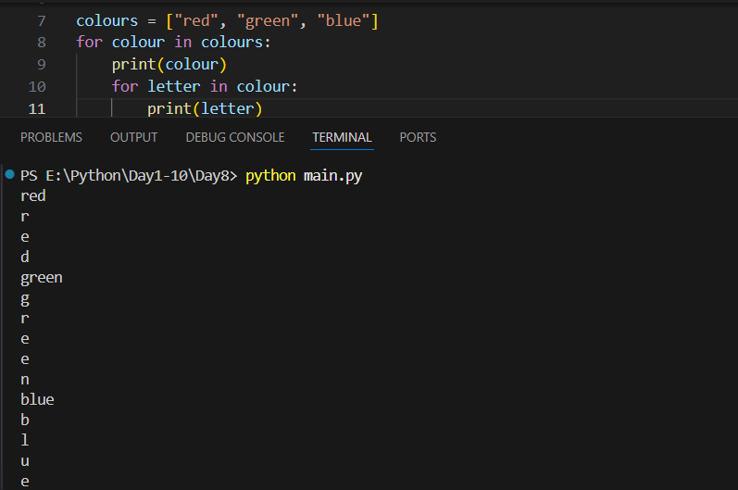

Example: basic use of range()
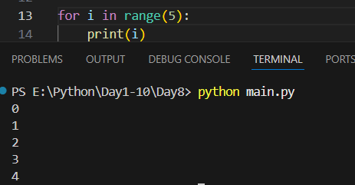
Example: printing from 1 to 5 using the range()
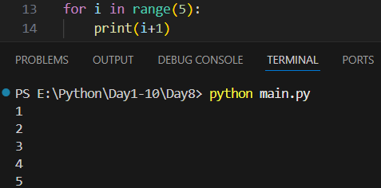
Example: range(start, stop)
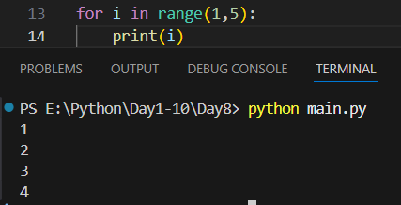

Example: range(start, stop, step)
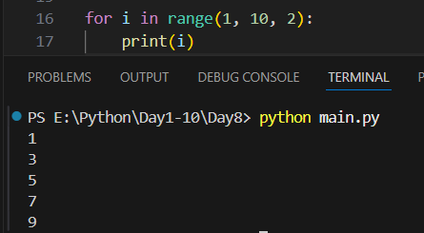
Example: break statement-stops the loop
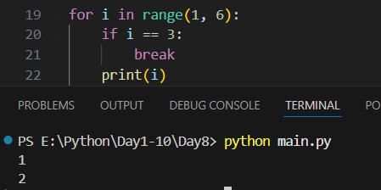
Example: continue statement- skip current iteration
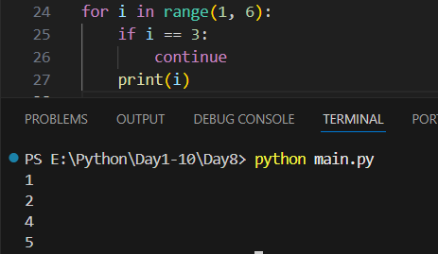

Example: nested for loop
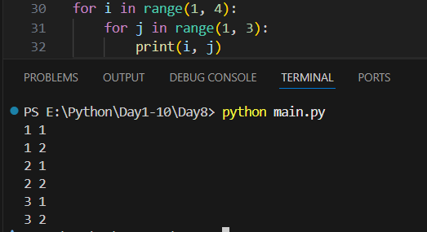
Summary:
- for loop repeats code multiple times
- Used with sequences and range()
- Syntax: for var in sequence:
- break stops loop
- continue skips iteration
- Can use else with loop
- Nested loops are allowed

While Loops in Python:
What is a while loop?
A while loop is used to repeat a block of code as long as a condition is True. When the condition becomes False, the loop stops.
Basic Syntax
while condition:
# code to repeat
Example: printing using the for loops
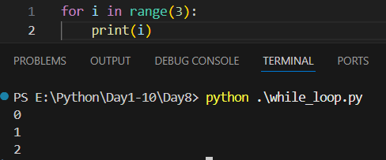
Example: basic code using the while loops
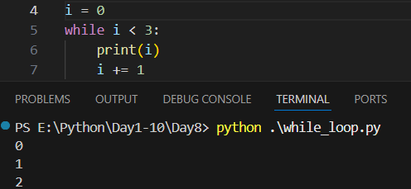
Example: condition never met in the below code and that’s why nothing gets printed
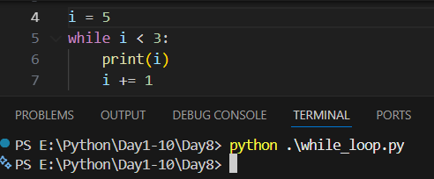
Example: using the increment line before the print()
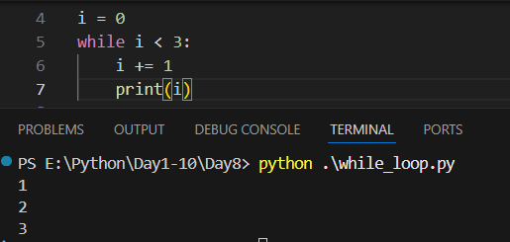

Example: taking the user input until the user enters less than 30.
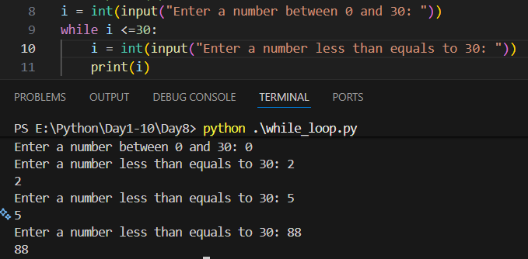
Example: infinite loop
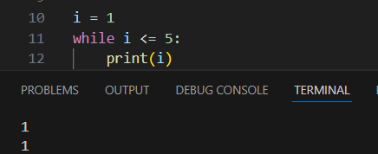
Example: iterating in the reverse order
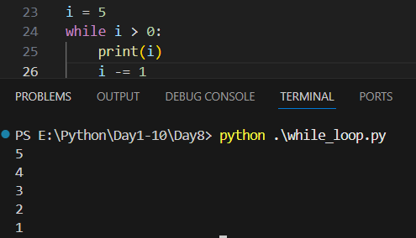

Example:
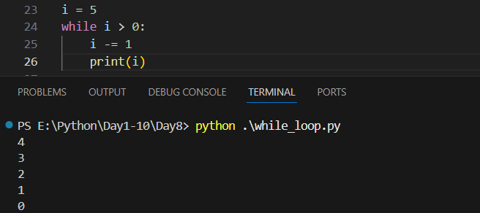

Summary,
- while loop runs while condition is True
- Best when number of iterations is not known
- Always update loop variable
- break stops loop
- continue skips iteration
- else runs after loop ends normally

--The End--

